**माननीय स्वास्थ्य मंत्रीजी द्वारा**

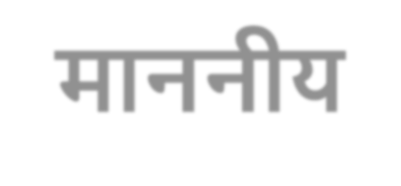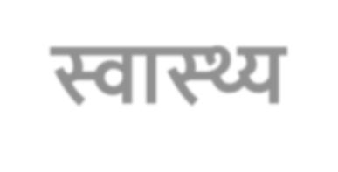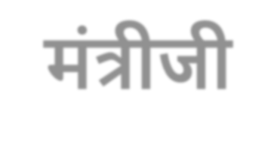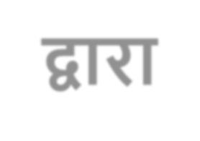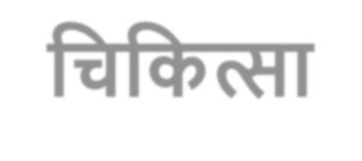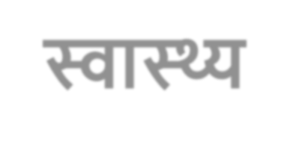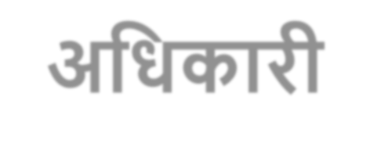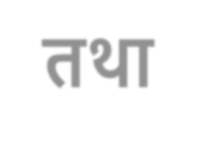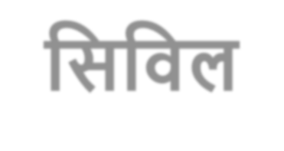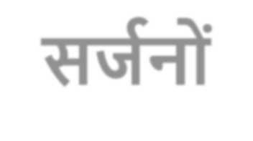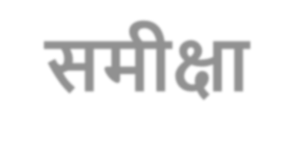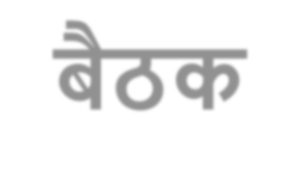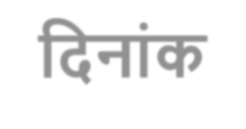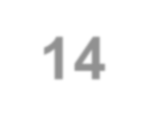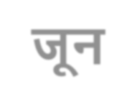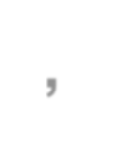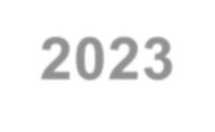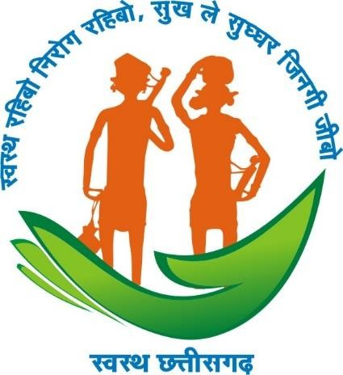

**मुख्य चिचित्सा एवं स्वास्थ्य अचििारी तथा चिचवल िजजन ं िी िमीक्षा बैठि**

**चिनांि- 14 जून, 2023**

**Maternal Health**

VHSND/UHSND Monitoring (April to 06th June 2023)

|  |  |  |  |  |
| --- | --- | --- | --- | --- |
| **SNo.** | **District** | **Total VHSND Monitoring Done** | | |
| **VHSND** | **UHSND** | **Total** |
| 1 | KANKER | 4202 | 165 | 4367 |
| 2 | KAWARDHA | 3887 | 117 | 4004 |
| 3 | RAIPUR | 1272 | 603 | 1875 |
| 4 | DURG | 889 | 549 | 1438 |
| 5 | DHAMTARI | 1280 | 121 | 1401 |
| 6 | RAIGARH | 1320 | 66 | 1386 |
| 7 | SURGUJA | 1252 | 86 | 1338 |
| 8 | JANJGIR | 1258 | 52 | 1310 |
| 9 | RAJNANDGAON | 1183 | 95 | 1278 |
| 10 | KORBA | 930 | 334 | 1264 |
| 11 | SURAJPUR | 1181 | 0 | 1181 |
| 12 | BALODA BAJAR | 1104 | 47 | 1151 |
| 13 | BILASPUR | 949 | 165 | 1114 |
| 14 | MAHASAMUND | 1030 | 26 | 1056 |
| 15 | GARIYABANDH | 1025 | 0 | 1025 |
| 16 | BALRAMPUR | 1002 | 0 | 1002 |
| 17 | SAKTI | 846 | 0 | 846 |
| 18 | BEMETARA | 825 | 0 | 825 |
| 19 | MOHLA MANPUR AMBAGARH CHOUKI | 808 | 0 | 808 |

|  |  |  |  |  |
| --- | --- | --- | --- | --- |
| **SNo.** | **District** | **Total VHSND Monitoring Done** | | |
| **VHSND** | **UHSND** | **Total** |
| 20 | BALOD | 799 | 0 | 799 |
| 21 | MANENDRAGARH CHIRIMIRI BHARATPUR | 703 | 79 | 782 |
| 22 | SARANGARH BILAIGARH | 688 | 0 | 688 |
| 23 | BASTAR | 573 | 40 | 613 |
| 24 | SUKMA | 594 | 0 | 594 |
| 25 | Gaurella Pendra Marwahi | 578 | 0 | 578 |
| 26 | KONDAGAON | 543 | 0 | 543 |
| 27 | JASHPUR | 497 | 0 | 497 |
| 28 | KHAIRGARH CHHUIKHADAN GANDAI | 490 | 0 | 490 |
| 29 | MUNGELI | 369 | 3 | 372 |
| 30 | NARAYANPUR | 368 | 0 | 368 |
| 31 | KORIA | 344 | 0 | 344 |
| 32 | DANTEWADA | 319 | 0 | 319 |
| 33 | BIJAPUR | 238 | 0 | 238 |
| **Total** | | **33346** | **25**3**48** | **35894** |

|  |  |
| --- | --- |
| **ANC Registrati** | **on against ELA (Apr-May 2023)** |
| **Percentage gradation** | **Name of district** |
| > 90% | Balrampur(128.4%), Bijapur(121.8%), Sukma(115.7%), Durg(114.3%), Narayanpur(112.7%), Bemetara(110%), Kanker(102.4%), Surguja(100.8%), Janjgir-Champa(98.6%), Mungeli(98.3%), Dantewada(97.5%), Kabirdham(97%), Balod(96%), Raipur(95.8%), Bilaspur(94%), Korea(92.6%), KCG(91.6%) |
| 89 to 75% | MMA(89.3%), Gariyaband(88.8%), Kondagaon(85.7%) GPM(85.1%), Mahasamund(83.8%), MCB(82.7%), Bastar(82.2%),  Rajnandgaon(81.9%), Jashpur(80%), Korba(77.7%), Surajpur(76.3%), Baloda Bazar(75.5%) |
| <75% | Sarangarh Bilaigarh(74%), Raigarh(73.9%), Sakti(66.9%), Dhamtari(63.9%) |

**\*Date source – google sheet**

|  |  |
| --- | --- |
| **ANC Registration wi** | **thin 1st trimester (April to May 2023)** |
| **Percentage gradation** | **Name of district** |
| > 90% | Kanker(100%), MCB(99.8%), Gariyaband(99%), Bemetara(98.8%), Korba(98.2%), Surguja(97.3%), Bastar(96.9%), Sarangarh Bilaigarh(96.4%), Dhamtari(96.4%), Balod(96.4%), Mahasamund(95.7%), Narayanpur(95.5%), Surajpur(95.4%), Kabirdham(95.4%), Mungeli(95.2%), Kondagaon(94.9%), MMA(94.8%), Rajnandgaon(94.7%), Baloda Bazar(94.5%), Sukma(94.5%), Bijapur(93.7%), Durg(92.6%), KCG(91.6%), Sakti(91.4%), Korea(91.4%),  Raigarh(90.7%) |
| 89 to 75% | GPM(88.8%), Jashpur(86.4%), Raipur(86.2%), Dantewada(85%), Bilaspur(82.5%), Janjgir-Champa(82.2%) |
| <75% | Balrampur(71.4%) |

**\*Date source – google sheet**

|  |  |
| --- | --- |
| **Pregnant Women rece** | **ived 4 or more ANC (April to May 2023)** |
| **Percentage gradation** | **Name of district** |
| > 90% | Raigarh(104.7%), Korba(99.5%), Bemetara(99.2%), MCB(98.8%), Narayanpur(97.9%), Kanker(97.9%), Kondagaon(97.3%), Mahasamund(95.7%), Jashpur(94.9%), Kabirdham(94.8%), Surguja(94.3%), Bilaspur(93.8%), Dhamtari(93.8%), Mungeli(91.8%), GPM(90.3%) |
| 89 to 75% | Durg(87.3%), Bastar(87.2%), Sarangarh Bilaigarh(86.4%), Sakti(85.3%), Balod(84.5%), Korea(82.9%), Dantewada(82.5%), Baloda Bazar(81.9%), Balrampur(81.4%), MMA(80.6%), Bijapur(79.3%), Raipur(78.1%), Rajnandgaon(76.1%) |
| <75% | Sukma(74.7%), KCG(74.2%), Surajpur(74.1%), Gariyaband(73.9%), Janjgir-  Champa(72.4%) |

**\*Date source – google sheet**

**Treatment of severe anemia against detected (April to May 2023)**

|  |  |
| --- | --- |
| **Percentage gradation** | **Name of district** |
| > 90% | Bastar(224.3%), Korba(100%), Bemetara(100%), Narayanpur(100%), Kanker(100%), Kondagaon(100%), Mahasamund(100%), Jashpur(100%), Kabirdham(100%), Surguja(100%), Dhamtari(100%), Mungeli(100%), Durg(100%), Sarangarh Bilaigarh(100%), Balod(100%), Korea(100%), Dantewada(100%), Baloda Bazar(100%), MCB (100%), MMA(100%), Raipur(100%), Rajnandgaon(100%), Sukma(100%), KCG(100%), Surajpur(100%), Gariyaband(100%), Janjgir- Champa(100%), Bilaspur(96.4%), GPM(93.4%), Bijapur(91.4%) |
| 89 to 75% | Raigarh (78.1%) |
| <75% | Balrampur (32.8%), Sakti(27.3%) |

**\*Date source – google sheet**

|  |  |
| --- | --- |
| **IFA** | **Distribution (April to May 2023)** |
| **Percentage gradation** | **Name of district** |
| > 90% | Raigarh(115.4%), MMA(100.4%), Narayanpur(100.4%), Kanker(100%), Kabirdham(100%), Sarangarh Bilaigarh(100%), Baloda Bazar(100%), Rajnandgaon(100%), Janjgir-Champa(100%), Bijapur(100%), GPM(99.9%), Surguja(99.8%), Mungeli(99.6%), Korba(99.5%), Mahasamund(99.3%), Bemetara(98.8%), MCB(98.8%), Kondagaon(98.4%), Dhamtari(98.4%), Surajpur(97.3%), Durg(97.2%), Raipur(96.8%), Bilaspur(96.2%), Jashpur(96.2%), Balrampur(96.1%), Bastar(95.5%), KCG(94.3%), Balod(94.3%), Gariyaband(93.7%), Sakti(90.6%) |
| 89 to 75% | Dantewada(89.1%), Korea(82.9%), Sukma(75.6%) |

**\*Date source – google sheet**

|  |  |
| --- | --- |
| **PW given one Albenda** | **zole tablet after 1st trimester (April to May 2023)** |
| **Percentage gradation** | **Name of district** |
| > 90% | Kanker(100%), Kabirdham(100%), MCB(99.8%), Bemetara(99.8%), Narayanpur(99.3%), GPM(98.9%), Korba(98.7%), Balod(98.1%), Sarangarh Bilaigarh(97%), Surguja(96.9%), Surajpur(96.1%), Mahasamund(95.2%), Mungeli(95.2%), Rajnandgaon(94.7%), Gariyaband(93.7%), Durg(93.2%), Kondagaon(92.3%), Korea(91.4%) |
| 89 to 75% | Dhamtari(89.6%), Janjgir-Champa(88.6%), Sakti(88%), Baloda Bazar(87.7%), Jashpur(86.4%), Bastar(86.3%), Bijapur(86.2%), Raigarh(85.8%), Bilaspur(85.4%), Balrampur(84.6%), KCG(81.9%), MMA(81.9%), Raipur(80%), Sukma(78.3%), Dantewada(76.4%) |

**\*Date source – google sheet**

|  |  |
| --- | --- |
| **PW received** | **360 calcium tablet (April to May 2023)** |
| **Percentage gradation** | **Name of district** |
| > 90% | Raigarh(113.1%), MMA(100.4%), Narayanpur(100.4%), Kanker(100%), Kabirdham(100%), Sarangarh Bilaigarh(100%), Rajnandgaon(100%), Baloda Bazar(100%), GPM(99.8%), Bijapur(99.8%), Mungeli(99.6%), Kondagaon(99.4%), Korba(99.2%), Bemetara(99%), Mahasamund(98.9%), MCB(98.8%), Dhamtari(98.4%), Janjgir-Champa(98.3%), Durg(97.2%), Raipur(96.8%), Bilaspur(96.2%), Jashpur(96%), Balrampur(95.8%), Surguja(95.2%), Bastar(94.9%), Balod(94.3%), Gariyaband(93.7%), KCG(92.2%), Surajpur(91.3%) |
| 89 to 75% | Dantewada(88.6%), Sakti(88%), Korea(82.9%), Sukma(77.8%) |

**\*Date source – google sheet**

|  |  |
| --- | --- |
| **Status of Instituti** | **onal Delivery against PELA (April to May 2023)** |
| Percentage gradation | Name of district |
| > 90% | Narayanpur(105.5%), Balrampur(95.5%), Surguja(94.3%) |
| 89 to 75% | Raigarh(87.7%), Sukma(84.4%), MCB(78.5%), Kanker(78.2%), Bijapur(76.5%) |
| <75% | Jashpur(74.6%), Korea(73.3%), Bemetara(73.1%), Mahasamund(71.7%), Kondagaon(70.3%), Baloda Bazar(69.3%)  Bilaspur(68.9%), Rajnandgaon(68.3%), Dantewada(67.8%), Dhamtari(66.7%), Mungeli(63%), Bastar(61.6%), Durg(60.7%), Kabirdham(59.9%), Raipur(54.7%), Balod(54.3%), Gariyaband(49.6%), Korba(48.9%), MMA(47.8%), Surajpur(46.8%), KCG(44%), Janjgir-Champa(42.9%), Sarangarh Bilaigarh(40.9%), GPM(40.5%), Sakti(36.3%) |

**\*Date source – google sheet**

|  |  |
| --- | --- |
| **Status of ANC Vs** | **Institutional Delivery (April to May 2023)** |
| **Percentage gradation** | **Name of district** |
| > 90% | Raigarh(107.9%), Dhamtari(94.9%) |
| 89 to 75% | MCB(86.2%), Narayanpur(85.1%), Surguja(85.1%), Jashpur(84.9%), Baloda Bazar(83.5%), Mahasamund(77.8%), Rajnandgaon(75.8%) |
| <75% | Kondagaon(74.6%), Korea(72%), Kanker(69.5%), Bastar(68.1%), Balrampur(67.7%), Bilaspur(66.7%), Sukma(66.3%), Dantewada(63.2%), Bemetara(60.4%), Mungeli(58.2%), Korba(57.2%), Bijapur(57.1%), Kabirdham(56.1%), Surajpur(55.8%), Raipur(51.9%), Balod(51.5%), Gariyaband(50.9%), Sarangarh Bilaigarh(50.3%), Sakti(49.4%), MMA(48.7%), Durg(48.3%), KCG(43.7%), GPM(43.3%), Janjgir-  Champa(39.6%) |

**\*Date source – google sheet**

|  |  |
| --- | --- |
| **Status of C-section agai** | **nst Institutional Delivery against PELA (April to May 2023)** |
| **Percentage gradation** | **Name of district** |
| > 15% | Durg(47.9%), Raipur(47.2%), Rajnandgaon(32.3%), Bilaspur(28.6%),  Raigarh(28.6%), Surguja(26.2%), Balod(24.2%), Korba(19.2%), Korea(16.6%) |
| 10 to 15% | Mungeli(14.6%), Dhamtari(14.5%), Baloda Bazar(12.4%), Sakti(12.1%), Mahasamund(11%), Kondagaon(10.9%) |
| <10% | Janjgir-Champa(9.9%), Narayanpur(9.4%), Kanker(9.2%), Bijapur(8.4%), Dantewada(8.4%), Kabirdham(8.3%), Sarangarh Bilaigarh(8%), Jashpur(6.3%), Bastar(6.3%), KCG(5.7%), Sukma(4%), Bemetara(2.7%), Gariyaband(2.1%), MCB(1.8%), Surajpur(1.6%), MMA(1%), Balrampur(0.4%), GPM(0%), |

**\*Date source – google sheet**

High Risk Pregnancy (PMSMA) (April – May 2023)

|  |  |  |  |  |  |  |  |
| --- | --- | --- | --- | --- | --- | --- | --- |
| SNo | **District** | **Total number of pregnant women Received Antenatal care under PMSMA** | **Total HRP identified** | **% HRP**  **identified (against ELA**  **i.e. 15%)** | **Total Managed or referred** | **% managed & reffered** | **Difference neither managed nor reffered against identified** |
| 1 | **BALOD** | **2239** | **259** | **77.12** | **205** | **79.15** | **54** |
| 2 | **BALODA BAZAR** | **1111** | **85** | **51.01** | **82** | **96.47** | **3** |
| 3 | **BALRAMPUR** | **1638** | **20** | **8.14** | **15** | **75.00** | **5** |
| 4 | **BASTAR** | **878** | **86** | **65.30** | **74** | **86.05** | **12** |
| 5 | **BEMETARA** | **1382** | **203** | **97.93** | **169** | **83.25** | **34** |
| 6 | **BIJAPUR** | **733** | **86** | **78.22** | **86** | **100.00** | **0** |
| 7 | **BILASPUR** | **1652** | **240** | **96.85** | **170** | **70.83** | **70** |
| 8 | **DANTEWADA** | **0** | **0** | **0.00** | **0** | **0.00** | **0** |
| 9 | **DHAMTARI** | **1677** | **197** | **78.31** | **138** | **70.05** | **59** |
| 10 | **DURG** | **3310** | **732** | **147.43** | **626** | **85.52** | **106** |
| 11 | **GARIYABAND** | **996** | **162** | **108.43** | **142** | **87.65** | **20** |
| 12 | **JANJGIR- CHAMPA** | **1356** | **136** | **66.86** | **74** | **54.41** | **62** |
| 13 | **JASHPUR** | **1899** | **207** | **72.67** | **168** | **81.16** | **39** |
| 14 | **KABIRDHAM** | **2894** | **565** | **130.15** | **565** | **100.00** | **0** |

|  |  |  |  |  |  |  |  |
| --- | --- | --- | --- | --- | --- | --- | --- |
| SNo | **District** | **Total number of pregnant women Received Antenatal care under PMSMA** | **Total HRP identified** | **% HRP**  **identified (against ELA**  **i.e. 15%)** | **Total Managed or reffered** | **% managed & reffered** | **Difference neither managed nor reffered against identified** |
| 15 | **KANKER** | **562** | **25** | **29.66** | **29** | **116.00** | **-4** |
| 16 | **KONDAGAON** | **499** | **41** | **54.78** | **30** | **73.17** | **11** |
| 17 | **KORBA** | **540** | **47** | **58.02** | **44** | **93.62** | **3** |
| 18 | **KOREA** | **1661** | **133** | **53.38** | **77** | **57.89** | **56** |
| 19 | **MAHASAMUND** | **1425** | **252** | **117.89** | **241** | **95.63** | **11** |
| 20 | **MUNGELI** | **1722** | **250** | **96.79** | **233** | **93.20** | **17** |
| 21 | **NARAYANPUR** | **223** | **14** | **41.85** | **4** | **28.57** | **10** |
| 22 | **RAIGARH** | **1739** | **246** | **94.31** | **253** | **102.85** | **-7** |
| 23 | **RAIPUR** | **4423** | **884** | **133.24** | **702** | **79.41** | **182** |
| 24 | **RAJNANDGAON** | **3152** | **299** | **63.24** | **190** | **63.55** | **109** |
| 25 | **SUKMA** | **27** | **0** | **0.00** | **0** | **0.00** | **0** |
| 26 | **SURAJPUR** | **1366** | **38** | **18.55** | **38** | **100.00** | **0** |
| 27 | **SURGUJA** | **2414** | **284** | **78.43** | **253** | **89.08** | **31** |
|  | **Total** | **41518** | **5491** | **88.17** | **4608** | **83.92**14 | **883** |

|  |  |
| --- | --- |
| **High Risk Pregnanc** | **y Identification (as per RCH portal)** |
| **Percentage gradation**  **(against ANC registration)** | **Name of district** |
| >15% | Jashpur (26.6%), Kabeerdham(16.5%) |
| 10-15% | Raipur(12.6%), MCB(10.7%) |
| 9-6% | Sarangarh Bilaigarh(9.1%), Janjgir - Champa(8.4%), Mahasamund(8.3%), KCG(7.3%)  MMA-Chowki(7%), Koriya(7%), Dantewada(7%), Rajnandgaon(6.9%), Raigarh(6.7%), Kanker(6.6%), Baloda bajar(6.2%), GPM(6.2%) |
| <6% | Durg(5.3%), Bemetara(5.2%), Balod(5%), Dhamtari (4.9%), Narayanpur(4.8%), Korba (4.7%), Mungeli(4%), Gariyabandh(3.8%), Bastar(3.7%), Bilaspur(3.6%), Kondagaon(3.1%), Sakti(2.8%), Bijapur(2.4%), Balrampur(1.9%), Surguja(1.6%), Sukma(1.5%), Surajpur(1.3%) |

Status of HRP reporting in the State

|  |  |  |  |  |  |  |  |  |
| --- | --- | --- | --- | --- | --- | --- | --- | --- |
| **S.NO** | **District** | **PW Registered** | **PW**  **Registered in 1st Trimester** | **% of total PW registered** | **High risk PW Registered** | **% HRP registered against total PW registered** | **Severe Anaemic PW Registered** | **Maternal Death** |
| 1 | Jashpur | 2779 | 2404 | 86.5 | 731 | 26.3 | 23 | 0 |
| 2 | Kabeerdham | 4255 | 3811 | 89.6 | 683 | 16.1 | 6 | 0 |
| 3 | Raipur | 8354 | 6323 | 75.7 | 1053 | 12.6 | 15 | 0 |
| 4 | Koriya | 1784 | 1615 | 90.5 | 169 | 9.5 | 11 | 0 |
| 5 | Mahasamund | 3371 | 3116 | 92.4 | 278 | 8.2 | 9 | 0 |
| 6 | Raigarh | 2838 | 2206 | 77.7 | 226 | 8.0 | 5 | 0 |
| 7 | Rajnandgaon | 5311 | 4602 | 86.7 | 372 | 7.0 | 11 | 0 |
| 8 | Dantewada | 979 | 931 | 95.1 | 66 | 6.7 | 4 | 0 |
| 9 | Kanker | 2020 | 1906 | 94.4 | 134 | 6.6 | 4 | 0 |
| 10 | Janjgir - Champa | 3929 | 2911 | 74.1 | 249 | 6.3 | 12 | 0 |
| 11 | BALODA BAJAR | 2988 | 2313 | 77.4 | 177 | 5.9 | 5 | 0 |
| 12 | Durg | 5036 | 4062 | 80.7 | 262 | 5.2 | 6 | 0 |
| 13 | BEMETARA | 2911 | 2361 | 81.1 | 149 | 5.1 | 3 | 0 |
| 14 | Dhamtari | 2301 | 2111 | 91.7 | 114 | 5.0 | 1 | 0 |
| 15 | BALOD | 1913 | 1691 | 88.4 | 93 | 4.9 | 5 | 0 |
| 16 | Korba | 4588 | 3890 | 84.8 | 210 | 4.6 | 12 | 0 |
| 17 | Narayanpur | 568 | 462 | 81.3 | 25 | 4.4 | 0 | 0 |
| 18 | Bilaspur | 6151 | 4299 | 69.9 | 255 | 4.1 | 8 | 0 |
| 19 | MUNGELI | 2187 | 1409 | 64.4 | 85 | 3.9 | 0 | 0 |
| 20 | GARIYABANDH | 2282 | 2109 | 92.4 | 85 | 3.7 | 1 | 1 |
| 21 | Bastar | 2408 | 2147 | 89.2 | 86 | 3.6 | 1 | 0 |
| 22 | KONDAGAON | 1605 | 1260 | 78.5 | 47 | 2.9 | 3 | 0 |
| 23 | Bijapur | 1126 | 1003 | 89.1 | 29 | 2.6 | 5 | 0 |
| 24 | BALRAMPUR | 3485 | 3222 | 92.5 | 66 | 1.9 | 2 | 0 |
| 25 | Surguja | 2438 | 1780 | 73.0 | 41 | 1.7 | 5 | 0 |
| 26 | SUKMA | 916 | 866 | 94.5 | 13 | 1.4 | 0 | 0 |
| 27 | SURAJPUR | 2201 | 1771 | 80.5 | 26 | 1.2 | 6 | 1 |

**Top 15 districts with more than 100 HRP registered in April and May**

|  |  |  |
| --- | --- | --- |
| **HRP bif**  **Criteria** | **urcation St**  **Numbers** | **ate level**  **%** |
| Previous LSCS | 1183 | **22.3** |
| High BP | 1073 | **20.2** |
| Anemia cases | 537 | **10.1** |
| Abortion | 447 | **8.4** |
| Multigravida | 444 | **8.4** |
| out of which severe  anemia | 290 | **5.5** |
| Diabetic | 278 | **5.2** |
| Sickling | 185 | **3.5** |
| Short stature | 182 | **3.4** |
| Low weight | 168 | **3.2** |
| AGE ABOVE 35  YEARS | 145 | **2.7** |
| Still birth | 109 | **2.1** |
| AGE <18 | 108 | **2.0** |
| Overweight | 46 | **0.9** |
| Low BP | 33 | **0.6** |
| Gap more than 3 yrs | 27 | **0.5** |
| Thyorid | 50 | **0.9** |
|  | **5305** |  |

|  |  |  |
| --- | --- | --- |
| **S.NO** | **District** | **High risk PW Registered** |
| 1 | Raipur | 1053 |
| 2 | Jashpur | 731 |
| 3 | Kabeerdham | 683 |
| 4 | Rajnandgaon | 372 |
| 5 | Mahasamund | 278 |
| 6 | Durg | 262 |
| 7 | Bilaspur | 255 |
| 8 | Janjgir - Champa | 249 |
| 9 | Raigarh | 226 |
| 10 | Korba | 210 |
| 11 | BALODA BAJAR | 177 |
| 12 | Koriya | 169 |
| 13 | BEMETARA | 149 |
| 14 | Kanker | 134 |
| 15 | Dhamtari | 114 |
| 16 | BALOD | 93 |
| 17 | Bastar | 86 |
| 18 | MUNGELI | 85 |
| 19 | GARIYABANDH | 85 |
| 20 | Dantewada | 66 |
| 21 | BALRAMPUR | 66 |
| 22 | KONDAGAON | 47 |
| 23 | Surguja | 41 |
| 24 | Bijapur | 29 |
| 25 | SURAJPUR | 26 |
| 26 | Narayanpur | 25 |
| 27 | SUKMA | 13 |

|  |  |  |  |
| --- | --- | --- | --- |
| **Facilities** | **FIRST**  **Designated** | **REFERR**  **Functional** | **AL UNIT (FRU)**  **Functional as per conditionality DH > 10 C- Section per month & CH & CHC > 5 C- Section per month** |
| DH FRU | 24 | 24 | 19 |
| Civil Hospital FRU | 3 | 2 | 02  (Nagri, Kharsia) |
| CHC FRU | 32 | 25 | 9  (Baghbahara, Manendragarh, Pithora, Lormi, Lailunga, Tilda, Chhuikhadan, Pali, Katghora) |
| Total | 59 | 51 |  |

**Not fulfilling conditionality DH**

Balrampur, Bemetara, Gariyabandh, GPM, Narayanpur

|  |  |  |  |
| --- | --- | --- | --- |
| **Facilities** | **Number** | **MCH**  **Functional** | **Wing**  **Remarks** |
| **50 bedded** | 19 | 18 | **Non-functional –**  Korea – Approved in 2020-21, under process |
| **100 bedded** | 10 | 10 |  |
| **300 bedded** | 1 | 0 | Raipur Medical college - Approved in 2020-21, construction Not yet started |

|  |  |
| --- | --- |
| **Status of JSY paym** | **ent against ROP PELA (April to May 2023)** |
| **Percentage gradation** | **Name of district** |
| > 90% | Bilaspur(184%), Sukma(162.6%), Bijapur(138.1%), Mungeli(136%), Balrampur(127.6%), Raipur(118.9%), Narayanpur(118.3%), Surguja(114.8%), Dhamtari(106.9%), Surajpur(106.2%), Jashpur(105.6%), Bastar(101.1%), Baloda Bazar(99.4%), Kabirdham(93.3%), Gariyaband(91.9%), Durg(90.9%) |
| 89 to 75% | Raigarh(75.3%) |
| <75% | Dantewada(71.8%), Kanker(70.7%), Mahasamund(61.4%), Bemetara(60.3%), Janjgir-Champa(59.1%), Kondagaon(55.1%), Rajnandgaon(49.6%), Balod(48.3%), Korea(39.8%), Gaurella Pendra Marwahi(34.5%), Korba(33.7%) |

**\*Date source – google sheet**

|  |  |
| --- | --- |
| **Status of JSSK die** | **t against ROP P.ELA (April to May 2023)** |
| **Percentage gradation** | **Name of district** |
| > 90% | Surguja(153.3%), Bilaspur(125.5%), Raipur(107.6%), Surajpur(106.1%),  Bijapur(105.8%), Jashpur(90.9%) |
| 89 to 75% | Kabirdham(83%), Sukma(82.9%), Mungeli(78%) |
| <75% | Durg(73.9%), Dhamtari(67%), Baloda Bazar(61.6%), Bastar(61.2%), Bemetara(58.5%), Janjgir-Champa(57.4%), Balrampur(55.8%), Kanker(53.7%), Kondagaon(48.2%), Mahasamund(46.4%), Narayanpur(44.9%), Gariyaband(42.8%), Rajnandgaon(41.6%), Gaurella Pendra Marwahi(38%), Korba(36.4%), Balod(36.1%), Korea(34.7%), Dantewada(25.8%), |

**Report not entered by : Raigarh & Sakti**

**\*Date source – google sheet**

**Status of MDSR Review April-May 2023**

Other districts reported 0 maternal death

**Data Source- PM Portal**

|  |  |  |  |  |
| --- | --- | --- | --- | --- |
| **Sno.** | **District** | **Total Death** | **Review by CMHO** | **Review by DM** |
| 1 | RAIPUR | 9 | 9 | 0 |
| 2 | SURGUJA | 5 | 5 | 5 |
| 3 | KORBA | 4 | 4 | 0 |
| 4 | JASHPUR | 3 | 3 | 1 |
| 5 | DURG | 2 | 2 | 3 |
| 6 | KAWARDHA | 2 | 2 | 2 |
| 7 | MAHASAMUND | 2 | 2 | 0 |
| 8 | RAJNANDGAON | 2 | 2 | 0 |
| 9 | DANTEWADA | 1 | 1 | 0 |
| 10 | KANKER | 1 | 1 | 0 |
| 11 | KONDAGAON | 1 | 0 | 0 |
| 12 | SURAJPUR | 1 | 1 | 1 |
| **State Total** | | **33** | **32** | **12** |



###### Blood Transfusion Services in State - Facilities

**Particular/ Activity Achievement as on March 2023**

**Total no. of Blood Banks 120**

**Total Govt. Blood Banks 33**

**Total Non. Govt. Blood Banks 87**

**Government facilities**

District Hospital Blood Bank 22

Medical College Blood Banks* 9

Red Cross Blood Bank 01

CHC Blood Bank 01

**Transportation & Collection facility -**

Blood Mobile Van 2

Blood Transportation Van 4 24

State Scenario –Blood Collection

|  |  |  |
| --- | --- | --- |
| **Head** | **FY 2022- 23** | **April-May 2023** |
| 1 % of total population requires blood | 2.55 lakh units | 24578 units for 2 months |
| Total no. of Blood banks | 120 | 120 |
| Government | 33 | 33 |
| Non-Government | 87 | 87 |
| Total blood collection | 234480 | 34259 |
| Government Collection | 113568 Unit | 18898 units |
| Non-Government Collection | 120912 Unit | 15361 units |
| Percentage Collection | 92 % | 139 % |
| GAP units required to fulfill | 7344(8%) | 0 25 |

|  |  |  |  |  |  |  |
| --- | --- | --- | --- | --- | --- | --- |
| **Blood Collection in Chhattisgarh State (April 2022 to March 2023)** | | | | | | |
| **SNo.** | **Name of District** | **12 months target** | **Total Voluntary Collection** | **Total**  **Replacement**  **Collection** | **Grand Total Blood Collection** | **Percentage Collection Against Target** |
| 1 | Raipur | 25443 | 27938 | 36445 | 64383 | 253 |
| 2 | Surguja | 8947 | 4800 | 15487 | 20287 | 227 |
| 3 | Bilaspur | 20866 | 11741 | 14835 | 26576 | 127 |
| 4 | Rajnandgaon | 15375 | 11038 | 8440 | 19478 | 127 |
| 5 | Dantewada | 2640 | 985 | 1959 | 2944 | 112 |
| 6 | Kanker | 7486 | 2101 | 6081 | 8182 | 109 |
| 7 | Dhamtari | 7992 | 5567 | 3003 | 8570 | 107 |
| 8 | Narayanpur | 1402 | 608 | 876 | 1484 | 106 |
| 9 | Durg | 19210 | 6953 | 11466 | 18419 | 96 |
| 10 | Kondagaon | 5203 | 785 | 3447 | 4233 | 81 |
| 11 | Bastar | 8913 | 77 | 7142 | 7219 | 81 |
| 12 | Mahasamund | 10323 | 4122 | 2882 | 7004 | 68 |
| 13 | Bijapur | 2552 | 184 | 1518 | 1702 | 26  67 |

|  |  |  |  |  |  |  |
| --- | --- | --- | --- | --- | --- | --- |
| **Blood Collection in Chhattisgarh State (April 2022 to March 2023)** | | | | | | |
| **S. No.** | **Name of District** | **11 months target** | **Total Voluntary**  **Collection** | **Total Replacement Collection** | **Grand Total Blood**  **Collection** | **Percentage Collection Against Target** |
| 14 | Koriya | 6590 | 3534 | 389 | 3923 | 60 |
| 15 | Kawardha | 8222 | 869 | 3580 | 4449 | 54 |
| 16 | Sukma | 2688 | 333 | 1021 | 1354 | 50 |
| 17 | Raigarh | 14936 | 2932 | 4436 | 7368 | 49 |
| 18 | Korba | 12066 | 2367 | 2681 | 5048 | 42 |
| 19 | Surajpur | 7657 | 336 | 2794 | 3130 | 41 |
| 20 | Janjgir-Champa | 16206 | 2684 | 3112 | 5796 | **36** |
| 21 | Jashpur | 8520 | 79 | 2758 | 2837 | **33** |
| 22 | Mungeli | 5755 | 146 | 1649 | 1795 | **31** |
| 23 | Baloda Bazar | 9164 | 2016 | 591 | 2606 | **28** |
| 24 | Balrampur | 7009 | 842 | 913 | 1755 | **25** |
| 25 | Gariyaband | 6014 | 501 | 855 | 1355 | **23** |
| 26 | Balod | 7993 | 376 | 1144 | 1520 | **19** |
| 27 | Bemetara | 6227 | 1056 | 7 | 1063 | **17** |
|  | **Total** | **255399** | **94970** | **139510** | **234480** | 27**92** |

|  |  |  |  |  |  |  |  |  |
| --- | --- | --- | --- | --- | --- | --- | --- | --- |
| **Blood Collection in Chhattisgarh State (April -May 2023)** | | | | | | | | |
| **S.No.** | **Name of District** | **Projected Population 2023** | **Target for blood collection (about 1**  **% of popn requires blood)** | **Target for 02 months** | **Total Collection in Govt Blood Banks** | **Total Collection in Private Blood Banks** | **Grand Total Collection** | **Percentage collection** |
| 1 | Raipur | 2617678 | 26177 | 2181 | 2758 | 6020 | 8778 | 402 |
| 2 | Surguja | 943322 | 9433 | 786 | 1848 | 1282 | 3130 | 398 |
| 3 | Narayanpur | 156374 | 1564 | 130 | 299 | 0 | 299 | 229 |
| 4 | Bilaspur | 2371523.1 | 23715 | 1976 | 1313 | 3039 | 4352 | 220 |
| 5 | Rajnandgao n | 1745841 | 17458 | 1455 | 1070 | 1813 | 2883 | 198 |
| 6 | Dantewada | 315827.03 | 3158 | 263 | 490 | 0 | 490 | 186 |
| 7 | Kanker | 1033736 | 10337 | 861 | 960 | 536 | 1496 | 174 |
| 8 | Sukma | 262243 | 2622 | 219 | 327 | 0 | 327 | 150 |
| 9 | Durg | 1891770.8 | 18918 | 1576 | 1322 | 934 | 2256 | 143 |
| 10 | Bastar | 937813.4 | 9378 | 782 | 1058 | 0 | 1058 | 28 135 |

|  |  |  |  |  |  |  |  |  |
| --- | --- | --- | --- | --- | --- | --- | --- | --- |
| **Blood Collection in Chhattisgarh State (April -May 2023)** | | | | | | | | |
| **SNo.** | **Name of District** | **Projected Population 2023** | **Target for blood collection (about 1**  **% of popn**  **requires blood)** | **Target for 02 months** | **Total Collection in Govt Blood Banks** | **Total Collection in Private Blood Banks** | **Grand Total Collection** | **Percentage collection** |
| 11 | Bijapur | 268861.99 | 2689 | 224 | 276 | 0 | 276 | 123 |
| 12 | Kondagaon | 649423 | 6494 | 541 | 610 | 0 | 610 | 113 |
| 13 | Dhamtari | 870434.87 | 8704 | 725 | 422 | 332 | 754 | 104 |
| 14 | Korba | 1366088 | 13661 | 1138 | 747 | 405 | 1152 | 101 |
| 15 | Koriya | 713046 | 7130 | 594 | 532 | 51 | 583 | 98 |
| 16 | Mahasamun d | 1174834 | 11748 | 979 | 575 | 183 | 758 | 77 |
| 17 | Jashpur | 935946 | 9359 | 780 | 573 | 0 | 573 | 73 |
| 18 | Raigarh | 1678969 | 16790 | 1399 | 848 | 159 | 1007 | 72 |
| 19 | Surajpur | 894643 | 8946 | 746 | 502 | 0 | 502 | 67 |
| 20 | Janjgir-  Champa | 1873477 | 18735 | 1561 | 383 | 607 | 990 | 29 63 |

|  |  |  |  |  |  |  |  |  |
| --- | --- | --- | --- | --- | --- | --- | --- | --- |
| **Blood Collection in Chhattisgarh State (April -May 2023)** | | | | | | | | |
| **S.No.** | **Name of**  **District** | **Projected Population 2023** | **Target for blood**  **collection (about 1**  **% of popn requires blood)** | **Target for**  **02 months** | **Total Collection in Govt Blood Banks** | **Total Collection in Private Blood Banks** | **Grand Total**  **Collection** | **Percentage**  **collection** |
| 21 | Kawardha | 825573 | 8256 | 688 | 402 | 0 | 402 | 58 |
| 22 | Mungeli | 873368 | 8734 | 728 | 378 | 0 | 378 | 52 |
| 23 | Balod | 880104 | 8801 | 733 | 334 | 0 | 334 | 46 |
| 24 | Balrampur | 840369 | 8404 | 700 | 230 | 0 | 230 | **33** |
| 25 | Bemetara | 1007581 | 10076 | 840 | 219 | 0 | 219 | **26** |
| 26 | Gariyaband | 668340 | 6683 | 557 | 141 | 0 | 141 | **25** |
| 27 | Baloda Bazar | 1695813 | 16958 | 1413 | 281 | 0 | 281 | **20** |
|  | **Total** | **29493000** | **294930** | **24578** | **18898** | **15361** | **34259** | 30 **139** |

|  |  |  |  |  |
| --- | --- | --- | --- | --- |
| **Status of Blood Storage Units in FRU CHCs & CHs** | | | | |
| **S.N.** | **Name of District** | **Name of Facility** | **Transfusion (April 2022- Feb 2023)** |  |
| 26 | Baloda Bazar | CHC Kasdoal | 0 |  |
| 27 | Balrampur | CHC Wadrafnagar | 0 |  |
| 28 | Bastar | CHC Bakawand | 0 |  |
| 29 | Kabirdham | CHC Pandariya | 0 |  |
| 30 | Kanker | CHC Pakhanjur | 0 |  |
| 31 | Rajanandgaon | CHC Chhuriya | 0 |  |
| 32 | Manpur-Mohela-Chouki | CHC Manpur | 0 |  |
| 33 | Rajnandgaon | CHC Dongargarh | 0 |  |
| 35 | Janjgir-Champa | CHC Sakti | 0 |  |

|  |  |  |  |  |
| --- | --- | --- | --- | --- |
|  | **Govt Bl** | **ood Cen** | **ter Ca** | **mp Co** |
| **SNo.** | **District** | **Total camp** | **Camp**  **Collection** | **Average collection per camp** |
| 1 | Raipur | 140 | 7977 | 57 |
| 2 | Korba | 33 | 1884 | 57 |
| 3 | Mahasamund | 42 | 1858 | 44 |
| 4 | Durg | 52 | 2220 | 43 |
| 5 | Rajnandgaon | 55 | 2299 | 42 |
| 6 | Bilaspur | 45 | 1843 | 41 |
| 7 | Jagdalpur | 25 | 919 | 36 |
| 8 | Dantewara | 12 | 413 | 34 |
| 9 | Dhamtari | 14 | 473 | 33 |
| 10 | Kanker | 24 | 752 | 31 |
| 11 | Surguja | 45 | 1302 | 29 |
| 12 | Mungeli | 12 | 320 | 26 |
| 13 | Janjgir | 32 | 811 | 25 |
| 14 | Balrampur | 4 | 98 | 22 |

|  |  |  |  |  |
| --- | --- | --- | --- | --- |
| **llect**  **SNo.** | **ion Apr**  **District** | **il 22- Ma**  **Total**  **camp** | **rch**  **Camp**  **Collection** | **23**  **Average collection per camp** |
| 15 | Bijapur | 8 | 160 | 21 |
| 16 | Narayanpur | 12 | 243 | 20 |
| 17 | Raigarh | 54 | 919 | 17 |
| 18 | Kawardha | 15 | 260 | 17 |
| 19 | Sukma | 7 | 110 | 17 |
| 20 | Balodabazar | 6 | 87 | 16 |
| 21 | Bemetara | 18 | 264 | 15 |
| 22 | Koriya | 17 | 234 | 14 |
| 23 | Gariyaband | 11 | 141 | 13 |
| 24 | Surajpur | 25 | 315 | 12 |
| 25 | Balod | 8 | 95 | 12 |
| 26 | Kondagaon | 26 | 311 | 12 |
| 27 | Jashpur | 26 | 173 | 7 |
|  | **Total** | **768** | **26478** | **34** |

**Sickle Cell Disorder Management Program**

|  |  |  |  |  |  |  |  |  |  |  |  |
| --- | --- | --- | --- | --- | --- | --- | --- | --- | --- | --- | --- |
| **Sickle Cell screening in Sickle Cell Prabandhan unit**  **(01 April 2023 to 31 May 2023)** | | | | | | | | | | | |
| **SNO** | **District**  **Name** | **Total** | **AA** | **AS** | **SS** | **Total Pending Solubility** | **Daily Follow up Patient (SS)** | **Total Hydroxiurea given to new patients** | **Total Hydroxiure a given to old patients** | **Total**  **CBC** | **Total BT** |
| 1 | Bastar | 2189 | 1749 | 389 | 50 | 45 | 114 | 23 | 37 | 63 | 4 |
| 2 | Durg | 1956 | 1427 | 436 | 43 | 28 | 388 | 32 | 272 | 1886 | 60 |
| 3 | Raigarh | 1715 | 1397 | 221 | 96 | 8 | 207 | 39 | 176 | 133 | 1 |
| 4 | Surajpur | 1689 | 1240 | 340 | 24 | 284 | 128 | 5 | 114 | 120 | 3 |
| 5 | Raipur | 1632 | 874 | 603 | 81 | 17 | 2062 | 19 | 1366 | 1092 | 0 |
| 6 | Dhamtari | 1237 | 1038 | 14 | 28 | 54 | 61 | 30 | 44 | 426 | 14 |
| 7 | Korba | 892 | 779 | 67 | 46 | 16 | 48 | 25 | 11 | 16 | 4 |
| 8 | Balod | 851 | 735 | 96 | 9 | 23 | 17 | 3 | 12 | 12 | 1 |

|  |  |  |  |  |  |  |  |  |  |  |  |
| --- | --- | --- | --- | --- | --- | --- | --- | --- | --- | --- | --- |
| **Sickle Cell screening in Sickle Cell Prabandhan unit (01 April 2023 to 31 May 2023)** | | | | | | | | | | | |
| **SNO** | **District Name** | **Total** | **AA** | **AS** | **SS** | **Total PendingS olubility** | **Daily Follow up Patient (SS)** | **Total Hydroxiurea given to new patients** | **Total Hydroxiurea given to old patients** | **Total CBC** | **Total BT** |
| 9 | Sarguja | 825 | 608 | 70 | 115 | 65 | 66 | 7 | 60 | 67 | 5 |
| 10 | Mahasamund | 684 | 641 | 9 | 26 | 25 | 38 | 28 | 14 | 129 | 0 |
| 11 | Jashpur | 663 | 512 | 83 | 6 | 272 | 0 | 5 | 0 | 224 | 0 |
| 12 | Kawardha | 637 | 566 | 58 | 12 | 9 | 20 | 4 | 14 | 18 | 0 |
| 13 | Gariyaband | 592 | 514 | 72 | 3 | 81 | 20 | 0 | 0 | 1 | 0 |
| 14 | Bijapur | 587 | 538 | 35 | 3 | 0 | 65 | 0 | 0 | 77 | 0 |
| 15 | Balodabazar | 585 | 558 | 15 | 5 | 90 | 1 | 1 | 1 | 3 | 0 |
| 16 | Dantewada | 571 | 518 | 50 | 3 | 1 | 12 | 1 | 1 | 8 | 0 |
| 17 | Mungeli | 568 | 463 | 73 | 20 | 50 | 12 | 0 | 0 | 0 | 0 |

|  |  |  |  |  |  |  |  |  |  |  |  |
| --- | --- | --- | --- | --- | --- | --- | --- | --- | --- | --- | --- |
| **Sickle Cell screening in Sickle Cell Prabandhan unit (01 April 2023 to 31 May 2023)** | | | | | | | | | | | |
| **SNO** | **District Name** | **Total** | **AA** | **AS** | **SS** | **Total Pending Solubilit y** | **Daily Follow up Patient (SS)** | **Total Hydroxiurea given to new patients** | **Total Hydroxiurea given to old patients** | **Total CBC** | **Total BT** |
| 18 | Rajnandgaon | 484 | 321 | 73 | 24 | 37 | 81 | 23 | 21 | 318 | 39 |
| 19 | Kondagaon | 386 | 315 | 66 | 1 | 19 | 3 | 1 | 0 | 0 | 0 |
| 20 | Bilaspur | 368 | 360 | 4 | 3 | 152 | 4 | 0 | 0 | 0 | 0 |
| 21 | Balrampur | 335 | 307 | 10 | 17 | 34 | 0 | 17 | 2 | 19 | 3 |
| 22 | Bemetara | 255 | 196 | 51 | 8 | 9 | 8 | 5 | 4 | 14 | 0 |
| 23 | Janjgir Champa | 245 | 220 | 0 | 25 | 0 | 1 | 24 | 1 | 23 | 0 |
| 24 | Kanker | 245 | 41 | 1 | 0 | 621 | 1 | 0 | 0 | 4 | 0 |
| 25 | Sukma | **177** | 134 | 30 | 2 | 28 | 0 | 1 | 1 | 105 | 0 |
| 26 | Narayanpur | **136** | 10 | 106 | 6 | 47 | 0 | 0 | 0 | 0 | 0 |
| 27 | Manendrarh- Chirmiri-Bharatpur | **121** | 105 | 0 | 0 | 10 | 2 | 0 | 0 | 1 | 0 |
| 28 | Koriya | **58** | 57 | 0 | 0 | 1 | 20 | 0 | 16 | 7 | 19 |
| 29 | Gaurela Pendra  Marwahi | **39** | 3 | 27 | 7 | 0 | 0 | 0 | 0 | 0 | 0 |
| 30 | Sakti | **21** | 0 | 0 | 0 | 62 | 0 | 0 | 0 | 0 | 0 |
|  | **Total** | **20743** | **16226** | **2999** | **663** | **2088** | **3379** | **293** | **2167** | **4766** | **153** |

**PC & PNDT**

|  |  |  |
| --- | --- | --- |
| **INS** | **PECTION OF EACH CENTERS** | **IN EVERY QUARTER** |
| **PERFORMANCE** | **DISTRICT 22-23** | **DISTRICT APRIL-MAY 23** |
| 100-70% | KABIRDHAM(100%),BEMETARA(81%), BALRAMPUR(75%), DANTEWADA(75%), KORBA(75%), MAHASAMUND(74%), KANKER(72%), MUNGELI(72%) | KONDAGAON(150%) BIJAPUR(100%), DANTEWADA(150%), KANKER( 150%), NARAYANPUR(150%), SUKMA(150%), SURAJPUR (150%), RAJNANDGAON(121%), GPM (117%), KORBA(116%), BEMETARA(100%), KABIRDHAM (100%),KCG(100%), DURG (92%), BILASPUR (92%), SAKTI (90%), KORIA (88%),  BASTAR(87%), MAHASAMUND (75%) RAIGARH(75%), SURGUJA(71%) |
| 69-50% | RAJNANDGAON(69%), KONDAGAON(68%), RAIGARH(68%), GPM(58%), SURGUJA(58%), KORIA(54%), NARAYANPUR(50%), SUKMA(50%), SURAJPUR(50%) | DHAMTARI (57%), BALRAMPUR (50%) |
| 49-0% | BASTAR(49%), BILASPUR(47%), GARIYABAND(46%), JASHPUR(46%), DHAMTARI(38%), DURG(33%), BIJAPUR(25%), BALOD(23%), RAIPUR(17%), JANJGIR-  CHAMPA(16%), BALODA BAZAR(13%) | GARIYABAND(43%), MCB (38%), BALODA BAZAR (33%), JASHPUR(33%) JANJGIR-CHAMPA(31%),  SARANGADH BILAIGADH (30%), BALOD (20%),  MUNGELI (20%)  38  RAIPUR (20%), |

|  |  |  |
| --- | --- | --- |
| **DISTRICT**  **PERFORMANCE** | **ADVISORY COMMITTEE MEETI**  **DISTRICT 22-23** | **NG IN EVERY 2 MONTHS**  **DISTRICT APRIL-MAY 23** |
| 100-70% | BASTAR(117%), MAHASAMUND(117%), BILASPUR(100%), DURG(100%), JASHPUR(100%), KABIRDHAM(100%), KANKER(100%), KORBA(100%), MUNGELI(100%), RAIPUR(100%), GARIYABAND(83%), RAJNANDGAON(83%) | BILASPUR, SURGUJA, BALOD, BALODA BAZAR BALRAMPUR, BASTAR, BEMETARA, BIJAPUR DHAMTARI, DURG, GARIYABAND, GPM, JANJGIR-CHAMPA, JASHPUR, KABIRDHAM, KANKER, KONDAGAON, KORBA, KORIA,MAHASAMUND, MCB  MUNGELI, RAIPUR, RAJNANDGAON, SARANGADH BILAIGADH, SUKMA, SURAJPUR, SAKTI (100%) |
| 69-50% | BEMETARA(67%), DHAMTARI(67%), KONDAGAON(67%), KORIA(67%), RAIGARH(67%), SURGUJA(67%), BALOD(50%), BALRAMPUR(50%), JANJGIR-CHAMPA(50%), SUKMA(50%), SURAJPUR(50%) |  |
| 49-0% | BALODA BAZAR(33%), DANTEWADA(33%),  GPM(33%), NARAYANPUR, BIJAPUR(17%) | DANTEWADA, KCG, MOHLA MANPUR,  NARAYANPUR, RAIGARH (0%)  39 |

**Child Health (FBNC)**

|  |  |  |  |  |  |  |  |  |
| --- | --- | --- | --- | --- | --- | --- | --- | --- |
| **SNCU Admission, BOR & Outcome (April 2023 – May 2023 )** | | | | | | | | |
| **S.N.** | **District / Unit Name** | **Beds** | **Admissions** | **Bed Occupancy Rate (%)** | **Discharge (%)** | **LAMA (%)** | **Refer (%)** | **Death (%)** |
| **1** | **SNCU MC Raipur** | **35** | **414** | **103** | **60** | **7** | **1** | **32** |
| **2** | **SNCU DH Raigarh** | **12** | **198** | **124** | **72** | **6** | **3** | **20** |
| **3** | **SNCU MC Jagdalpur** | **36** | **512** | **143** | **81** | **2** | **1** | **16** |
| **4** | **SNCU MC Ambikapur** | **35** | **685** | **174** | **78** | **4** | **3** | **15** |
| **5** | **SNCU DH Kanker** | **12** | **148** | **99** | **84** | **0** | **3** | **13** |
| **6** | **SNCU DH Korba** | **12** | **242** | **123** | **81** | **6** | **1** | **13** |
| **7** | **SNCU DH JAGDALPUR** | **15** | **41** | **3** | **80** | **0** | **10** | **10** |
| **8** | **SNCU DH Bijapur** | **12** | **79** | **55** | **76** | **7** | **7** | **10** |
| **9** | **SNCU DH Durg** | **13** | **226** | **131** | **87** | **0** | **4** | **9** |
| **10** | **SNCU DH Narayanpur** | **10** | **57** | **56** | **81** | **3** | **8** | **8** |
| **11** | **SNCU DH Balodabazar** | **12** | **131** | **64** | **66** | **16** | **10** | **8** |
| **12** | **SNCU MCH Kondagoan** | **12** | **151** | **125** | **79** | **1** | **14** | **6** |
| **13** | **SNCU DH Dhamtari** | **16** | **186** | **136** | **93** | **0** | **2** | **5** |
| **14** | **SNCU DH Dantewada** | **12** | **85** | **59** | **73** | **2** | **19** | **5** |
| **15** | **SNCU DH Kawardha** | **17** | **174** | **86** | **92** | **0** | **4** | **4** |

|  |  |  |  |  |  |  |  |  |
| --- | --- | --- | --- | --- | --- | --- | --- | --- |
| **SNCU Admission, BOR & Outcome (April 2023 – May 2023 )** | | | | | | | | |
| **S.N.** | **District / Unit Name** | **Beds** | **Admissions** | **Bed Occupancy Rate (%)** | **Discharge (%)** | **LAMA (%)** | **Refer (%)** | **Death (%)** |
| **16** | **SNCU DH Bemetra** | **12** | **76** | **66** | **88** | **3** | **5** | **4** |
| **17** | **SNCU DH Jashpur** | **12** | **156** | **190** | **90** | **4** | **3** | **4** |
| **18** | **SNCU DH Balrampur** | **13** | **109** | **79** | **93** | **1** | **3** | **4** |
| **19** | **SNCU DH Mahasamund** | **12** | **162** | **107** | **74** | **6** | **17** | **3** |
| **20** | **SNCU DH Surajpur** | **36** | **158** | **87** | **91** | **0** | **6** | **3** |
| **21** | **SNCU DH Baikunthpur** | **18** | **208** | **149** | **90** | **1** | **7** | **3** |
| **22** | **SNCU DH Sukma** | **12** | **89** | **85** | **94** | **1** | **2** | **3** |
| **23** | **SNCU DH Rajnandgaon** | **30** | **176** | **96** | **86** | **1** | **10** | **3** |
| **24** | **SNCU MCH Bilaspur** | **12** | **94** | **74** | **78** | **14** | **6** | **2** |
| **25** | **SNCU MCH Balod** | **12** | **120** | **90** | **92** | **1** | **6** | **2** |
| **26** | **SNCU DH Janjgir Champa** | **12** | **89** | **72** | **81** | **7** | **11** | **1** |
| **27** | **SNCU DH Raipur** | **12** | **156** | **90** | **90** | **3** | **6** | **1** |
| **28** | **SNCU DH Mungeli** | **12** | **145** | **76** | **80** | **1** | **18** | **0** |
| **29** | **SNCU CIMS Bilaspur** | **25** | **2** | **1** | **100** | **0** | **0** | **0** |
| **Total** | | **443** | **5069** | **95** | **83** | **3** | **7** | **7** |

**Cause of Death Profile April 2023 to May 2023**

HIE / Moderate-Severe Birth Asphyxia

Meconium Aspiration

Syndrome

**12%**

**4%**

**1%**

**15%**

**22%**

**4%**

**42%**

Respiratory Distress Syndrome

Major Congenital

Malformation

Prematurity ( <28 weeks of Gestation)

E.L.B.W. (Wt. less than 1000g)



Sepsis

**Child Health Nutrition, HBNC & HBYC**

**Bed Occupancy Rate at Nutrition Rehabilitation Centers (NRCs)**

*As per NRC MIS portal April 23 to May 2023*

|  |  |
| --- | --- |
| **Range** | **Districts (State= 104%)** |
| **>75** | Gariyaband (187%), Bijapur (178%), Balod (144%), Bemetara (130%), Korba  (125%), Surguja (121%), Balodabazar (119%), Raigarh (118%), Bastar (117%),  Sakti (113%), Dhamtari (110%), Manendragarh (110%), Sarangarh (108%),  Jashpur (107%), Kawardha (105%), Bilaspur (104%), Janjgir- Champa (100%),  Surajpur (99%), Dantewada (98%), Raipur (98%), Narayanpur (96%),  Kondagaon (95%), Durg (93%), Sukma (88%), Mohla Manpur (88%), Mungeli  (87%), Balrampur (86%), Mahasamund (84%), Rajnandgaon (83%) & GPM (79%) |
| **50-75** |  |
| **<50** | **Koriya (49%), Kanker (46%) & Khairagarh (0%)**  45 |

**Successful Discharge Rate at Nutrition Rehabilitation Centres (NRCs)**

*As per NRC MIS portal April 23 to May 2023*

|  |  |
| --- | --- |
| **Range** | **Districts (State= 80%)** |
| **>75** | Surguja (96%), Mahasamund (92%), Korba (89%), Gariyaband (89%),  Kawardha (89%), Raipur (87%), Balodabazar (87%), Sukma (87%),  Manendragarh (86%), Sakti (86%), Bemetara (84%), Narayanpur (84%),  Balrampur (82%), Surajpur (82%), Mungeli (82%), Raigarh (82%), Sarangarh  (82%), Durg (81%), GPM (80%), Bilaspur (77%), Janjgir-Champa (77%), Bastar  (77%), Kondagaon (76%) & Koriya (76%) |
| **50-75** | Kanker (75%), Balod (74%), Rajnandgaon (73%), Jashpur (71%), Dantewada  (68%), Bijapur (66%), Dhamtari (64%) & Mohla Manpur (63%) |
| **<50** |  |

|  |  |
| --- | --- |
| **Nutrition** | **Rehabilitation Center (NRC)** |
| **Challenges** | **Proposed solutions** |
| **Admission of Non-SAM/MAM children in NRCs on referral by AWW. Adds to poor management of actual SAM children**   * **If these children are refused admissions, future referral from field stops** * **There are no protocols for managing**   **non-SAM children in NRC** | * Only cases of SAM certified by ANM/CHO/MO in field should be sent   to NRC (This activity should be undertaken every fortnight at AWC.   * In case Non-SAM child is referred to NRC, the child should not be refused admission, while should be provided investigations, multivitamin and IFA supplementation, antibiotics if any illness and admitted to NRC for couple of days where mother can be counselled for better child care practices and then discharged. * Entry of such admissions should be maintained in separate register in   simple format. |
| **Lost to follow up on discharge from NRC** | * Linking all children discharged from NRC with CMAM programme for admission and weekly follow up for 16 weeks. Joint guidance to be issued by Health & DWCD. |
| **Data feeding difficulties in field despite of regular NRC MIS training** | * Training of Staff Nurses/FD for data entry in NRC portal – were planned. |

##### Nutrition Rehabilitation Center (NRC)

**Additional suggested interventions for strengthening FSAM programme:**

1. AIIMS Raipur to act as State Centre of Excellence for management of children with SAM and support state NRCs in following ways:
   1. SMART Unit at AIIMS Raipur will act as tertiary referral centre for all complicated (medical, surgical, oncological) cases of SAM
   2. Tele-monitoring unit is being established at AIIMS Raipur. Medical officers from Telemonitoring unit will take tele rounds for 15 NRCs per day and provide technical guidance on case management and follow up on improvement for every child admitted to NRCs.
   3. Any NRC facing issue with case management can contact telemonitoring centre on need basis and get support
   4. Team from SCoE-4N will undertake physical monitoring visits to NRCs to strengthen quality of services and

provide hands on training as necessary.

1. SAM management units/beds should be reserved in every pediatric ward of medical colleges.
   1. All children between 0-5 years admitted to pediatric wards should be screened for SAM
   2. If a child is found to have underlying SAM, the case should be managed as per NRC protocols for medicines

and nutrition rehabilitation

* 1. Medical colleges should share their SAM data with State.

1. Monitoring of NRCs using standard checklist and digital tools.

**AMB_% of Children 6-59 months given 8-10 doses of IFA syrup every month**

*As per HMIS April 22 to March 2023*

|  |  |
| --- | --- |
| **Range** | **Districts (State= 78.46%)** |
| **>75** | Mungeli (106%), Bijapur (100%), Bemetara (100%), GPM (97%),  Bilaspur (96%), Narayanpur (95%), Kabirdham (94%), Kondagaon  (92%), Korba (90%), Surguja (89%), Bastar (89%), Jashpur (86%),  Raipur (85%), Balod (85%), Korea (83%), Durg (78%) & Mahasamund  (77%) |
| **50-75** | Kanker (72%), Rajnandgaon (70%), Dhamtari (70%), Balrampur  (70%), Surajpur (69%), Janjgir-Champa (67%), Dantewada (63%),  Raigarh (63%), Sukma (62%) & Gariyaband (54%) |
| **<50** | **Balodabazar (45%)** 49 |

**% of Children 5-9 years given 4-5 IFA tablets every month**

*As per HMIS April 22 to March 2023*

|  |  |
| --- | --- |
| **Range** | **Districts (State= 83.63%)** |
| **>75** | Bijapur (113%), Surguja (109%), Balod (105%), Kanker (102%),  Kabirdham (99%), Jashpur (98%), Bastar (94%), GPM (93%),  Gariyaband (92%), Bemetara (91%), Sukma (90%), Mahasamund  (88%), Mungeli (87%), Narayanpur (87%), Korba (87%), Raipur  (86%), Kondagaon (85%), Dantewada (85%), Durg (84%), Balrampur  (79%), Bilaspur (77%) & Surajpur (76%) |
| **50-75** | Rajnandgaon (74%), Dhamtari (73%), Janjgir-Champa (71%), Raigarh  (64%), Baloda Bazar (62%) & Korea (61%) |
| **<50** | 50 |

Coverage of in- school beneficiaries under WIFS Programme

*As per HMIS April 22 to March 2023*

|  |  |
| --- | --- |
| **Range** | **Districts (State= 86.14%)** |
| **>75** | Sukma (137%), Bastar (117%), Bijapur (108%), Balod (104%),  Jashpur (103%), Kanker (101%), Narayanpur (100%), Gariyaband  (99%), GPM (97%), Korea (96%), Balrampur (96%), Kabirdham  (95%), Mahasamund (91%), Raipur (90%), Dantewada (90%),  Bemetara (90%), Surguja (87%), Dhamtari (85%), Surajpur (83%),  Raigarh (81%), Korba (80%), Janjgir-Champa (79%), Kondagaon  (77%), Durg (76%) & Mungeli (76%) |
| **50-75** | Rajnandgaon (75%), Bilaspur (71%) & Baloda Bazar (66%) |
| **<50** | 51 |

Coverage of out- of-school (girls) under WIFS Programme

*As per HMIS April 22 to March 2023*

|  |  |
| --- | --- |
| **Range** | **Districts (State= 89.25%)** |
| **>75** | Bemetara (386%), Janjgir-Champa (247%), Dhamtari (213%),  Mungeli (183%), Surguja (144%), Kabirdham (98%), Jashpur (87%),  GPM (85%) & Kanker (78%) |
| **50-75** | Narayanpur (74%), Gariyaband (73%), Bilaspur (72%), Balod (70%),  Rajnandgaon (65%), Surajpur (65%), Korea (62%), Mahasamund  (61%), Raigarh (51%) & Korba (50%) |
| **<50** | **Balrampur (49%), Durg (48%), Baloda Bazar (44%), Kondagaon**  **(41%), Bastar (33%), Raipur (27%), Sukma (27%), Bijapur (22%) &**  **Dantewada (21%)**  52 |

|  |  |
| --- | --- |
| **Anemia Mu** | **kt Bharat (AMB)** |
| **Issues** | **Possible Solution** |
| Reporting   * Irregular and incorrect reporting in HMIS by districts * Reporting despite no submission by schools / AWCs * No reporting on stock | * Strengthening review mechanism at district level * Strengthening coordination with Education and WCD at district level * Strengthen capacity of data entry operator |
| * Denominator mismatch with ICDS | * Coordination with WCD for up-to-date data for current FY |
| * Districts still following distribution and reporting channel developed during pandemic | * Strengthening coordination with Education and WCD at district level * Regular Inter-departmental meetings at district level |
| * Poor knowledge of FLWs on program (Supplementation & reporting etc) | * Strengthening supportive supervision * On-job capacity building |
| * No reporting on WIFS, Jr. WIFS by newly formed   districts | * Sharing of denominators and program guidelines with new districts * Handhold support from parent districts |
| Supply Chain   * Stock-out at schools and AWCs instead of availability of   sufficient stock at CHC (Janjgir)   * No indenting from field level | * Capacity building of Nodal teachers, FLWs on indenting,   maintaining of stock and reporting   * Strengthening coordination with Education and WCD at district level |
| * NO counselling by FLWs/ nodal teachers | * Supportive supervision to strengthen counselling |

**Rashtriya Bal Swasthya Karyakram (Chirayu)**

**Status of children Screening (School + AWC) 2022-23 (Data Source- RBSK Portal)**

105

100

95

90

85

80

**% of Students Screened against target (School + AWC)**

100 100 100 100 100 100

96 95 95 94

91 90 89 88 88

87 87

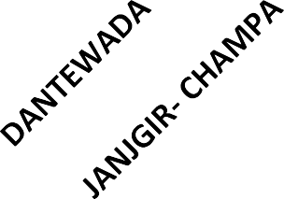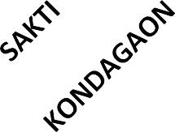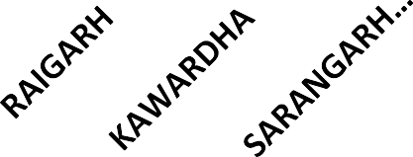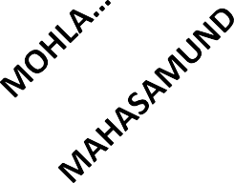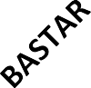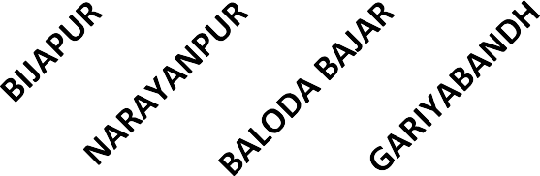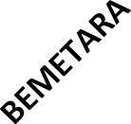

100

80

60

40

20

0

**% of Students Screened against target (School + AWC)**

84 82 81 81 79 78 75 75 73 71 70 69 68 68

64

58

**Status of AWC visited & children Screening (April & May 2023-24)**

**% of AWCs Visited & Children Screened**

80 **73 64**

60

40

20

0

**70 74**

**67 69**

**66 74**

**65 59**

**62 55 62 47 62 48 59 59**

**59 51 59 55 58 46**

**58 54**

**58 57 55**

**34**

**55 47**

**% of AWC Visited % of Students Awc Screened**

**% of AWCs Visited & Children Screened**

60 **54 5350**

**55**

**44**

50 **40**

40

30

20

10

0

**52 5052**

**40**

**50 5045**

**37**

**49 4738 4637 4439 4338 43 4241**

**32 29**

**3231**

**2523**

**2 2**

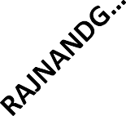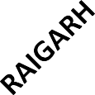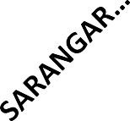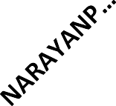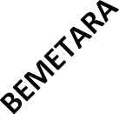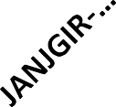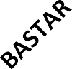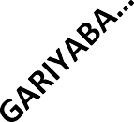

**% of AWC Visited % of Students Awc Screened**

**Data Source- Google sheet updated by distr**5**ic**6**ts**

**Treatment Status in all Category (A,B,C,D,E) 2023-24 April & May**

**% of Children Treated in all Categories out of Identified (ABCDE)**

102

100

98

96

94

92

90

100 100 99 99 98

97 97 97 97 97

96 96 94 94 94 94

100

80

60

40

20

0

**% of Children Treated in all Categories out of Identified (ABCDE)**

94 93 93 93 91 91 90 90 88 85 84 83

76 72

54 50

29

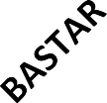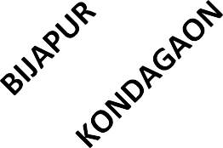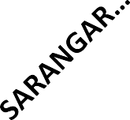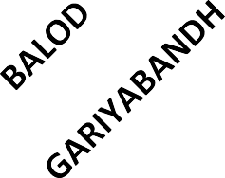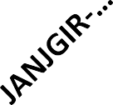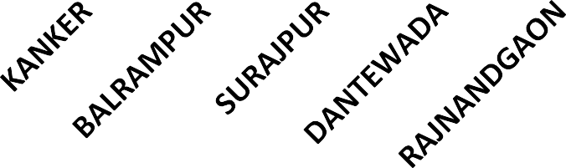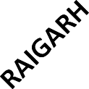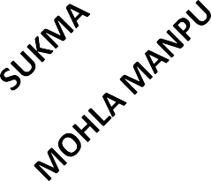

**Data Source- Google sheet updated by distr**5**i**7**cts**

|  |  |  |
| --- | --- | --- |
|  | **Observation/Issues** | **and Recommendations** |
| **SN** | **Observations/ Issues** | **Recommendation** |
| 1 | Delay in identification of birth defect or any complication in newborn leads to delay in referral & treatment. | * All newborn should be screened at delivery points, SNCU & PNC ward for early identification, referral & treatment. |
| 2 | Poor attendance of children in School & AWCs (% of children screened is less against the target in spite of 95- 100% visit) | * Interdepartmental meeting should be conducted in district/ block level for better implementation of program. * Every school must nominate nodal teachers for Chirayu program so that when ever team visits schools, their responsibility to ensure 100% screening of students. * Sharing of 3 month advance tour plan with education   & WCD department.   * Give intimation/reminder call to teacher & AWW for full attendance of children on the day of screening. * 120 screening per day/ team to be follow. |

|  |  |  |
| --- | --- | --- |
|  | **Observation/Issu** | **es and Recommendations** |
| **SN** | **Observations/ Issues** | **Recommendation** |
| 3 | Unavailability of essential equipments/ medicines with RBSK team during field visit | * Ensure availability of all essential equipments/medicines like- stethoscope, BP apparatus, stadiometer, weighing machine, torch, MUAC tap, snelllen’s chart, thermometer, HB meter, medicine box etc. |
| 4 | Many identified Childrens are pending for treatment in different categories. | * Cat A patient may refer to DH/ MC/ Higher center. * Cat B & C patient should be treated by RBSK team/PHC/CHC/DH level * Cat D patient refer to DEIC/ District Rehabilitation Centre. * Treatment entry in Chirayu Portal |
| 5 | Incomplete HR in a team | * Recruitment of RBSK HR on priority basis. |
| 6 | Engagement of RBSK Staff for other  work | * Ensure RBSK HR should not engaged in other work like   OPD duty, Haat Bazar, recruitments etc. |
| 7 | Engagement of RBSK vehicles for other  activity | * RBSK vehicle must use only for RBSK program. * Visible RBSK IEC in Vehicle. |

**Routine Immunization**

|  |  |  |
| --- | --- | --- |
| **Range** | Full Immunization Coverage in %  **Name of District** | |
| **FY 2022-23** | **April-May 2023** |
| Good (>95%) | Surguja (110%), Sukma (106%), Raigarh (105%),  Surajpur (104%), Kondagaon (103%), Bemetara  (102%), Mungeli (101%), Korba (100%), Bijapur  (100%), Bilaspur (99%), Raipur (99%), Durg (99%),  Narayanpur (98%), Balrampur (97%), Koriya (97%),  Bastar (97%), Jashpur (96%), Janjgir-Champa (96%)  Mahasamund (96%), Kabirdham (96%) &  Dantewada (96%) | Mungeli (112%), Balrampur (107%), Korba (100%),  Surguja (100%), Bemetara (98%), Kabirdham (98%) &  Narayanpur (97%) |
| Average  (90-95%) | GPM (92%), Kanker (91%) & Gariyaband (90%) | Sukma (94%), Jashpur (92%) & Kanker (91%) |
| Poor (<90%) | Rajnandgaon (87%), Dhamtari (81%) Balod (81%) &  Balodabazar (78%) | Bilaspur (89%), Janjgir Champa (89%), MMA (88%),  Rajnandgaon (82%), Balod (81%), Koriya (80%), Durg  (78%), Bijapur (78%), MCB (77%), Raipur (76%), Bastar  (76%), KCG (74%), Kondagaon (74%), Dhamtari (72%),  GPM (69%), SB (69%), Sakti (68%), Balodabazar (61%),  Mahasamund (60%), Surajpur (56%), Gariyaband (52%),  Dantewada (49%) &  Raigarh (23%) |

|  |  |  |
| --- | --- | --- |
| **Range** | Adherence to Open vial policy  **Name of District** | |
| **FY 2022-23** | **April-May 2023** |
| Good (>95%) | Korba, Rajnandgaon, Bastar, Durg,  Raigarh, J Champa | Kondagaon |
| Average (90-95%) | Raipur, Jashpur, Kanker, Surajpur, Bemetara, Bilaspur, Surguja, Balod, Dhamtari, Koriya, Bijapur, Kondagaon, Balrampur, Mahasamund | Surajpur, Surguja, Durg, Kawardha, Sukma, Dhamtari, Narayanpur, Raipur, Kanker, Mungeli, GPM, Balod, Korba, Raigarh, J Champa, Balrampur, Bijapur |
| Poor (<90%) | Baloda Bazar, Dantewada, Sukma,  Mungeli, Gariaband, Gaurela Pendra  Marwahi, Narayanpur | Bastar, Mahasamund, Jashpur, Koriya, B  Bazar, Rajnandgaon, Gariaband,  Bemetara, Bilaspur, Dantewada |

Source : eVIN

|  |  |  |
| --- | --- | --- |
| **Range** | Discard of RI vaccine doses  **Name of District** | |
| **FY 2022-23** | **April-May 2023** |
| Good (>95%) | Gariaband, B Bazar, Mahasamund, Koriya, Bilaspur, Raigarh, Bemetara, Kawardha, Mungeli, J Champa, Bijapur, Balod, Jashpur, Surguja, Balrampur,  GPM | Balod, Balrampur, Bilaspur, Kawardha, Mahasamund, Mungeli, Narayanpur, Sukma, Kanker, Bijapur, Bemetara, Durg, Rajnandgaon, Kondagaon,  Surguja, Raipur |
| Average (90-95%) | Rajnandgaon, Raipur, Durg, Kanker,  Dhamtari, Korba, Narayanpur, Sukma | Raigarh, Dantewada, Bastar |
| Poor (<90%) | Kondagaon, Dantewada, Bastar, Surajpur | Dhamtari |

Source : eVIN

**Adolescent Health**

|  |  |  |  |  |  |  |
| --- | --- | --- | --- | --- | --- | --- |
|  | Training of  Name of District | Health and welln  FY 2022-23 | | ess amba  Name of Districts | ssador(SHWP)  FY 2023-24(New districts) | |
|  |  |  |  |  |
| S.No | Target | Achievement | Target | Achievement |
| 1 | Mahasamund | 1348 | 1348 (100%) | Kondagaon | 1520 | 0 |
| 2 | Bastar | 1630 | 832 (51%) | Kanker | 1700 | 0 |
| 3 | Rajnandgoan, (MMA,KCG) | 1030 | 419 (41%) | Korba | 1396 | 0 |
| 4 | Bilaspur | 1486 | 1197 (81%) | Dantewada | 578 | 0 |
| 5 | GPM | 604 | 0 (0%) | Bijapur | 648 | 0 |
| 6 | Sukma | 424 | 0 (0%) | Total | 5842 | 0 |
| 7 | Narayanpur | 338 | 0 (0%) |  |  |  |
|  | Total | 6860 | 3796 (55%) |  |  | 65 |



|  |  |  |
| --- | --- | --- |
| Pe | rmanent FP Services Status: | - (Apr 23 to May 2023) |
| **Performance**  **% against annual ELA** | **Male sterilization** | **Female sterilization** |
| >=25% | Balod(36.7), Mungeli(31.37), Jashpur(33.72), | MCB (23.65), |
| 10%-24% | Narayanpur(15.25), Manendragarh Bharatpur(15.34), Dhamtari(9.86), Raipur(9.84), | Dhamtari(10.58), Jashpur(28.06), Balod(16.96), Raipur(14.1), Durg(14.81), Bastar(14.94), Mungeli(14.9), Surguja(12.2), Rajnandgaon(11.41), |
| 1%-9% | Durg(3.74), Balodabazar(4.04), Raigarh(9.25), Bemetara(3.51), Kabirdham(3.34), Dantewada(4.8), Surajpur(1.7), Janjgir Champa(0.54), Kondagaon(1.56), Bijapur(1.56), KCG(0.4), | Korba(6.83), Janjgir Champa(4.57), Balodabazar(6.96), Sarangarh Bilaigarh(2.89), Bemetara(2.9), Korea(5.38), MMC(1.4), Kabirdham(2.44), KCG(1.72),  Kondagaon(2.18), Bijapur(4.95), Dantewada(3.56), Sukma(3.71), Kanker(0.98), Gariyaband(1.06), Surajpur(0.7), Raigarh(1.22), Narayanpur(0.64), Sakti(0.41), Mahasamund(0.11), |
| 0% | Balrampur(0), Bastar(0), Bilaspur(0), Gariyaband(0), Gaurela Pendra(0), Kanker(0), Korba(0), Korea(0), Mahasamund(0), Mohla manpur chauki(0), Rajnandgaon(0), Sakti(0), Sarangarh Bilaigarh(0),  Sukma(0), Surguja(0), | Balrampur(0), Gaurela Pendra(0), |

|  |  |  |
| --- | --- | --- |
| S | pacing FP Services Status:- | (Apr 23 to May 2023) |
| **Performanc e % against annual ELA** | **PPIUCD** | **ANTARA** |
| >=25% | Sakti(56.18), Narayanpur(50.24), Khairgarh Chhuikhadan Gandai(44.02), Dantewada(34.93), Baloda Bazar(33.43),  Mungeli(33.14), Surguja(29.13), Durg(26.06),  Korba(25.92), Surajpur(25.89), | Balod(33.97),  KCG(109.68),  Rajnandgaon(100.07), |
| 10%-24% | Kondagaon(24.76), Mohla Manpur Ambagarh Chouki(31.18), Raipur(22.23), Dhamtari(20.08), Bastar(19.86), Mahasamund(17.93), Balrampur(17.91), GPM(17.47), Bemetara(17.31), Jashpur(14.47), Bilaspur(13.97), Bijapur(12.32), Sukma(11.82), Sarangarh Bilaigarh(11.78), Rajnandgaon(10.16), | Mungeli(22.86), Narayanpur(23), Dhamtari(21.29), Baloda Bazar(19.9), Bemetra(18.75), Jashpur(17.1), Mahasamund(16.61), Koriya(16.51), Surajpur(15.33), MCB(14.31), Surguja(12.4), Korba(11.23), Raipur(10.98), |
| 1%-9% | Manendragarh Chirimiri Bharatpur(9.66), Janjgir-Champa(8.17), Gariyaband(7.95), Kabirdham(5.95), Kanker(5.46), Korea(5.43), Raigarh(3.3), | Bastar(9.94), Durg(9.16), Janjgir Champa(8.55), Kanker(8.48), Gariyaband(7.66), Sakti(7.57), Bilaspur(7.01), MMA(21.84), Bijapur(5.87), Kondagaon(5.86), SB(4.78), Raigarh(4.36), Dantewada(2.65), Balrampur(2.28), Sukma(1.07),  Kawardha(0.2), GPM(0), |

|  |  |  |  |  |
| --- | --- | --- | --- | --- |
| **PPIUC** | **D Acceptanc** | **e %** |  |  |
| **ROP Deliverables** | **Target for the**  **FY (2022-23)** | **Progress for**  **2022-23** |  | **Target for**  **FY 2023-24** |
| % PPIUCD acceptance among public institutional deliveries | **23%** | **20.1%** |  | **25.3%** |
| **District PPIUCD Accep. %(20** | **22-23) D** | **istrict** | **PPI** | **UCD Accep. %(2022-23)** |
| **Durg 35.5** | **Kondagaon** |  |  | **15.7** |
| **Dhamtari 35.2** | **Korea** |  |  | **15.0** |
| **Kabirdham 28.4** | **Surguja** |  |  | **14.9** |
| **Raipur 25.7** | **Gariyaband** |  |  | **14.2** |
| **Balod 23.9** | **Raigarh** |  |  | **12.8** |
| **Korba 23.7** | **Bastar** |  |  | **11.0** |
| **Surajpur 23.2** | **Bilaspur** |  |  | **10.8** |
| **Mahasamund 22.8** |  |  |  |  |
| **Jashpur 19.2** | **Janjgir-Champa** |  |  | **10.4** |
| **Baloda Bazar 17.5** | **Kanker** |  |  | **10.0** |
| **Bemetara 17.2** | **Rajnandgaon** |  |  | **8.1** |
| **Dantewada 16.8** | **Balrampur** |  |  | **7.3** |
| **Gaurella Pendra Marwahi 16.4** | **Bijapur**  **Sukma** |  |  | **6.0**  **5.9** |
| **Mungeli 16.1** | **Narayanpur** |  |  | **4.3**69 |

% Injectable MPA users among eligible couples

**ROP Deliverables**

% Injectable MPA users among eligible couples

**Target for the FY (2022-23)**

**0**

|  |  |  |
| --- | --- | --- |
| **.2%**  **District** |  | **0.14%**  **% Injec. MPA (2022-23)** |
| **Bijapur** |  | **0.3** |
| **Sukma** |  | **0.2** |
| **Raigarh** |  | **0.2** |
| **Surguja** |  | **0.2** |
| **Mahasamund** |  | **0.2** |
| **Jashpur** |  | **0.2** |
| **Balrampur** |  | **0.2** |
| **Bastar** |  | **0.2** |
| **Dhamtari** |  | **0.1** |
| **Baloda Bazar** |  | **0.1** |
| **Kanker** |  | **0.1** |
| **Balod** |  | **0.1** |
| **Dantewada** |  | **0.1** |

**Progress for 2022-23**

**Target for FY 2023-24**

**0.3%**

Total Injectable MPA users per 100 MWRA

0.14

2019-20 2020-21 2021-22 2022-23

0.10

0.12

0.11

**District**

**Kondagaon Korba**

**Surajpur Gariyaband Korea Bemetara Raipur Rajnandgaon Bilaspur Janjgir-**

**Champa**

**Kabirdham Mungeli Durg**

**% Injec. MPA (2022-23)**

**0.1**

**0.1**

**0.1**

**0.1**

**0.1**

**0.1**

**0.1**

**0.1**

**0.1**

**0.1**

**0.1**

**0.1**

**0.1**

**Narayanpur**

70 **0.0**

##### Key FP Priorities

|  |  |
| --- | --- |
| **Raigarh** | **56** |
| **Dantewada** | **54.4** |
| **Narayanpur** | **52.8** |
| **Sukma** | **51.4** |
| **Bilaspur** | **50.3** |
| **Surajpur** | **50.1** |
| **koriya** | **49.4** |

|  |  |
| --- | --- |
| **Balod** | **79.9** |
| **Dhamtari** | **78.3** |
| **Durg** | **76.4** |
| **Kabeerdham** | **72.2** |
| **Raipur** | **72.1** |
| **Bemetara** | **71.2** |
| **Rajnandgaon** | **70.5** |



Modern Contraceptive Use:

**Uttar Bastar… 69.6**

**MCPR has increased.**

**6.1**

**3.2**

**NFHS IV**

**MCPR UN**

**NFHS V**

**Traditional Method**

**Contraceptive use is low in:**

* **Married adolescents (15-19 years) is 11.7%**
* **Young (20-24 years)- 27.8%**
* **In 0-1 parity women-25.5 %**

**54.5**

**61.7**

**8.3**

**11.1**

**Surguja**

**49.1**

**Gariyaband**

**Janjgir - Champa Mahasamund Baloda Bazar Kodagaon Mungeli**

**68.3**

**66.3**

**64.2**

**62.8**

**60.5**

**60.3**

**Bastar Jashpur Korba Balrampur**

**Bijapur**

**47.7**

**47.2**

**46.9**

**39.4**

**32.4**

71

**Balrampur Surajpur Jashpur Surguja Korba koriya Bijapur Bastar Bilaspur Raigarh Mungeli**

**Key FP Priorities**

**Unmet Need for Modern Contraception:**

**Traditional method use needs to be addressed in all the districts**

**Janjgir - Champa**

**Narayanpur Baloda Bazar Mahasamund Dantewada Gariyaband Kodagaon Raipur**

**NFHS 5**

**Sukma Bemetara Kabeerdham Rajnandgaon**

**Durg Uttar Bastar kanker**

**Dhamtari**

**Balod**

**31.9**

**23.8**

**21.7**

**21.1**

**20.1**

**19.6**

**18.8**

**18.6**

**18.6**

**18.4**

**15.1**

**14.8**

**14.1**

**14**

**12.7**

**11.5**

**11.4**

**11.4**

**10.8**

**9.9**

**9.4**

**9.2**

**9.1**

**9.1**

**8.1**

**7.3**

**6.2**



|  |  |
| --- | --- |
| Suspect | Examination Rate – Jan to March 2023 |
| **Indicator** | **District** |
| SER above 2000 | GPM (4039), Sarguja (3436), Bijapur (2981), Raigarh (2880), Kanker  (2867), MCB (2282), Raipur (2252), Dantewada (2201), Gariyaband  (2165), Sarangarh (2099), Kawardha (2083), Narayanpur (2003) |
| SER between 1500 - 2000 | MMC (1962), Janjgir (1893), Balrampur (1831), Mungeli (1777), Sukma  (1639) |
| SER below 1500 | Surajpur (1465), Jashpur (1432), KCG (1343), Dhamtari (1318), ) Korba  (1204), Sakti (1202), Bastar (1194), Rajnandgaon (1175), Bemetara  (1132), Koriya (1098), Mahasamund (1088), Kondagaon (1029), Balod  (986), Baloda Bazaar (981), Durg (978), Bilaspur (955) |

|  |  |
| --- | --- |
| Percentage | of Notification achieved against Target Jan to May 2023 |
| **Indicator** | **District** |
| Notification above 85% | Sukma (92), Dantewada (88) |
| Notification between 75%  to 85% | Sarangarh (85), Kawardha (84), Raigarh (83), Koriya (83),  Narayanpur (82), Raipur (78), Mungeli (77), Sarguja (77) Sakti (77), |
| Notification below 75% | Korba (74), Jashpur (73), Dhamtari (72), Mahasamund (71), MCB  (68), Kanker (68), Durg (67), Bilaspur (65), Balrampur (63), MMC  (63), Kondagaon (59), Bastar (58), Bijapur (58), Balod (57), Baloda  bazaar (55), KCG (55), Gariyaband (54), Bemetara (52), GPM (49),  Janjgir (47), Rajnandgaon (46), Surajpur (35) |

|  |  |
| --- | --- |
|  | Success Rate  Jan to May 2023 |
| **Indicator** | **District** |
| Success rate above 90% | Sarguja (94), Kanker (93), MMC (93), Korba (92), GPM (92), Jashpur  (92), KCG (91), Balrampur (91), Kawardha (91), Raigarh (91),  Bemetara (91) |
| Success rate between 86%  to 90% | MCB (90), Surajpur (90), Sarangarh (90), Rajnandgaon (89), Baloda  bazaar (88), Dantewada (88), Janjgir Champa (88), Sakti (87),  Gariyaband (86), Mungeli (86) |
| Success rate below 86% | Narayanpur (85), Dhamtari (85), Koriya (85), Bilaspur (85), Bijapur  (84), Sukma (84), Balod (84), Raipur (83), Durg (83), Bastar (81),  Mahasamund (80), Kondagaon (72) |

|  |  |
| --- | --- |
|  | NPY Payment  Jan to May 2023 |
| **Indicator** | **District** |
| NPY Payment above 75% | KCG (89), Narayanpur (84), MMC (79) |
| NPY Payment between 50% to 75% | GARIYABAND (68), BALOD (66), BASTAR (65), SARGUJA (65), SUKMA  (65), JANJGIR (60), SAKTI (59), SURAJPUR (52), MCB (51),  RAJNANDGAON (50) |
| NPY Payment below 50% | DURG (47), BEMETARA (44), MUNGELI (43), DHAMTARI (43),  BILASPUR (39), KAWARDHA (39), BALODA BAZAAR (38),  SARANGARH (38), MAHASAMUND (38), RAIGARH (34), KORIYA (33),  GPM (33), KANKER (31), DANTEWADA (31), RAIPUR (30),  KONDAGAON (27), BIJAPUR (26), JASHPUR (25), KORBA (8),  BALRAMPUR (7) |

|  |  |
| --- | --- |
| Adoptio | n status of TB patients by Nikshay Mitra  Sep 2022 to May 2023 |
| **Indicator** | **District** |
| Adoption % above 80% | Kanker (98), Dantewada (97), Durg (95), Balrampur (93),  Rajnandgaon (92), Bijapur (91), Balod (90), Dhamtari (90), Bastar  (89), Kondagaon (88), Sukma (87), Gariyaband (87), Surajpur (86),  Narayanpur (86), Raipur (83), Jashpur (82), Kawardha (81), Baloda  Bazaar (81), Koriya (81) |
| Adoption % between 60% to 80% | Mungeli (80), Janjgir (79), Korba (72), MMC (63), Bilaspur (62),  Raigarh (61), GPM (60) |
| Adoption % below 60% | Mahasamund (56), MCB (46), Bemetara (40), Sarguja (35),  Sarangarh (0), Sakti (0), KCG (0) |



|  |  |  |
| --- | --- | --- |
|  | New Cas | e ( April & |
| **S.N.** | **District** | **New case** |
| 1 | Mahasamund | 157 |
| 2 | Raipur | 147 |
| 3 | Raigarh | 91 |
| 4 | Bilaspur | 90 |
| 5 | Durg | 78 |
| 6 | Sarangarh | 72 |
| 7 | Sakti | 50 |
| 8 | Balodabazar | 48 |
| 9 | Korba | 46 |
| 10 | Bastar | 45 |
| 11 | Jashpur | 45 |
| 12 | Mungeli | 40 |
| 13 | Kabirdham | 38 |
| 14 | Balod | 37 |
| 15 | Bemetara | 32 |
| 16 | Dhamtari | 32 |
| 17 | Janjgir | 31 |

M

|  |  |  |
| --- | --- | --- |
| ay 20  **S.N.** | 23) F.Y. 2023-24  **District** | **New case** |
| 17 | Janjgir | 31 |
| 18 | Gariyaband | 25 |
| 19 | Rajnandgaon | 14 |
| 20 | GPM | 13 |
| 21 | Sarguja | 12 |
| 22 | Surajpur | 11 |
| 23 | Kanker | 10 |
| 24 | Khairagarh-Chuikhadan | 10 |
| 25 | Kondagaon | 8 |
| 26 | Dantewada | 8 |
| 27 | Sukma | 4 |
| 28 | Mohla -Maanpur | 3 |
| 29 | Koriya | 3 |
| 30 | MCB | 3 |
| 31 | Balrampur | 2 |
| 32 | Narayanpur | 1 |
| 33 | Bijapur | 1 |
|  | **CG TOTAL** | 8**1**0**207** |

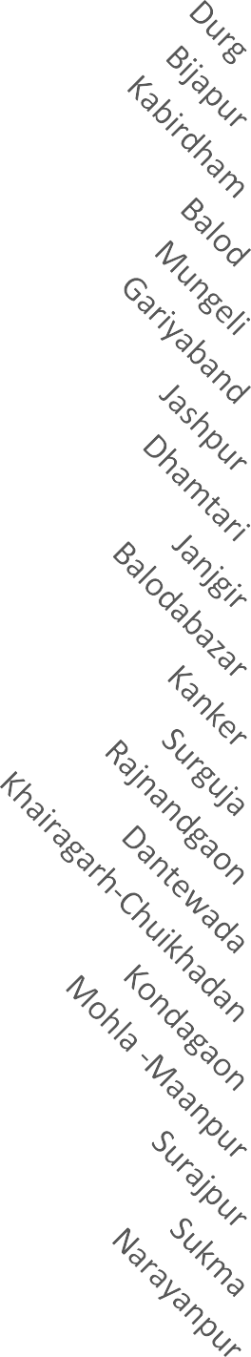

**PR /10000 ( Till May 2023)-FY 2023-24**

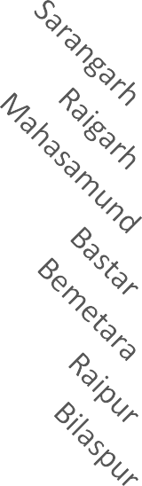3.15

3.01

2.97

2.96

2.72

2.34

2.21

2.21

2.04

2.01

1.95

1.82

1.81

1.72

1.44

1.43

1.43

1.40

1.36

1.33

1.30

1.11

1.08

1.02

0.89

0.87

0.84

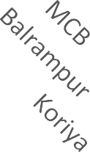0.62

0.47

0.45

0.38

3.90

5.38

6.22

|  |  |  |  |
| --- | --- | --- | --- |
|  | Percentage  **G2D % > 4** | of G2D among new cas  **G2D % 1 to 4** | e  **G2D % < 1** |
| **FY 2022-**  **23** | Sukma (45.00), Kanker (14.07),  Dantewada (11.54),Bastar (11.43),  Bijapur( 10.34) ,Raipur (8.03),  Surajpur (7.41), Balrampur (7.32),  Balodabazaar (5.69), GPM (5.49) ,  Koriya (5.17 )  **G2D % > 4**  Mohla –Maanpur (33.33),  Sukma (25),Dantewada (12.50),  Khairagarh-Chuikhadan (10),  Raipur (9.52),Surajpur (9.09),  Kabirdham (7.89), Mahasamund (4.46),  Bastar (4.44),Korba (4.35),  Balodabazar (4.17) | Mahasamund (3.80), Rajnandgaon (3.70),Kondagaon(3.53), Bilaspur(3.51),Balod(2.93), Janjgir- Champa(2.76)  ,Jashpur(2.70),Bemetara(2.54),  Kawardha(2.51),Durg (2.32),  Korba(2.32),Raigarh(2.30), Mungeli (1.40)  **G2D % 1 to 4**  **G2**  Bemetara (3.13), Kond  Durg (1.28), Narayanpur  Bilaspur (1.11), Sarang  Raigarh (1.10) Balod  Dham  Surguja |  |
| **C.G-**  **(4.11)**  **April & May FY 2023-24**  **C.G- 3.23** | Gariyaband(0.67)  ,Narayanpur (0.00),  Dhamtari (0.00), Sarguja  (0.00)  **G2D % < 1**  **D case- 0**  agaon,Kanker,  ,Bijapur, GPM,Mungeli, arh,Janjgir Sakti  ,Rajnandgaon , tari ,Gariyaband,  ,Balrampur ,Jashpur Koriya ,MCB |

**FY 2022-**

###### Percentage of Child case among new case

**Child Case % > 6 Child Case % - 2 to 6 Child Case % < 2**

Bilaspur(5.90),Raipur(5.39), Balodabazar (5.03),Durg

**23**

**CG-**

**4.88**

Narayanpur(11.11), Koriya

(8.62),

Kondagaon (7.06),

Mahasamund (6.99),

Kabirdham (6.96),

Raigarh (6.81)

(4.87) ,Gariyaband(4.70),Korba(4.64), Dantewada(3.85),Bastar(3.81), Janjgir(3.68),Bijapur(3.45), Dhamtari(3.28),Mungeli(3.27), Rajnandgaon(3.09),Surajpur(2.47), Balrampur (2.44),Kanker (2.22), GPM (2.20),Balod (2.09)

Bemetara (1.98),

Jashpur (1.62),

Surguja (0.70)

Sukma (0)

**(April & May 2023)**

**FY 2023-**

**24**

**CG-4.97**

**Child Case % > 6**

Surajpur (9.09),Bastar(8.89) Raigarh (8.79),

Kabirdham (7.89),

Mahasamund (7.64),

Raipur (6.80),Jashpur (6.67),

Korba (6.52)

**Child Case % - 2 to 6**

Bilaspur(5.56),Mungeli (5.00),

Sarangarh (4.17),

Gariyaband(4.00),

Janjgir (3.23),Dhamtari (3.13), Balodabazar(2.08)

Sakti (2.00)

**Child Case % < 2**

Durg(1.28)

**Child Case - 0**

Kondagaon ,Sukma ,Kanker,Dantewada

,Narayanpur ,Bijapur,GPM Balod,Bemetara,Rajnandgaon, Mohla –Maanpur,

Khairagarh-Chhuikhadan, Surguja,Balrampur,Koriya,MCB

|  |  |  |  |
| --- | --- | --- | --- |
|  | Percentage  **MB % > 70** | of MB case among new case  **MB% > 50 to 70** | **MB % ≤ 50** |
| **FY 2022-**  **23** | Sukma(100.00), Dantewada (84.62),  Bilaspur (81.73),  Balrampur (80.49),  Bijapur (79.31),  Surajpur (77.78),  Raipur (75.48) | Janjgir(69.98),GPM(69.23),Jashpur(68.65),  Kondagaon(68.24), Narayanpur(66.67),Sarguja(66.43), Bastar(64.76),Raigarh(63.85)Rajnandgaon(62.35), Korba(61.34),Gariyaband(59.73),Kanker(58.52), Mungeli(57.01),Koriya(56.90) ,Kabirdham (55.15), Durg (54.29)Balod (53.97),Balodabazar(53.83) Mahasamund(52.43) | Dhamtari (44.26),  Bemetara (40.96) |
| **CG-62.75** |

|  |  |  |  |
| --- | --- | --- | --- |
|  | **MB % > 70** | **MB% > 50 to 70** | **MB % ≤ 50** |
| **(April &**  **May2023) FY 2023-**  **24** | Sukma (100), Dantewada(100),  Narayanpur (100),Bijapur (100), Rajnandgaon(100),Gariyaband(92), Sarguja (91.67), Surajpur (90.91), Bilaspur(90),Kondagaon(87.50), Balod(81.08),Raipur (80.95),Sakti (78),Janjgir (77.42),Korba(76.09), Bastar(73.33) | Khairagarh -Chhuikhadan(70) GPM(69.23),Jashpur (68.89),  Mohla –Maanpur (66.67),Koriya(66.67),  MCB (66.67),Durg (62.82),Bemetara (62.50),  Raigarh (61.54),Kabirdham(60.53), Sarangarh (59.72),Dhamtari(59.38), Mungeli(57.50),Mahasamund(57.32), Balodabazar (52.08) |  |
|  | Balrampur  (50),  Kanker (40) |
| **CG-70.09** |  |

|  |  |  |  |  |  |  |  |  |
| --- | --- | --- | --- | --- | --- | --- | --- | --- |
| **S** | **tatus of Eligib**  **District** | **le cases**  **Eligible for RCS** | **for R**  **RCS**  **Done** | **CS and RCS performed Till May 2023 –F.Y. 2023-24**  **Pending SN District Eligible for RCS Done**  **RCS** | | | | |
| 1 | Raipur | 9 | 3 | 6 | 18 | Bijapur | 0 | 0 |
| 2 | Bastar | 4 | 0 | 4 | 19 | Bilaspur | 0 | 0 |
| 3 | Sarangarh | 2 | 0 | 2 | 20 | GPM | 0 | 0 |
| 4 | Janjgir | 2 | 0 | 2 | 21 | Mungeli | 0 | 0 |
| 5 | Khairagarh-Chhuikhadan | 2 | 2 | 0 | 22 | Korba | 0 | 0 |
| 6 | Balodabazar | 2 | 2 | 0 | 23 | Balod | 0 | 0 |
| 7 | Raigarh | 1 | 1 | 0 | 24 | Bemetara | 0 | 0 |
| 8 | Sakti | 1 | 0 | 1 | 25 | Rajnandgaon | 0 | 0 |
| 9 | Durg | 1 | 0 | 1 | 26 | Mohla-Maanpur | 0 | 0 |
| 10 | Mahasamund | 1 | 1 | 0 | 27 | Kabirdham | 0 | 0 |
| 11 | Surajpur | 1 | 1 | 0 | 28 | Dhamtari | 0 | 0 |
| 12 | Jashpur | 1 | 1 | 0 | 29 | Gariyaband | 0 | 0 |
| 13 | Kondagaon | 0 | 0 | 0 | 30 | Surguja | 0 | 0 |
| 14 | Sukma | 0 | 0 | 0 | 31 | Balrampur | 0 | 0 |
| 15 | Kanker | 0 | 0 | 0 | 32 | Koriya | 0 | 0 |
| 16 | Dantewada | 0 | 0 | 0 | 33 | MCB | 0 | 0 |
| 17 | Narayanpur | 0 | 0 | 0 |  | **CG TOTAL** | **27** | 85 **11** |



|  |  |
| --- | --- |
| **Targe** | **t vs Achievement (Blood Slide + RDT)**  **(January to May 2023)** |
| **Less than 95%** | **More than 95%** |
| No Districts | Bijapur(299.4%), Dantewada(218.6%), Narayanpur(198.1%), Kawardha(188%),Kanker(180%), Jashpur(154%), GPM(149%),Bastar(146.9%), Sukma(!46.5%), Sarangarh(141.2%),  Kondagaon(136.7%), Janjgir(132.4%), Balod(132.2%), Balrampur(131.4%), Dhamtari(125.1%),Rajnandgaon(124.6%), Mungeli(123.8%), Raigarh(123.2%), Surajpur(121.7%), Mohla-Manpur(121.5%), Raipur(118.6%), Khairagarh-Chhuikhadan(118.4%0, Bemetara(11.3%), Manendragarh-Chirmiri(116.9%), Korea(115.7%), Sakti(112%),  Mahasamund(110.6%), Baloda Bazar(110.6%), Bilaspur(107.2%),  87 |

|  |  |
| --- | --- |
| **Indoor Residual Spr** | **ay : Population Coverage in 2nd round 2022** |
| **Less than 90%** | **More than 90%** |
| Bijapur(87%) | Bilaspur(100%), Balrampur(100%), GPM(99%), Dhamtari(99%), Surajpur(99%), Surguja(99%), Kawardha(99%), Narayanpur(98%), Baloda Bazar(98%), Korba(98%), Raigarh(98%), Jashpur(98%), Kanker(98%), Kondagaon(97%), Bastar(97%), Gariaband(97%), Janjgir(97%), Bastar(97%), Balod(95%), Rajnandgaon(94%), Sukma(94%), Dantewada(92%), Korea(92%),  Mahasamund(99%) |

**Note :-1. Population Coverage in 2nd round is 95%**

**2. Indoor Residual Spray 2023 , 1st round is continuing**

**Dengue Cases**

**01.01.2023 to 08.06.2023**

**District**

Bijapur Bastar Kawardha Baloda Bazar Balod Bemetara Durg

Sukma Dhamtari Gariaband

**Total Dengue Case : 36**

**Dengue Cases**

7

5

3

2

2

2

2

1

1

1

**District** Raipur Rajnadgaon

Bilaspur

Janjgir Korba Mungeli Raigarh Balrampur Surajpur Sakti

**Dengue Cases**

1

1

1

1

1

1

1

1

1

1

**Morbidity Management : Disease Prevention services for**

**Lymphedema cases (January to December 2022)**

**More than 70%**

* Bastar (81.8%), Koriya(100%), Jashpur(100%), Kawardha(100%), Rajnandgaon(100%), Balod(100%), Durg(100%), Dhamtari(100%), Bemetara(100%), Raipur(100%), Bilaspur(100%), GPM(100%), Kondagaon(100%), Kanker(100%), Gariaband(119%), Janjgir(174%)

**50 to 70%**

* + Balrampur(53.1%)

**Less than 50%**

* Surguja(0%), Mahasamund(0%), Baloda Bazar(0%), Mungeli(0%), Raigarh(31.4%),

Surajpur(41.9%)

**Note :- 1. % of MMDP service to Lymphedema Patient is 85.5%**

1. **Zero Lymphedema case reported from Dantewada, Bijapur, Narayanpur , Sukma and Korba**

|  |  |  |
| --- | --- | --- |
| **Morbid**  **(Jan** | **ity Management**  **uary to March 2023)** | **Status** |
| **MMDP kit not distributed** | **Less than 100% kit distributed** | **100% MMDP kit**  **distributed** |
| Raigarh(894), Sarangarh- Baramkela(303), Janjgir(473), Sakti(593), Korba(11), Bemetara(75), Dhamtari(109), Surguja(61), koriya (8) | Gariyaband(164), Bastar(66), Mahasamund(138), Kawardha(20), Raipur(468), Balod(113), Durg(213), Mungeli(63), Baloda Bazar(169),  Jashpur(324) | Kanker(27), Kondagaon(8), GPM(77), Bilaspur(399), Korba(11),Rajnandgaon(414), , Balrampur(27), Surajpur(42), Manendragarh-Chirmiri(90) |

Note :- Zero Lymphedema case reported from Bijapur, Dantewada, Narayanpur, Sukma

|  |  |
| --- | --- |
| **Hydrocelectomy Status** | **(January to March 2023)** |
| **Less than 50 cases pending for operation** | **More than 50 cases pending for operation** |
| Kawardha(49), Bastar(39), Sarangarh- Baramkela(33), Surajpur(33), Mungeli(32), Manendragarh-Chirmiri(31), Balrampur(28), Korea(20), Dhamtari(17), Bemetara(16), Mahasamund(14), Kanker(10) | Jashpur(667), Raigarh(435), Surguja(246), Baloda Bazar(241), Sakti(220), GPM(178), Janjgir(170), Gariaband(170), Korba(85), Bilaspur(77), Balod(53) |

Note :-Zero Hydrocele cases reported from Bijapur, Dantewada,Narayanpur, Kondagaon, Sukma, Raipur, Durg, Rajnandgaon, Mohla-Manpur, Khairagarh-Chhuikhadan

|  |  |  |  |  |  |  |
| --- | --- | --- | --- | --- | --- | --- |
| **Acute Encephalitis Syndrom January to December 2022**  **Year 2022** | | | **e/Japa & 01.01** | **nese En**  **.2023 to** | **cephalit 08.06.2**  **Year 2023** | **is 023** |
| **District** | **(Jan-Dec)** | |  | **(01.01.2023 to 08.06.2023)** | | |
|  | AES cases | JE cases | Death | AES cases | JE cases | Death |
| Bastar | 111 | 15 | 1 | 32 | 0 | 0 |
| Bijapur | 20 | 2 | 0 | 12 | 0 | 0 |
| Dantewada | 16 | 1 | 1 | 15 | 0 | 0 |
| Sukma | 10 | 1 | 0 | 4 | 0 | 0 |
| Kondagaon | 5 | 0 | 0 | 3 | 0 | 0 |
| Kanker | 0 | 0 | 0 | 0 | 0 | 0 |
| Narayanpur | 5 | 0 | 0 | 3 | 0 | 0 |
| **Total** | **167** | **19** | **2** | **66** | **0** | 93 **0** |

**Integrated Disease Surveillance Programme (IDSP)**

**IHIP Reporting Status (April-May 2023**

|  |
| --- |
| **)** |
| **Target-71 %** |
| **Good (≥71%)** |
| **Average (60-70%)** |
| **Poor (<60%)** |

**Syndromic Surveillance**

|  |  |  |  |  |  |  |  |  |  |  |  |  |  |  |  |  |  |  |  |  |  |  |  |  |  |  |  |  |  |  |  |  |  |
| --- | --- | --- | --- | --- | --- | --- | --- | --- | --- | --- | --- | --- | --- | --- | --- | --- | --- | --- | --- | --- | --- | --- | --- | --- | --- | --- | --- | --- | --- | --- | --- | --- | --- |
| **100**  **90**  **80**  **70**  **60** | **100** | **100** | **100** | **99** | **99** | **96** | **96** | **94** | **94** | **90** | **89** | **89** | **89** | **88** | **88** | **87** | **86** | **85** | **85** | **83** | **83** | **82** | **82** | **81** | **80** | **80** | **80** | **78** | **75** | **65** | **63** | **54** |  |
| **50** |  |  |  |  |  |  |  |  |  |  |  |  |  |  |  |  |  |  |  |  |  |  |  |  |  |  |  |  |  |  |  |  | **40** |
| **40** |  | | | | | | | | | | | | | | | | | | | | | | | | | | | | | | | | |
| **30** |
| **20** |
| **10** |
| **0** |

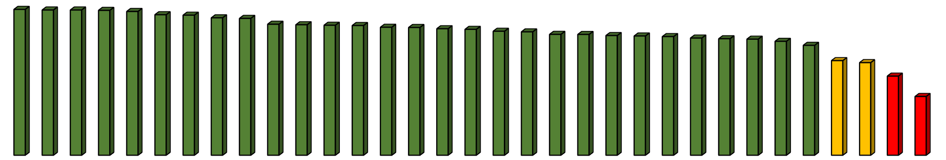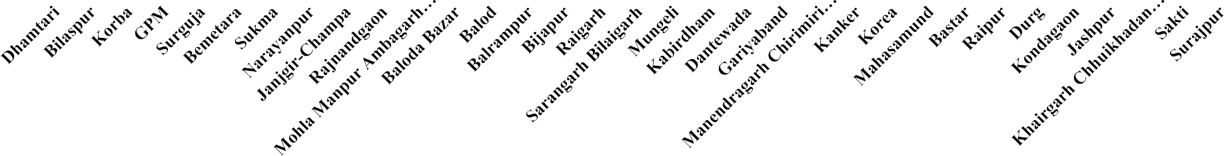

**100**

**90**

**80**

**70**

**60**

**50**

**40**

**30**

**20**

**10**

**0**

**Presumptive surveillance**

**100 100 100 100 99 98 97 95 93 91 91 89 89**

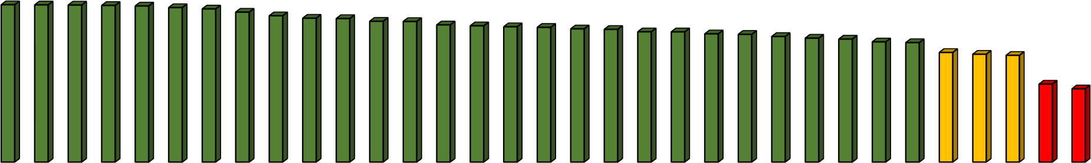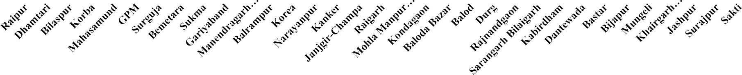

**87 87 86 86 85 84 83 83 81 81 80 79 78**

**76 76 70 69 68**

**50 47**

|  |
| --- |
| **Target-75 %** |
| **Good (≥75%)** |
| **Average (60-74%)** |
| **Poor (<60%)** |

**IHIP Reporting Status (April-May 2023)**

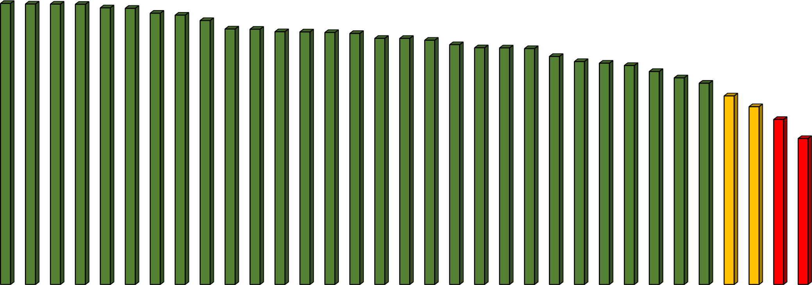**Laboratory Surveillance**

**98 98**

**97**

**96**

**94**

**91 91**

**90**

**90 90 89**

**88**

**88**

**87**

**85**

**84**

**84 84**

**81**

**79**

**79**

**78**

**76 74**

**72**

**67**

**63**

**59**

**52**

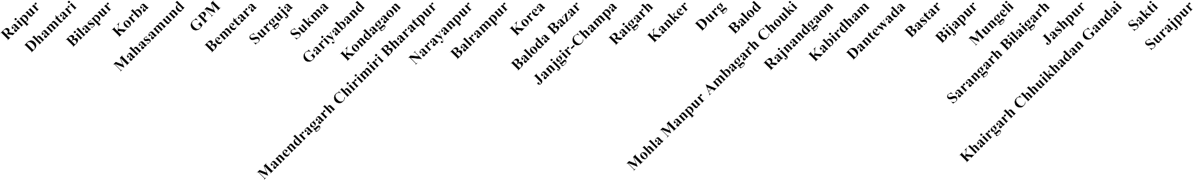

|  |
| --- |
| **Target-72 %** |
| **Good (≥72%)** |
| **Average (60-71%)** |
| **Poor (<60%)** |

|  |  |  |  |  |
| --- | --- | --- | --- | --- |
|  | **100** | **100** | **100** | **100** |
| **100** |  |  |  |  |
| **90** |  |  |  |  |
| **80** |  |  |  |  |
| **70** |  |  |  |  |
| **60** |  |  |  |  |
| **50** |  |  |  |  |
| **40** |  |  |  |  |
| **30** |  |  |  |  |
| **20** |  |  |  |  |
| **10** |  |  |  |  |
| **0** |  |  |  |  |



|  |  |
| --- | --- |
| **Cataract Su** | **rgery Public Sector & Pvt Sector against ELA (April 2022 to March 2023) (GOI Target 1.08 Lakh Achiv 135113=125%) &**  **(District Distributaion Target 1.25 Lakh Achiv 135113=108%)** |
| **Range** | **District** |
| >=100% | Raipur 192% (Govt 35 + Pvt 157), Surajpur 130% (Govt 119 + Pvt 11),  Balodabazar 123% (Govt 44 + Pvt 79), Bilaspur 122% (Govt 21 + Pvt 100)  Balod 117% (Govt 7 + Pvt 110), Mahasamund 115% (Govt 46 + Pvt 69),  Dhamtari 111% (Govt 75 + Pvt 36) Rajnandgaon 110% (Govt 13 + Pvt 97),  Durg 104% (Govt 37 + Pvt 67) Bemetara 100% (Govt 11 + Pvt 89) |
| 99%-75% | Beejapur 95% (Govt 95 + Pvt 0), Kawardha 94% (Govt 21 + Pvt 73), Korea 92%  (Govt 65 + Pvt 27), Korba 91% (Govt 46 + Pvt 45), Balrampur 90% (Govt 90 + Pvt  0), Surguja 81% (Govt 45 + Pvt 36), Kondagaon 76% (Govt 76 + Pvt 0), Bastar 75%  (Govt 67 + Pvt 8), Raigarh 75% (Govt 43 + Pvt 32) |

|  |  |
| --- | --- |
| 74%-50% | Mungeli 62% (Govt 60 + Pvt 2), Gariyaband 53% (Govt 27 + Pvt 26), |
| 49%-0% | Dantewada 49% (Govt 49 + Pvt 0), Kanker 49% (Govt 39 + Pvt 10), Sukma 49% (Govt 49 + Pvt 0),  Jaspur 47% (Govt 47 + Pvt 0), Janjgir 46% (Govt 8 + Pvt 39), GPM 23% (Govt 19 + Pvt 4),  Narayanpur 19% (Govt 19 + Pvt 0), 98 |

|  |  |
| --- | --- |
| **School Eye** | **Screening (Provided Free Glasses) Apr-Mar 2022-23 State Average –107%** |
| **Range** | **District** |
| **100%** | Raipur (196%), Janjgeer (174%), Rajnandgaon (136%), Narayanpur(132%),  Durg (128%), Balrampur (124%), Kabirdham (118%), Bilaspur (115%),  Balodabazar (112%), Balod (108%), Bemetara (108%), Jashpur (107%),  Dhamtari (103%), Mahasamund (103%) |
| **99% - 75%** | Surajpur (95%), Kanker (93%), Kondagaon (89%), Raigarh (86%), Korba  (85%), Dantewara (80%), Gariyaband (79%), Koria (79%), Bijapur  (78%), Sukma (78%) |
| **74%-50%** | Mungeli (74%), Sarguja (68%), GPM (64%), Bastar (61%)  99 |

|  |  |  |  |
| --- | --- | --- | --- |
| **Catara** | **ct Surgery Public Sector & Pvt Sector against ELA (April to May 2023)** |  |  |
| **Monthly Achieveme nt** | **District Achievement /Target Monthly District Achievement /Target Achievement** |  |  |
| 100 %  **99% -**  **50%** | Raipur - 4908/2000 = 245% (Govt 922 + Pvt 3986),  Sukma - 199/100 = 199% (Govt 199 + Pvt 0) Dhamtari - 796/500 = 159% (Govt 533 + Pvt 263), Bilaspur - 2099/1400 = 150 %(Govt 392+ Pvt 1707) Kawardha - 473/350 = 135% (Govt 45 + Pvt 428) , Balod - 462/350 = 132% (Govt 7+ Pvt 455),  Korba - 517/450 =115% (Govt 290 + Pvt 227),  Mahasamund - 334/300 = 111% (Govt 63 + Pvt 271),  Balodabazar - 359/350 =103% (Govt 245 + Pvt 114) **Raigarh - 410/850 = 48% (Govt 233 + Pvt 177), Balrampur - 90/100 = 90% (Govt 90 + Pvt 0), Surguja - 207/450 = 46% (Govt 130 + Pvt 77), Gariyaband - 132/150 = 88% (Govt 5 + Pvt 127), 49%-0% Dantewada - 60/150 = 40% (Govt 60 + Pvt 0),**  **Durg - 882/1100 = 80% (Govt 383 + Pvt 499), Janjgir - 155/450 = 34% (Govt 10 + Pvt 145),**  **Mungeli - 119/150 = 79% (Govt 119 + Pvt 0),**  **Jaspur - 198/250 = 79% (Govt 198 + Pvt 0), Narayanpur - 11/150 = 7% (Govt 11 + Pvt 0),**  **Korea - 228/300 = 76% (Govt 152 + Pvt 76), Bastar - 338/450 = 75% (Govt 283 + Pvt 55) Kondagaon - 111/150 = 74% (Govt 111 + Pvt 0), Bemetara - 219/300 = 73% (Govt 30 + Pvt 189), Beejapur - 71/100 = 71% (Govt 71 + Pvt 0), Surajpur - 99/150 = 66% (Govt 90 + Pvt 9), Kanker - 205/350 = 59% (Govt 184 + Pvt 21),**  **Rajnandgaon 543/1000 = 54% (Govt 85 + Pvt 458),** 100 |  |  |

|  |  |
| --- | --- |
| **Sch Apr** | **ool Eye Screening (Provided Free Glasses) il to May 2023 (School Vacation going on)** |
| **Proportionate**  **Target** | **District** |
| **100 %-50%** | Jashpur (68%), |
| **49% - 25%** | Sarguja (47%), Raipur (26%), |
| **24% - 5%** | Dhamtari (12%), Dantewara (6%), |
| **0 %** | Janjgeer , Rajnandgaon, Narayanpur, Durg, Balrampur, Kabirdham, Bilaspur, Balodabazar , Balod , Bemetara, Mahasamund Surajpur , GPM, Kanker , Kondagaon, Raigarh, Korba, Bastar, Gariyaband, Koria Bijapur , Sukma Mungeli,  101 |

|  |  |  |  |  |
| --- | --- | --- | --- | --- |
|  | **Catarac** | **t backlog Year 202** | **Free District 2-23** |  |
| **S.No.** | **Indicator** | **Target – 2022-23** | **District** | **Achiev** |
| 1 | No. of Districts Certified as  Cataract backlog Free | 5 | Kabirdham, Raipur, Balodabazar, Balod, Rajnandgaon, Dhamtari, Raigarh | 7 (140%) |
|  |  | **Year 202** | **3-24** |  |
| **S.No.** | **Indicator** | **Target – 2023-24** | **District** | **Achiev** |
| 1 | No. of Districts Certified as Cataract backlog Free | 10 | Nil | Nil |

**National Programme for Prevention and Control of Diabetes, Cardiovascular Disease and Stroke (NPCDCS)**

|  |  |  |  |  |
| --- | --- | --- | --- | --- |
| **National NCD Portal Active User Status from 1st June 2023 till 7th June 2023** | | | | |
| **District name** | **% Active DH Users** | **% CHC Active Users** | **% Active Users at**  **PHC** | **% Active Users in**  **SHC HWC** |
| BALOD | 100% | 100% | 69% | 36% |
| Baloda Bazar | 100% | 36% | 33% | 31% |
| Bastar | 100% | 45% | 61% | 52% |
| BEMETARA | 100% | 56% | 76% | 26% |
| Bijapur | 100% | 100% | 33% | 54% |
| Dantewada | 100% | 50% | 27% | 28% |
| Dhamtari | 100% | 50% | 81% | 71% |
| Durg | 100% | 94% | 52% | 25% |
| GARIYABANDH | 100% | 75% | 47% | 43% |
| GPM | 100% | 71% | 65% | 51% |
| Kabeerdham | 100% | 50% | 69% | 48% |
| Kanker | 100% | 100% | 67% | 69% |
| KONDAGAON | 100% | 67% | 85% | 69% |
| Mahasamund | 100% | 100% | 61% | 110040% |

|  |  |  |  |  |
| --- | --- | --- | --- | --- |
| **District name** | **% Active DH Users** | **% CHC Active Users** | **% Active Users**  **at PHC** | **% Active Users in**  **SHC HWC** |
| MUNGELI | 100% | 50% | 83% | 69% |
| Raigarh | 100% | 100% | 28% | 19% |
| Raipur | 100% | 100% | 62% | 90% |
| SUKMA | 100% | 11% | 31% | 28% |
| SURAJPUR | 100% | 32% | 56% | 51% |
| Surguja | 100% | 17% | 4% | 23% |
| BALRAMPUR | 0% | 33% | 55% | 60% |
| Bilaspur | 0% | 47% | 60% | 36% |
| Janjgir - Champa | 0% | 45% | 30% | 38% |
| Jashpur | 0% | 56% | 65% | 43% |
| Korba | 0% | 68% | 65% | 80% |
| Koriya | 0% | 25% | 6% | 17% |
| Narayanpur | 0% | 50% | 6% | 47% |
| Rajnandgaon | 0% | 60% | 33% | 29% |
| KCG | NA | 0% | NA | 29% |
| MCB | NA | 0% | NA | 11% |
| MMC | NA | 0% | NA | 25% |
| SAKTI | NA | 0% | NA | 27% |
| Sarangarh Bilaigarh | NA | 100% | NA | 11075% |

NEW ENROLMENT STATUS- APRIL TO MAY 2023

## Above 50 %

* + NIL

## 50 % to 30 %

* Raipur(37%), Narayanpur(33%), Sukma (30%)

## Below 30 %

* + Kondagaon(24 %), Bastar (22 %), kawardha(16%),Bijapur(15%), Gariyaband(15%), Dantewada(13%), Jashpur(12%), Balrampur(12%), Korba (12%), Bemetetra(11%), Mungeli(11%), Kanker(11%), Balod(10%), MCB,(10%), GPM (9%), Surguja(9%), Bilaspur(9%), Janjgir champa(8 %), Sakti ( 8 %), Koriya (7%), rajnandgaon(7%), Dhamtari( 7%), Surajpur(7%), Mahasamund(6%), MMC( 5%), KCD( 5 %), Balodabazzar( 5 %),
  + Raigarh(5%), Durg(4 %), Sarangarh-bhilaigarh(2%)

|  |  |  |  |
| --- | --- | --- | --- |
| **ABHA ID STATUS (APR 2023 - MAY 2023)** | | | |
| **District** | **ABHA ID TARGET** | **ABHA Number** | **Percentage** |
| GARIYABANDH | 104431 | 8017 | 7.7 |
| Raipur | 170718 | 5421 | 3.2 |
| BALRAMPUR | 148580 | 3074 | 2.1 |
| Kabeerdham | 185852 | 2348 | 1.3 |
| BALOD | 162508 | 2275 | 1.4 |
| Jashpur | 181150 | 1687 | 0.9 |
| Bastar | 80439 | 1562 | 1.9 |
| Dhamtari | 127754 | 1175 | 0.9 |
| Bilaspur | 413834 | 824 | 0.2 |
| SAKTI | 148132 | 563 | 0.4 |
| MUNGELI | 160880 | 526 | 0.3 |
| Raigarh | 227477 | 490 | 0.2 |
| Bijapur | 41135 | 485 | 1.2 |
| Surguja | 155188 | 428 | 0.3 |
| Durg | 424409 | 152 | 0.0 |
| Janjgir - Champa | 236040 | 84 | 0.0 |
| BEMETARA | 170352 | 56 | 0.0 |

|  |  |  |  |
| --- | --- | --- | --- |
| **ABHA ID STATUS (APR 2023 - MAY 2023)** | | | |
| **District** | **ABHA ID TARGET** | **ABHA Number** | **Percentage** |
| Sarangarh Bilaigarh | 126807 | 53 | 0.0 |
| Baloda Bazar | 256641 | 20 | 0.0 |
| Kanker | 141976 | 20 | 0.0 |
| Rajnandgaon | 198807 | 16 | 0.0 |
| Korba | 280932 | 13 | 0.0 |
| Mahasamund | 227284 | 9 | 0.0 |
| SURAJPUR | 155252 | 8 | 0.0 |
| Dantewada | 40689 | 5 | 0.0 |
| KONDAGAON | 82154 | 3 | 0.0 |
| Narayanpur | 19886 | 3 | 0.0 |
| KCG | 88839 | 1 | 0.0 |
| GPM | 84259 | 0 | 0.0 |
| Koriya | 47990 | 0 | 0.0 |
| MCB | 57877 | 0 | 0.0 |
| MMC | 59099 | 0 | 0.0 |
| SUKMA | 38793 | 0 | 0.0 |

NATIONAL NCD PORTAL SCREENING STATUS- APRIL TO MAY 2023

Above 50%

30 % to 50 %

* + - NIL
    - Raipur(38%)

Below 30%

* + - * Kawardha(28%), Narayanpur(24%), Korba (23 %), Bemetra(21%), balod(20%), koriya(20%), balrampur(18%), Mungeli(18%), Kanker(16%), Gariyaband(16%), Dantewada(16%), Surguja(15%), Bilaspur 15 %, Bastar(15%), MCB (15%), Jashpur(15%), Mahasamund(15%), Sakti(15%), Kondagaon(14%), Janjgir Champa(14%), Sukma(13%), Rajnandgaon(13%), Dhamtari(12%), GPM(12%), Surajpur(11%), KCG(11%), Sarangarh Bhilaigarh(10%), Bijapur(10%), MMA(9%), Balodabazzar(9 %), Raigarh(9%), Durg(8%)

109

NATIONAL NCD PORTAL RE- SCREENING STATUS- APRIL TO MAY 2023

Above 50%

30 % to 50 %

* + - Kawardha(67%), Balodabazzar(57%),
    - Rajnandgaon(47%), MMC(36%), Korba(35%), Mahasamund(32%)

Below 30%

* + - * Durg(30 %), Jashpur (30%, Raipur(27%),Balrampur(26%), Bemetra(24%), Balod(23%), GPM(23%), Dhamtari(23%), Khairagarah Chuikhadan Gandai(23%), Gariyaband(22%), Kanker(22%), Narayanpur (21%), Surguja(20%), Mungeli(18%), Sarangarh-Bhilaigarh(18%), Bilaspur(16%), Janjgir-champa(16%), Raigarh(15%), Kondagaon(15%), Surajpur(14%), Dantewada(14%), Sakti(13%), Bastar(12%), Sukma(12%), Koriya(11%), MCB(10%), Bijapur(9%)

NATIONAL NCD PORTAL NEW DIABETES TREATMENT STATUS- APRIL TO MAY 2023

Above 50%

30 % to 50 %

* + - NIL
    - Narayanpur(34%),

Below 30%

* + - * Bemetra(17%), Mungeli(16%), Balod(13%), Surguja(11%), Raipur(11%), Kabeerdham(10%), Korba(10%), GPM(10%), Janjgir Champa(9%), MMA(8%), Mahasamund(7%), Bijapur(7%), Rajnandgaon(6%), Bilaspur(6%), Dhamtari(6%), Balrampur(6%), Koriya(6%), MCB(6%), Sukma(5%), Bastar(5%), Dantewada(5%), Kondagaon(5%), Sarangarh-Bhilaigarh(4%), Sakti(4%), Jashpur( 3%), Durg(3%), Surajpur(3%), Gariyaband(3%), Raigarh(3%), raigarh(3%) and KCG(3%)

111

NATIONAL NCD PORTAL DIABETES FOLLOW-UP STATUS- APRIL TO MAY 2023

Above 50%

30 % to 50 %

* + - Raipur(56%)
    - Dhamtari(41%), Bemetra(33%), Mungeli(30%)

Below 30%

* + - * GPM(29%), Balod(27%), Kabeerdham(27%), Sarangarh Bhilaigarh(27%), Bilaspur(25%), Durg(23%), Surguja(22%), Mahasamund( 19%), Kanker(19%), Korba(16%), Sakti(15%), Janjgir Champa(14%), Balodabazzar(14%), Bastar(14%), Balrampur(13%), MCB(11%),Raigarh(11%), Kondagaon(11%), Jashpur(10%), Rajnandgaon(9%), Gariyaband(8%), Surajpur(8%), Koriya(8%), MMC(8%), Narayanpur(5%), KCG(8%), Sukma(3%), Bijapur(3%) Dantewada(3%)

112

NATIONAL NCD PORTAL NEW HYPERTENSION ON TREATMENT STATUS- APRIL TO MAY 2023

Above 50%

30 % to 50 %

* + Nil
  + Nil

#### Below 30%

* + - Narayanpur(24%), Bemetra(23%), Balod(18%), Raipur(15%), GPM(14%), Mungeli(13%), Kawardha(10%), Surguja(9%), Bijapur(9%), Korba(8%), Dhamtari(8%), MCB(8%), Mahasamund(7%), Kanker(7%), Bastar(7%), Janjgir Champa(7%),

NATIONAL NCD PORTAL HYPERTENSION FOLLOW-UP STATUS- APRIL TO MAY 2023

Above 50%

30 % to 50 %

* Raipur-71 %
* Dhamtari(49%), bemetra(34%),Durg(33%), Balod(31%), GPM(30%), Mungeli(30%),

### Below 30%

* + Kawardha(20%), Kanker(26%), Sarangarh- Bhilaigarh(26%), Bilaspur(26%), Mahasamund(23%), bastar(23%), Surguja(22%), Sakti(18%), Balrampur(18%), Jashpur(17%), Korba(16%), Kondagaon(16%), Rajnandgaon(15%), Raigarh(13%), JanjgirChampa(13%), Balodabazzar(12%), Surajpur(12%), MCB(11%), Gariyaband(10%), Narayanpur(9%), Koriya(9%), MMC(8%), KCG(8%), Dantewada(6%),Bijapur(4%) Sukma(3%)

|  |  |  |
| --- | --- | --- |
| STATUS DAYCARE | CHEMOTHERAPY FUNC | TIONALITY 2023-24 |
| **DAYCARE CHEMOTHERAPY FUNCTIONAL DISTRICTS** | **NON FUNCTIONAL DISTRICTS – DUE TO NON AVAILABILITY OF MEDICINES** | **NON FUNCTIONAL DUE TO OTHER REASONS** |
| Balod, Balrampur, Bastar, Bilaspur, Janjgir-Champa, Jashpur,Kanker, Mahamasund, Narayanpur,Raipur, Surajpur, Dhamtari and Sarguja Raigarh Kawardha, Rajnandgaon, Balodabazzar recently made functional | Durg, Kondagaon, Korba, Korea, Mungeli, Sukma,, Dantewada | GPM and Gariyaband don’t have dedicated ward for daycare chemotherapy. Bemetra and Bijapur Mo to be trained by state nomination awaited from district  115 |

|  |  |  |  |  |
| --- | --- | --- | --- | --- |
|  | DAYC | ARE CHE | MOTH | E |
| **Sr.**  **No.** | **Name of DH** | **No. of Patients Screened**  **for Cancer** | **Chemo total** |  |
| 1 | Mahasamund | 736 | 80 |  |
| 2 | Bastar | 294 | 78 |  |
| 3 | Janjgir | 23 | 19 |  |
| 4 | Jashpur | 18 | 18 |  |
| 5 | Sarguja | 356 | 17 |  |
| 6 | Dhamtari | 1054 | 16 |  |
| 7 | Kanker | 67 | 13 |  |
| 8 | Raigarh | 22 | 12 |  |
| 9 | Raipur | 54 | 8 |  |
| 10 | Surajpur | 34 | 6 |  |
| 11 | Balod | 154 | 4 |  |
| 12 | Rajnandgaon | 439 | 2 |  |
| 13 | Narayanpur | 48 | 2 |  |
| 14 | Balrampur | 16 | 2 |  |
| 15 | Balodabazzar | 2 | 2 |  |
| 16 | Kawardha | 76 | 1 |  |

|  |  |  |  |  |
| --- | --- | --- | --- | --- |
| RA  **Sr.**  **No.** | PY APR  **Name of DH** | IL AND  **No. of Patients Screened for Cancer** | MAY 20  **Chemo total** | 23  **Remark** |
| 17 | Bemetra | 142 | 0 | Training nomination to be provided to state |
| 18 | Bilaspur | 126 | 0 | Need More IEC Drives in District |
| 19 | Kondagaon | 620 | 0 | Medicine Yet Not Made  Available |
| 20 | GPM | 22 | 0 |  |
| 21 | Gariyaband | 0 | 0 | Unit Not Started |
| 22 | Dantewada | 0 | 0 |  |
| 23 | Durg | 0 | 0 | Chemotherapy ward established will start services soon |
| 24 | Korba | 0 | 0 |  |
| 25 | Korea | 0 | 0 |  |
| 26 | Mungeli | 0 | 0 |  |
| 27 | Sukma | 0 | 0 |  |
| 28 | Bijapur | 0 | 0 | Training nomination to be provided to state |

|  |  |
| --- | --- |
| CERVICAL CANCER SCREENING I  20 | N DH AND PRECANCER TREATMENT  23-24 |
| **CERVICAL CANCER SCREENING AND PRECANCER TREATMENT FUNCTIONAL IN DISTRICT HOSPITAL** | **NON-FUNCTIONAL DISTRICTS** |
| BASTAR,KANKER, KONDAGAON, NARAYANPUR, JANJGIRCHAMPA, BALOD, BALODABAZZAR, BEMETRA, DURG, RAJNANGAON, DHAMTARI, GARIYABAND, MAHASAMUND, RAIPUR, BALRAMPUR, SARGUJA | BIJAPUR, DANTEWADA, SUKMA, BILASPUR, GPM, KORBA, MUNGELI, RAIGARH,KAWARDHA,JASHPUR, KOREA, SURAJPUR  117 |

|  |  |  |
| --- | --- | --- |
| Cervical cancer screeni | ng and precancer treatm | ent- April and May 2023 |
|  |  |  |
| **District** | **VIA Screening** | **Pre-cancer Treated by Thermo-**  **ablation** |
| Gariyaband | 17 | 0 |
| Rajnandgaon | 8 | 0 |
| Kanker | 25 | 2 |
| Surajpur | 606 | 3 |
| Balodabazzar | 48 | 0 |
| Mahasamund | 15 | 0 |
| Dhamtari | 11 | 0 |
| bastar | 88 | 1 |
| Raipur | 29 | 2 |
| Durg | 213 | 1 |
| Bemetra | 29 | 0 |
| Janjgir Champa | 15 | 0 |
| Kawardha | 23 | 2 |
| Balod | 5 | 1 |
| Surguja | 197 | 0 |
| **Total** | **1935** | **12** |

|  |  |
| --- | --- |
| HEART ATTACK(STEMI) THROM  STATUS | BOLYSIS TREATMENT AVAILABILITY  -2023-24 |
| **FUNCTIONAL DISTRICT** | **NON-FUNCTIONAL DISTRICT** |
| Bastar, Bemetra, Bijapur, Bilaspur, Dantewada, Durg, Janjgir Champa, Kanker, Kondagaon,Korba,Narayanpur | Balod, Balodabazzar, Balrampur,Dhamtari, gariyaband, GPM, Jashpur, Kawardha, korea, Mahasamund, Mungeli,Raigarh, Raipur,Rajnandagon, Sukma, Surajpur, Surguja  119 |

**National Mental Health Program (NMHP)**

50 % to 30 %

* Kondagaon(41%), Bastar(36%), Kanker(33%), Sukma(32%)

DISTRICT HOSPITAL MENTAL HEALTH OPD (APRIL AND MAY 2023-24)

Above 50 %

* Durg(60%), Dhamtari(57%), Narayanpur(53%)

## Below 30 %

* + Jashpur(29%), Dantewada(26%),Kawardha(25%),Mahasamund(22%

), Bilaspur(22%),Rajnandgaon(22%), Mungeli(21%),Gariyaband(21%), Bemetra(20%), Korba(14%),Surguja(14%), Korea(14%),Raipur(14%),Surajpur(14%), Balodabazzar(12%),Raigarh(12%), Janjgir Champa(11%), Balod(10%),GPM(3%), Bijapur(0%)

121

NMHP DISTRICT HOSPITAL IPD/DAYCARE FACILITY APRIL and May 2023-24

# Above 50 %

* + - Dantewada(70%), Dhamtari-52%, Sukma(50%)

# 50 % to 30 %

* + Narayanpur(30%), Bastar(31%)

# Below 30 %

* + - Gariyaband (29%), Jashpur (29%), Kawardha (25%), Durg (24%), Mahasamund (23%)Balrampur (21 %), Surajpur(19 %), Korba(18%), Kondagaon (16 %), Kanker(19%),Mungeli(14%), Surguja(16%), Janjgir- Champa (9 %), Balodabazzar (8 %), Korea(8 %), Bemetra (5%), Balod(7%), Bilaspur(7%), GPM(17%), Raipur(0%), Rajnandgaon(2%), Raigarh(1%), Bijapur (0%)

122

|  |  |  |  |  |
| --- | --- | --- | --- | --- |
| CH | C AND PH | C MEN | TAL | HEALTH |
| **S.No.** | **District Name** | **Target** | **Total** | **Percentage** |
| 1 | Balod | 8977 | 465 | 5.18 |
| 2 | Balodabazar | 15469 | 1846 | 11.93 |
| 3 | Balrampur | 8591 | 25 | 0.29 |
| 4 | Bastar | 9768 | 411 | 4.21 |
| 5 | Bemetara | 10177 | 635 | 6.24 |
| 6 | Bijapur | 2789 | 0 | 0.00 |
| 7 | Bilaspur | 20282 | 278 | 1.37 |
| 8 | Dantewada | 3003 | 0 | 0.00 |
| 9 | Dhamtari | 8867 | 1051 | 11.85 |
| 10 | Durg | 8158 | 566 | 6.94 |
| 11 | Gariaband | 7842 | 270 | 3.44 |
| 12 | GPM | 4062 | 25 | 0.62 |
| 13 | Janjgir | 17773 | 178 | 1.00 |
| 14 | Jashpur | 9593 | 1809 | 18.86 |
| 15 | Kanker | 7905 | 1309 | 16.56 |
| 16 | Kawardha | 10445 | 2629 | 25.17 |

O

|  |  |  |  |  |
| --- | --- | --- | --- | --- |
| PD | 2023-24 (APRI | L AND | MAY | 2023) |
| SNo. | District Name | Target | Total | Percentage |
| 17 | Khairagarh-Chhuikhadan-  Gandai | 4624 | 369 | 7.98 |
| 18 | Kondagaon | 6461 | 32 | 0.50 |
| 19 | Korba | 14218 | 112 | 0.79 |
| 20 | Korea | 4632 | 0 | 0.00 |
| 21 | Mahasamaund | 11984 | 1879 | 15.68 |
| 22 | Manendragarh- Chirmiri- Bharatpur | 1943 | 0 | 0.00 |
| 23 | Mohla-Manpur-Ambagarh Chouki | 3184 | 30 | 0.94 |
| 24 | Mungeli | 8903 | 410 | 4.61 |
| 25 | Narayanpur | 1602 | 64 | 4.00 |
| 26 | Raigarh | 20317 | 1572 | 7.74 |
| 27 | Raipur | 27771 | 872 | 3.14 |
| 28 | Rajnandgaon | 8533 | 218 | 2.55 |
| 29 | Sakti | 2090 | 38 | 1.82 |
| 30 | Sarangarh-Bilaigarh | 5896 | 387 | 6.56 |
| 31 | Sukma | 2800 | 0 | 0.00 |
| 32 | Surajpur | 9001 | 320 | 3.56 |
| 33 | Surguja | 8938 | 925 | 10.35 |

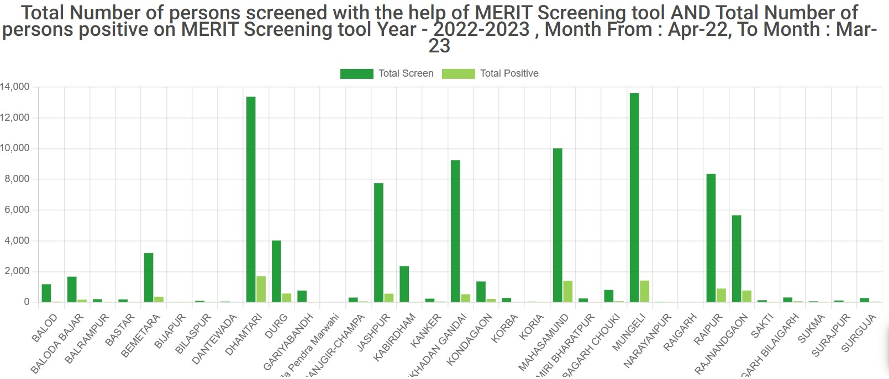

|  |  |  |  |  |
| --- | --- | --- | --- | --- |
| MENTAL HEAL | TH SCREENING | AT HWC -2023 | -24 (APRIL AND | MAY 2023) |
| **District Name** | **NMHP Screening target**  **at HWC** | **Number of persons screened for mental health issues at HWC** | **Percentage Achievement** | **Total Number of persons positive of mental health issues** |
| BALOD | 72540 | 527 | 0.7 | 82 |
| BALODA BAJAR | 125003 | 9604 | 7.7 | 1015 |
| BALRAMPUR | 69425 | 1029 | 1.5 | 100 |
| BASTAR | 78934 | 65496 | 83.0 | 531 |
| BEMETARA | 82239 | 814 | 1.0 | 128 |
| BIJAPUR | 22536 | 6 | 0.0 | 0 |
| BILASPUR | 163895 | 299 | 0.2 | 53 |
| DANTEWADA | 24270 | 64 | 0.3 | 19 |
| DHAMTARI | 71650 | 3879 | 5.4 | 732 |
| DURG | 65922 | 3253 | 4.9 | 501 |
| GARIYABANDH | 63371 | 95 | 0.1 | 21 |
| Gaurella Pendra Marwahi | 32821 | 0 | 0.0 | 0 |
| JANJGIR-CHAMPA | 143624 | 1397 | 1.0 | 328 |
| JASHPUR | 77519 | 2098 | 2.7 | 394 |
| KABIRDHAM | 84407 | 797 | 0.9 | 13 |
| KANKER | 63881 | 2752 | 4.3 | 796 |
| KHAIRGARH CHHUIKHADAN  GANDAI | 37371 | 2511 | 6.7 | 121 |
| KONDAGAON | 52211 | 386 | 0.7 | 117 |

125

|  |  |  |  |  |
| --- | --- | --- | --- | --- |
| MENTAL HEAL  **District Name** | TH SCREENING  **NMHP Screening**  **target at HWC** | AT HWC -202  **Number of persons screened for mental health issues at HWC** | 3-24 (APRIL AND  **Percentage**  **Achievement** | MAY 2023)  **Total Number of persons positive of mental health issues** |
| KONDAGAON | 52211 | 386 | 0.7 | 117 |
| KORBA | 114895 | 1135 | 1.0 | 66 |
| KORIA | 51461 | 80 | 0.2 | 16 |
| MAHASAMUND | 78708 | 7210 | 9.2 | 1553 |
| MANENDRAGARH CHIRIMIRI BHARATPUR | 21856 | 366 | 1.7 | 100 |
| MOHLA MANPUR AMBAGARH CHOUKI | 25727 | 335 | 1.3 | 62 |
| MUNGELI | 71941 | 4455 | 6.2 | 369 |
| NARAYANPUR | 12947 | 14 | 0.1 | 6 |
| RAIGARH | 103143 |  | 0.0 |  |
| RAIPUR | 224412 | 6984 | 3.1 | 781 |
| RAJNANDGAON | 68950 | 1990 | 2.9 | 267 |
| SAKTI | 16886 | 173 | 1.0 | 3 |
| SARANGARH BILAIGARH | 47641 | 595 | 1.2 | 65 |
| SUKMA | 22624 | 35 | 0.2 | 4 |
| SURAJPUR | 72736 | 1001 | 1.4 | 159 |
| SURGUJA | 72223 | 31 | 0.0 | 126  7 |

**Report of Dialysis unit** Under PMNDP April & May 2023

|  |  |  |  |  |  |  |
| --- | --- | --- | --- | --- | --- | --- |
| **S.No** | **District Name** | **Total Dialysis machine available** | **Program started in District** | **Ideal utilization of machine @ 3 session per machine per day** | **Total Dialysis Session** | **Percentage achieved** |
| **1** | **SARGUJA** | **4** | **Jun-21** | **720** | **1125** | **156.3** |
| **2** | **BILASPUR** | **5** | **Mar-20** | **900** | **1225** | **136.1** |
| **3** | **MUNGELI** | **3** | **Aug-22** | **540** | **674** | **124.8** |
| **4** | **JANJGIRCHAMPA** | **5** | **Apr-22** | **900** | **966** | **107.3** |
| **5** | **KORBA** | **7** | **Mar-20** | **1260** | **1165** | **92.5** |
| **6** | **KAWARDHA** | **4** | **Sep-22** | **720** | **630** | **87.5** |
| **7** | **KANKER** | **5** | **Mar-20** | **900** | **754** | **83.8** |
| **8** | **GARIABAND** | **4** | **Mar-20** | **720** | **588** | **81.7** |
| **9** | **DURG** | **5** | **Mar-20** | **900** | **687** | **76.3** |
| **10** | **RAJNANDGAON** | **3** | **Apr-18** | **540** | **408** | **75.6** |
| **11** | **MAHASAMUND** | **3** | **Jun-21** | **540** | **371** | **68.7** |
| **12** | **KOREA** | **4** | **Aug-22** | **720** | **435** | **60.4** |
| **13** | **BIJAPUR** | **4** | **Sep-22** | **720** | **410** | **56.9** |
| **14** | **BALODABAZAR** | **5** | **Apr-22** | **900** | **471** | **52.3** |
| **15** | **RAIPUR** | **10** | **Apr-22** | **1800** | **924** | **51.3** |
| **16** | **BALOD** | **4** | **Sep-22** | **720** | **321** | **44.6** |
| **17** | **JASHPUR** | **5** | **Sep-22** | **900** | **393** | **43.7** |
| **18** | **DHAMTARI** | **4** | **Sep-22** | **720** | **267** | **37.1** |
| **19** | **SURAJPUR** | **6** | **Jun-21** | **1080** | **343** | **31.8** |
| **20** | **JAGDALPUR** | **5** | **Apr-22** | **900** | **272** | **30.2** |
| **21** | **BEMETARA** | **5** | **Jan-23** | **900** | **117** | 128 **13.0** |
| **22** | **SUKMA** | **4** | **Feb-23** | **720** | **53** | **7.4** |

##### PMNDP Portal Entry Status District Wise

|  |  |  |  |  |  |
| --- | --- | --- | --- | --- | --- |
| **S.No.** | **District Name** | **Hemodialysis Session (Portal**  **Entry)** | **Dialysis Session**  **(Manual Report)** | **Gap** | **Percentage achieved** |
| **1** | **Surajpur** | **647** | **698** | **51** | **92.7** |
| **2** | **Bastar** | **1184** | **1556** | **372** | **76.1** |
| **3** | **Rajnandgaon** | **636** | **872** | **236** | **72.9** |
| **4** | **Raipur** | **2433** | **3352** | **919** | **72.6** |
| **5** | **Durg** | **2972** | **4284** | **1312** | **69.4** |
| **6** | **Balod** | **458** | **677** | **219** | **67.7** |
| **7** | **Bilaspur** | **4076** | **6057** | **1981** | **67.3** |
| **8** | **Baloda Bazar** | **864** | **1371** | **507** | **63.0** |
| **9** | **Gariyabandh** | **1036** | **1848** | **812** | **56.1** |
| **10** | **Mungeli** | **1185** | **2259** | **1074** | **52.5** |
| **11** | **Dhamtari** | **528** | **1008** | **480** | **52.4** |
| **12** | **Kanker** | **748** | **1901** | **1153** | **39.3** |
| **13** | **Bijapur** | **565** | **1505** | **940** | **37.5** |
| **14** | **Mahasamund** | **1023** | **2886** | **1863** | **35.4** |
| **15** | **Korba** | **2476** | **7037** | **4561** | **35.2** |
| **16** | **Koriya** | **503** | **1491** | **988** | **33.7** |
| **17** | **Surguja** | **1377** | **6976** | **5599** | **19.7** |
| **18** | **Jashpur** | **571** | **2950** | **2379** | **19.4** |
| **19** | **Janjgir - Champa** | **665** | **4244** | **3579** | **15.7** |
| **20** | **Kabeerdham** | **763** | **4937** | **4174** | **15.5** |
| **21** | **Bemetara** | **0** | **196** | **196** | **0.0**129 |
| **22** | **Sukma** | **0** | **1150** | **1150** | **0.0** |



Pradhan Mantri National Dialysis Program (PMNDP)

**Issues**

|  |  |  |  |  |  |
| --- | --- | --- | --- | --- | --- |
| **S.No**  **.** | **Indicator** | **Target – 2022-23** | **Achievement** | **Target – 2023-24**  **(April-May)** | **Achievement** |
| **1** | **Districts Covered**  **under PMNDP** | **28** | **22** | **33** | **22** |
| **2** | **Number of**  **Hemodialysis session** | **57600** | **46679 (81%)** | **62,425** | **12569 (20%)** |

* Dialysis services is under utilized currently average is 2.6 dialysis session per machine per day.
* Some hospital running dialysis services under PMNDP & DMF in same roof.
* Registration of patients and Dialysis session is less in PMNDP portal.
* No monitoring of dialysis services & PMNDP Portal entry as per MOU with agency by Hospital

Administration.

* Lack of awareness of dialysis service in hospital.

##### Status of Dialysis Unit in Other Source (DMF/CSR/JDS)

|  |  |  |  |  |  |
| --- | --- | --- | --- | --- | --- |
| **S.No** | **District Name** | **Total Dialysis machine available** | **Program started in District** | **Agency Information** | **Remark** |
| 1 | Dantewada | 4 | Dec-17 | DMF |  |
| 2 | Kondagaon | 1 | Jul-21 | DMF |  |
| 3 | Narayanpur | 2 | Jul-22 | JDS | **Dialysis Services not started under PMNDP in this Districts** |
| 4 | Balrampur | 3 | OCT-21 | DMF |
| 5 | Gourela-Pendra- Marwahi | 2 | Feb-21 | DMF |
| 6 | Raigarh | 2 | Oct-14 | JDS |  |
|  | Total | **14** |  | **0** | 131 |

**National Oral health programme (NOHP)**

NATIONAL ORAL HEALTH

**In FY.2022-23**,

overall 121% OPD services given to the patient in 28 districts.

25 districts (9%) have achieved more than 90% to provide OPD services to the patient.

3 districts (Durg, Raigarh,Sukma, ) fall between 80-75%. Almost all districts were done good.

**Status of OPD to the patient *(April to May 23-24)***

Yearly target set on the basis of IPHS norms 2022, which is of 20 OPD /day/facility). Districts –Dhamtari, Bilaspur, Koriya (9%)are achieved more than 90%

Districts-Balrampur, Jashpur, Kanker, Mahasamund,Sarangarh,Kawardha

districts (18 %) were achieved 80- 75% in OPD services given to the patient.

23 districts (69%) achieved less than 75%, have expected to achieve given target in upcoming

quarters.

Narayanpur reported zero OPD in last 2 months. Sakti, Dantewada, Bijapur – poor performing districts.

**NATIONAL ORAL HEALTH- Status of OPD to the patient (April to May 23)**

|  |  |  |  |  |  |  |
| --- | --- | --- | --- | --- | --- | --- |
| **Sr.no.** | **Districts Name** | **Yearly Target**  **2023-24(on**  **basis of 20 OPD**  **/day/facility)** | **P.Target** | **Achievem ent April to may 23** | **% Yearly Achievem ent** | **% P.**  **Achievem ent** |
| 1 | **Dhamtari** | 28500 | 4750 | 5022 | 18 | 106 |
| 2 | **Bilaspur** | 45600 | 7600 | 7890 | 17 | 104 |
| 3 | **Koriya** | 17100 | 2850 | 2690 | 16 | 94 |
| 4 | **Balrampur** | 45600 | 7600 | 6230 | 14 | 82 |
| 5 | **Jashpur** | 62700 | 10450 | 8249 | 13 | 79 |
| 6 | **Kanker** | 57000 | 9500 | 7409 | 13 | 78 |
| 7 | **Mahasamund** | 34200 | 5700 | 4418 | 13 | 78 |
| 8 | **Sarangarh** | 17100 | 2850 | 2221 | 13 | 78 |
| 9 | **Kawardha** | 39900 | 6650 | 4960 | 12 | 75 |
| 10 | **KCG** | 17100 | 2850 | 2116 | 12 | 74 |
| 11 | **Raigarh** | 62700 | 10450 | 7524 | 12 | 72 |
| 12 | **Rajnandgaon** | 39900 | 6650 | 4489 | 11 | 68 |
| 13 | **Bastar** | 51300 | 8550 | 5675 | 11 | 66 |
| 14 | **Korba** | 45600 | 7600 | 4807 | 11 | 63 |
| 15 | **Sukma** | 28500 | 4750 | 2885 | 10 | 61 |
| 16 | **Mungeli** | 28500 | 4750 | 2744 | 10 | 58 |
| 17 | **MMC** | 17100 | 2850 | 1659 | 10 | 58 |

|  |  |  |  |  |  |  |
| --- | --- | --- | --- | --- | --- | --- |
| **Sr.no.** | **Districts Name** | **Yearly Target 2023-24(on**  **basis of 20 OPD**  **/day/facility)** | **P.Targe t** | **Achieve ment April to may 23** | **% Yearly Achieve ment** | **% P.**  **Achieve ment** |
| 18 | **Baloda Bazar** | 39900 | 6650 | 3759 | 9 | 57 |
| 19 | **Gariyaband** | 45600 | 7600 | 4339 | 10 | 57 |
| 20 | **Kondagoan** | 45600 | 7600 | 4309 | 9 | 57 |
| 21 | **Durg** | 91200 | 15200 | 8622 | 9 | 57 |
| 22 | **JanjgirChampa** | 57000 | 9500 | 5005 | 9 | 53 |
| 23 | **Balod** | 45600 | 7600 | 3820 | 8 | 50 |
| 24 | **Bemetra** | 45600 | 7600 | 3788 | 8 | 50 |
| 25 | **MCB** | 28500 | 4750 | 2284 | 8 | 48 |
| 26 | **Surajpur** | 62700 | 10450 | 4717 | 8 | 45 |
| 27 | **Raipur** | 125400 | 20900 | 9126 | 7 | 44 |
| 28 | **Surguja** | 62700 | 10450 | 4454 | 7 | 43 |
| 29 | **GPM** | 22800 | 3800 | 1624 | 7 | 43 |
| 30 | **Dantewada** | 34200 | 5700 | 1732 | 5 | 30 |
| 31 | **Sakti** | 22800 | 3800 | 912 | 4 | 24 |
| 32 | **Bijapur** | 34200 | 5700 | 380 | 1 | 7 |
| 33 | **Narayanpur** | 17100 | 2850 |  | 0 | 0 |
|  | **Total** | **1419300** | **236550** | **139859** | **10** | **59** |

NATIONAL ORAL HEALTH

**In FY.2022-23,**

State has achieved 104% in dental procedure to the patient**.**

17 districts (60%) of districts were provided more then 100% dental procedures to the patient. Districts Bemetra, Balodabazar, Surajpur, Raigarh, Dhamtari were stand between the range of 75-85%.

Poor performing districts, who were achieved less then 75% – Korba, Sukma, Dantewada, Mahasamund, Kanker, Narayanpur.

**In FY.2023-24,**

In last 2 months state P. achievement is 61% in dental procedures.

Good performing districts are Bilaspur, Kawardha, Balrampur, - achieved more than 90 %.

Districts Sukma, Koriya, Durg, MMC, Dhamtari, Surguja, Mahasamund, Rajnandgaon achieved dental procedures between 80- 75%

14 (22%) of districts exist less then 75% dental procedures to the patient.

Districts - Bastar, Raipur, Surajpur, Kanker, Dantewada, Korba, Bijapur, Sakti are fall in the less then 50%.

Almost 18 (54%) districts were stand between the 50-70% of dental procedures achievement and expected to achieve target in upcoming quarters.

**o the patients (April to May 2023)**

**Yearly Target**

**Sr.no.**

**Districts Name**

**2023-24(on**

**basis of 8**

**P.Target**

**Total**

**% % P.**

**YearlyAchie Achieveme**

|  |  |  |  |  |  |  |
| --- | --- | --- | --- | --- | --- | --- |
|  | **Statu** | **s of de** | **nt** | **al proc** | **edu** | **res t** |
| **Sr.no.** | **Districts**  **Name** | **Yearly Target 2023-24(on**  **basis of 8**  **Procedures**  **/day/facility)** | **P.Target** | **Total** | **%**  **YearlyAchi**  **evemen** | **% P.**  **Achieveme**  **nt** |
| 1 | **Bilaspur** | 18240 | 3040 | 4221 | 23 | 139 |
| 2 | **Kawardha** | 15960 | 2660 | 2671 | 17 | 100 |
| 3 | **Balrampur** | 18240 | 3040 | 2999 | 16 | 99 |
| 4 | **Sukma** | 11400 | 1900 | 1691 | 15 | 89 |
| 5 | **Koriya** | 6840 | 1140 | 964 | 14 | 85 |
| 6 | **Durg** | 36480 | 6080 | 4883 | 13 | 80 |
| 7 | **MMC** | 6840 | 1140 | 886 | 13 | 78 |
| 8 | **Dhamtari** | 11400 | 1900 | 1352 | 12 | 71 |
| 9 | **Surguja** | 25080 | 4180 | 2962 | 12 | 71 |
| 10 | **Mahasamund** | 13680 | 2280 | 1619 | 12 | 71 |
| 11 | **Rajnandgaon** | 15960 | 2660 | 1879 | 12 | 71 |
| 12 | **Balod** | 18240 | 3040 | 2134 | 12 | 70 |
| 13 | **Jashpur** | 25080 | 4180 | 2841 | 11 | 68 |
| 14 | **KCG** | 6840 | 1140 | 750 | 11 | 66 |
| 15 | **JanjgirCham**  **pa** | 22800 | 3800 | 2364 | 10 | 62 |
| 16 | **Baloda Bazar** | 15960 | 2660 | 1627 | 10 | 61 |
| 17 | **Gariyaband** | 18240 | 3040 | 1850 | 10 | 61 |

1. **Raigarh**
2. **MCB**
3. **Kondagoan**
4. **Mungeli**
5. **Narayanpur**
6. **Sarangarh**
7. **Bemetra**
8. **GPM**
9. **Bastar**
10. **Raipur**
11. **Surajpur**
12. **Kanker**
13. **Dantewada**
14. **Korba**
15. **Bijapur**
16. **Sakti Total**

**Procedures**

**/day/facility)**

25080

11400

18240

11400

6840

6840

18240

9120

20520

50160

25080

22800

13680

18240

13680

9120

**567720**

4180

1900

3040

1900

1140

1140

3040

1520

3420

8360

4180

3800

2280

3040

2280

1520

**94620**

2569

1117

1704

1052

618

603

1585

758

1622

3578

1607

1110

644

794

431

267

**57752**

**vemen nt**

10 61

10 59

9 56

9 55

9 54

9 53

9 52

8 50

8 47

7 43

6 38

5 29

5 28

4 26

3 19

3 18

**10 61**

**National Programme for Health Care for the Elderly (NPHCE)**

|  |  |
| --- | --- |
| Geriatric | (Elderly) Ward Status |
| **Status** | **Name of District** |
| Functional | Gariyaband , Jashpur, Mungeli , Rajnandgaon , Raipur |
| Using for other Program | Dhamtari (Dialysis center) |
| **Currently using for COVID Pandemic Emergency** | **Balodabazar , Bilaspur , Durg** |
| Under Process | Dantewada, Kondagaon, Kawardha, Mahasamund, Surajpur |
| 10 bed reserved (5-5 at M-F Ward) | Balod, Balrampur, Bastar, Bemetra, Balodabazar, Bijapur, GPM, Kanker, Korba, Koriya, Narayanpur, Sukma, Surguja |

10 bedded Elderly ward , 14 out of 28 got approval from GOI till date in two phase.

**1st phase 9 district** Balodabazar, Bilaspur, Dhamtari, Durg, Gariyaband, Jaspur, Mungeli, Rajnandgaon, Raipur

**2nd phase 5 district**

Dantewada, Kawardha, Kondagaon, Mahasamund, Surajpur

**National Tobacco Control Programme (NTCP)**

Achievements of Tobacco Cessation Center (TCC) OPD

**FY 2022-23 (Number of Districts 28)**

Only 50 % (14) of District’s achieved the Target OPD @150 Per month

in Year 2022-23

Almost 18% (5) of District’s achieved More than 50% of Target OPD@150 Per month in Year 2022-23

32% (9) District’s are poor performing districts in Year 2022-23

(Narayanpur, Bijapur, Sukama, Dantewada, Raigarh, Balrampur, Balod, Bemetara, Surajpur)

**FY 2023-24 (till May 2023) (Number of Districts 33)**

In FY 2023-24 (till May 2023) 45% (15) of District District’s achieved the Target OPD @150 Per month.

Almost 12% (4) of District’s achieved More than 50% of Target OPD@150 Per month

43% (14) District’s are poor performing districts in including newly formed 5 districts.

**In newly formed 5 district TCC establishment need to start soon.**

**ACHIEVEMENT BY 28 DISTRICTS IN FY 2022-23**

100 percentage Target More than 50% Below 50%



**32%**

**50%**

**18%**

**ACHIEVEMENT BY 33 DISTRICTS IN FY 2023-24 (MAY 2023)**

100 percentage Target More than 50% Below 50%



**43%**

**45%**

**12%**

|  |  |  |
| --- | --- | --- |
| **S.No** | **TCC OP**  **Districts Name** | **D targets @150 pe**  **TCC OPD targets @150 per month (April to May 2023-24)** |
| 1 | Raipur | 2994 |
| 2 | Bastar | 1567 |
| 3 | Jashpur | 1252 |
| 4 | Rajnandgaon | 1219 |
| 5 | Durg | 1106 |
| 6 | Kanker | 903 |
| 7 | Koriya | 840 |
| 8 | Balrampur | 768 |
| 9 | Bilaspur | 759 |
| 10 | Mahasamund | 649 |
| 11 | Baloda Bazar | 583 |
| 12 | Kondagaon | 377 |
| 13 | Surguja | 361 |
| 14 | Gariyaband | 354 |
| 15 | Dhamtari | 344 |
| 16 | GPM | 280 |
| 17 | Narayanpur | 277 |

|  |  |  |
| --- | --- | --- |
| **mon**  **S.No** | **th (1800 An**  **Districts Name** | **ually)**  **TCC OPD targets @150 per**  **month (April to May 2023-24)** |
| 18 | Janjgir Champa | 176 |
| 19 | Mungeli | 174 |
| 20 | Korba | 117 |
| 21 | Dantewada | 86 |
| 22 | Bemetra | 78 |
| 23 | BALOD | 32 |
| 24 | Sukma | 30 |
| 25 | Raigarh | 28 |
| 26 | Bijapur | 0 |
| 27 | Kabirdham | 0 |
| 28 | KCG | 0 |
| 29 | MCB | 0 |
| 30 | MMC | 0 |
| 31 | Sakti | 0 |
| 32 | Sarangarh- Bilaigarh | 0 |
| 33 | Surajpur | 0 |
|  | **Total** | **15354** |

**r**

Tobacco Free Educational Institution -TOFEI Status

**FY 2022-23 (28 District)**

Total 57 % (1766) of Education institutions were declared as TOFEI against the target 110 Per District (110*28 = 3080).

36 % (10) of District has done TOFEI declaration for 100% of the Target institution (110)

11% (3) of District has done TOFEI declaration for less than 100% of the Target institution (110). 53% (15) of District has done any TOFEI declaration.

**FY 2023-24 (33 District) Till May 2023**

1.6% (58) of Education institutions were declared as TOFEI against the target 110 Per District. 24% (8) of District has done TOFEI declaration for less than 100% of the target institution (110). 76% (25) of District has done any TOFEI declaration.

**In last 14 Months 36% (12 Districts) other than 5 new districts were not declared any education institution as TOFEI**

( Bemetara, Balod, Raipur, Balrampur, Surajpur, Sukma, Bilaspur, GPM, Janjgir, Mungeli, Kondagaon, Raigarh )

**National Program for Prevention and Control of Deafness (NPPCD)**

|  |  |
| --- | --- |
|  | Audiometry Facilities |
| **Range** | **District** |
| **100%** | All districts except ( Bemetra, GPM & Sukma) |
| **50-75** | Bemetra & Sukma- Availability of HR but No Equipment available (Work under process at Store level) |
| **<50** | * GPM – No equipments (Work under process at Store level) & HR – not approved by GOI * New districts (Not approved by GOI) 144 |

|  |  |  |  |  |  |  |  |
| --- | --- | --- | --- | --- | --- | --- | --- |
|  | **N** | **umber of cases**  **OPD** | | **Investigation**  **Ear- Surgery** | | **s**  **Hearing Aidd** | |
| **SN** | **District Name** | **2022-23** | **April-May 2023** | **2022-23** | **April-May 2023** | **2022-23** | **April-May 2023** |
| 1 | Balod | 7207 | 891 | 20 | 1 | 26 | 9 |
| 2 | Baloda Bazar | 20563 | 2591 | 0 | 0 | 75 | 6 |
| 3 | Balrampur | 7212 | 1254 | 0 | 0 | 64 | 4 |
| 4 | Bastar | 5769 | 830 | 0 | 0 | 230 | 4 |
| 5 | Bemetra | 938 | 219 | 4 | 1 | 16 | 11 |
| 6 | Bijapur | 2118 | 0 | 109 | 0 | 0 | 0 |
| 7 | Bilaspur | 15937 | 3624 | 51 | 117 | 684 | 130 |
| 8 | Dantewada | 3003 | 614 | 104 | 27 | 21 | 0 |
| 9 | Dhamtari | 7240 | 1044 | 107 | 23 | 77 | 40 |
| 10 | Durg | 15099 | 1968 | 325 | 33 | 483 | 26 |
| 11 | Gariyaband | 6248 | 1035 | 69 | 22 | 102 | 16 |
| 12 | GPM | 5969 | 1760 | 51 | 0 | 157 | 0 |
| 13 | Janjgir | 2229 | 486 | 51 | 13 | 29 | 7 |
| 14 | Jashpur | 13354 | 1502 | 635 | 17 | 167 | 10 |
| 15 | Kanker | 8108 | 1766 | 350 | 56 | 79 | 24 |
| 16 | Kawardha | 8306 | 1641 | 71 | 0 | 21 | 2 |
| 17 | KCG | NA | 0 | NA | 0 | NA | 145 0 |

**Number of cases Investigations**

|  |  |  |  |  |  |  |  |  |
| --- | --- | --- | --- | --- | --- | --- | --- | --- |
|  |  | **OPD** | |  | **Ear- Surgery** | | **Hearing Aidd** | |
| **SN** | **District Name** | **2022-23** | **April-May**  **2023** | | **2022-23** | **April-May**  **2023** | **2022-23** | **April-May**  **2023** |
| 18 | Kondagaon | 3284 |  | 583 | 51 | 0 | 83 | 17 |
| 19 | Korba | 15360 |  | 1954 | 716 | 85 | 171 | 47 |
| 20 | Koriya | 8271 |  | 1162 | 237 | 26 | 91 | 0 |
| 21 | Mahasamund | 13329 |  | 2125 | 101 | 34 | 50 | 0 |
| 22 | MCB | NA |  | 0 | NA | 0 | NA | 0 |
| 23 | MMAC | NA |  | 0 | NA | 0 | NA | 0 |
| 24 | Mungeli | 11167 |  | 2919 | 37 | 15 | 157 | 1 |
| 25 | Narayanpur | 1915 |  | 329 | 51 | 7 | 84 | 31 |
| 26 | Raigarh | 14383 |  | 2539 | 121 | 55 | 58 | 23 |
| 27 | Raipur | 15036 |  | 2067 | 1198 | 150 | 152 | 17 |
| 28 | Rajnandgaon | 27143 |  | 2544 | 61 | 16 | 99 | 190 |
| 29 | Sakti | NA |  | 0 | NA | 0 | NA | 0 |
| 30 | Saranggarh-Bilaigarh | NA |  | 0 | NA | 0 | NA | 0 |
| 31 | Sukma | 1156 |  | 322 | 51 | 0 | 20 | 0 |
| 32 | Surajpur | 53 |  | 567 | 28 | 0 | 792 | 0 |
| 33 | Surguja | 115 |  | 1920 | 194 | 213 | 834 | 18 |
|  | **Total** | **240512** |  | **40256** | **4793** | **911** | **4822** | **633** |

**Comprehensive Primary Healthcare (CPHC)**

|  |  |  |  |  |  |  |  |  |
| --- | --- | --- | --- | --- | --- | --- | --- | --- |
| **HWCs Operational Status 31-03-2023** | | | | | | | | |
| **S.No** | **District** | **Total Facility** | **Co-located SHC HWC** | **Not Eligible Facility** | **Co-located SHC HWC+**  **Not Eligible**  **Facility** | **Final Target for Districts** | **Operational Status as 31-03-2023** | **HWCs**  **Operational**  **%** |
| 1 | Bijapur | 87 | 0 | 23 | 23 | 64 | 80 | 125% |
| 2 | Kondagaon | 195 | 9 | 13 | 22 | 173 | 195 | 113% |
| 3 | Sukma | 98 | 6 | 5 | 11 | 87 | 94 | 108% |
| 4 | Surajpur | 245 | 40 | 14 | 54 | 191 | 206 | 108% |
| 5 | Jashpur | 293 | 27 | 0 | 27 | 266 | 284 | 107% |
| 6 | Surguja | 226 | 9 | 17 | 26 | 200 | 207 | 104% |
| 7 | Mungeli | 151 | 26 | 4 | 30 | 121 | 125 | 103% |
| 8 | Mahasamund | 257 | 27 | 15 | 42 | 215 | 221 | 103% |
| 9 | Kanker | 280 | 46 | 0 | 46 | 234 | 238 | 102% |
| 10 | Balrampur | 220 | 27 | 9 | 36 | 184 | 187 | 102% |
| 11 | Balod | 226 | 6 | 0 | 6 | 220 | 222 | 101% |
| 12 | Bemetara | 147 | 10 | 19 | 29 | 118 | 119 | 101% |
| 13 | Raigarh | 399 | 35 | 0 | 35 | 364 | 367 | 101% |
| 14 | Rajnandgaon | 366 | 44 | 11 | 55 | 311 | 313 | 148  101% |

|  |  |  |  |  |  |  |  |  |
| --- | --- | --- | --- | --- | --- | --- | --- | --- |
| **HWCs Operational Status 31-03-2023** | | | | | | | | |
| **S.No** | **District** | **Total Facility** | **Colocated SHC HWC** | **Not Eligible Facility** | **Colocated SHC HWC+Not**  **Eligible Facility** | **Final Target for Districts** | **Operational Status as 31-03-2023** | **HWCs**  **Operational**  **%** |
| 16 | Raipur | 270 | 11 | 30 | 41 | 229 | 230 | 100% |
| 17 | Dhamtari | 201 | 11 | 0 | 11 | 190 | 190 | 100% |
| 18 | Janjgir-Champa | 317 | 38 | 2 | 40 | 277 | 277 | 100% |
| 19 | Kabirdham | 171 | 33 | 0 | 33 | 138 | 138 | 100% |
| 20 | Bastar | 278 | 13 | 0 | 13 | 265 | 264 | 100% |
| 21 | Baloda Bazar | 247 | 26 | 1 | 27 | 220 | 219 | 100% |
| 22 | Gariyaband | 214 | 8 | 0 | 8 | 206 | 205 | 100% |
| 23 | Korea | 223 | 36 | 0 | 36 | 187 | 179 | 96% |
| 24 | Durg | 185 | 5 | 0 | 5 | 180 | 171 | 95% |
| **25** | **Dantewada** | **89** | **4** | **2** | **6** | **83** | **74** | **89%** |
| **26** | **Korba** | **313** | **35** | **0** | **35** | **278** | **243** | **87%** |
| **27** | **Narayanpur** | **71** | **8** | **18** | **26** | **45** | **38** | **84%** |
| **28** | **Gaurella Pendra**  **Marwahi** | **91** | **10** | **4** | **14** | **77** | **65** | **84%** |
|  | **Total** | **6118** | **588** | **187** | **775** | **5343** | **5372** | **101%** |

|  |  |  |
| --- | --- | --- |
| Sno. | Average Number o  District | f Medicine Available in SHC HWC  Number of medicine Number of  Sno. District |
| 1 | Rajnandgaon | 114 medicine |
| 2 | Dhamtari | 100 1 Gariyabandh 85 |
| 3 | Mohla Manpur Ambagarh Chouki | 100 2 Kondagaon 83 |
| 4 | Mungeli | 100 3 Sarangarh Bilaigarh 83 |
| 5 | Narayanpur | 100 4 Raipur 82 |
| 6 | Balod | 98 5 Bastar 79 |
| 7 | Baloda bazar | 98 **1 Bilaspur 69** |
| 8 | Bemetara | 98 **2 Janjgir - champa 66** |
| 9 | Kabeerdham | 98 **3 Sakti 64** |
| 10 | Korba | 98 |
| 11 | Raigarh | 98 **4 Balrampur 60** |
| 12 | Surguja | 98 **5 Dantewada 56** |
| 13 | Sukma | 94 **6 Durg 52** |
| 14 | Jashpur | 93 **7 Kanker 50** |
| 15 | Koriya | 93 **8 Khairgarh Chhuikhadan 35** |
| 16 | Mahasamund | 93 **Gandai** |
| 17 | Manendragarh Chirimiri Bharatpur | 93 |
| 18 | Bijapur | 91 |
|  |  |  |
| 19 | Gaurella Pendra Marwahi | 91 **State Average 85** |
| 20 | Surajpur | 150  91 |

|  |  |  |
| --- | --- | --- |
| Sno. | Average Numb  District | er of Medicine Available in PHC HWC  Number of medicine |
| 1 | Balod | 172 Sno. District Number of medicine |
| 2 | Dhamtari | 154 |
| 3 | Mungeli | 151 25 Bastar 112 |
| 4 | Raigarh | 151 26 Durg 112 |
| 5 | Raipur | 144 |
| 6 | Narayanpur | 139 27 Dantewada 109 |
| 7 | Mahasamund | 138 28 Kanker 105 |
| 8 | Kondagaon | 136 |
| 9 | Baloda bazar | 135 29 Balrampur 103 |
| 10 | Bemetara | 135 |
| 11 | Bijapur | 135 30 Gaurella Pendra Marwahi 103 |
| 12 | Gariyabandh | 134 |
| 13 | Mohla Manpur Ambagarh Chouki | 134  31 Khairgarh Chhuikhadan 80 |
| 14 | Surajpur | 134 Gandai |
| 15 | Sarangarh Bilaigarh | 133 |
| 16 | Kabeerdham | 132 32 **Bilaspur 79** |
| 17 | Koriya | 132 33 **Rajnandgaon 25** |
| 18 | Manendragarh Chirimiri Bharatpur | 132 |
| 19 | Surguja | 132 State Average 124 |
| 20 | Sukma | 130 |
| 21 | Janjgir - champa | 126 |
| 22 | Jashpur | 122 |
| 23 | Korba | 122 |
| 24 | Sakti | 122 |

|  |  |  |
| --- | --- | --- |
| Average Number of Diagnostics  Sno. District Number of Diagnostics 1 | Available in  Sakti | SHC HWC  13 |
| 2 | Baloda bazar | 12 |
| 1 Rajnandgaon 14 3 | Bemetara | 12 |
| 2 Janjgir - champa 14 4 | Dantewada | 12 |
| 3 Kondagaon 14 5 | Dhamtari | 12 |
| 4 Mahasamund 14 6 | Gariyabandh | 12 |
| 7 | Jashpur | 12 |
| 5 Mohla Manpur 14 8 | Kanker | 12 |
| Ambagarh Chouki 9 | Korba | 12 |
| 6 Mungeli 14 10 | Koriya | 12 |
| 7 Raigarh 14 11 | Manendragarh Chirimiri  Bharatpur | 12 |
| 8 Raipur 14 12 | Narayanpur | 12 |
| **1 Balod 9** 13 | Sarangarh Bilaigarh | 12 |
| **2 Balrampur 9** 14 | Sukma | 12 |
| 15 | Bijapur | 11 |
| **3 Gaurella Pendra 8** 16 | Bilaspur | 11 |
| **Marwahi** 17 | Surguja | 11 |
| **4 Kabeerdham 8** 18 | Bastar | 10 |
| 19   1. **Durg 7**   **Khairgarh** State   1. **Chhuikhadan 7**   **Gandai** | Surajpur  Average | 10  12 |

g

|  |  |  |
| --- | --- | --- |
| nosti  Sno. | cs Available i  District | n PHC HWC  Number of Diagnostics |
| **1** | **Korba** | **39** |
| **2** | **Sukma** | **39** |
| **3** | **Gaurella Pendra Marwahi** | **36** |
| **4** | **Balrampur** | **35** |
| **5** | **Gariyabandh** | **35** |
| **6** | **Janjgir - champa** | **35** |
| **7** | **Kondagaon** | **34** |
| **8** | **Sakti** | **30** |
| **9** | **Balod** | **29** |
| **10** | **Bastar** | **24** |
| **11** | **Durg** | **23** |
| **12** | **Rajnandgaon** | **23** |
| **13** | **Kabeerdham** | **15** |
| **14** | **Khairgarh Chhuikhadan Gandai** | **11** |
|  | State Average | 40 153 |

|  |  |  |
| --- | --- | --- |
| Sno. | Average Nu  District | mber of Dia  Number of Diagnostics |
| 1 | Raipur | 63 |
| 2 | Narayanpur | 62 |
| 3 | Raigarh | 56 |
| 4 | Mungeli | 50 |
| 1 | Bemetara | 48 |
| 2 | Bijapur | 48 |
| 3 | Dhamtari | 48 |
| 4 | Baloda bazar | 46 |
| 5 | Sarangarh Bilaigarh | 46 |
| 6 | Surguja | 46 |
| 7 | Bilaspur | 45 |
| 8 | Kanker | 45 |
| 9 | Mahasamund | 44 |
| 10 | Mohla Manpur  Ambagarh Chouki | 44 |
| 11 | Surajpur | 44 |
| 12 | Koriya | 42 |
| 13 | Manendragarh Chirimiri Bharatpur | 42 |
| 14 | Dantewada | 41 |
| 15 | Jashpur | 41 |

|  |  |  |  |  |  |  |  |
| --- | --- | --- | --- | --- | --- | --- | --- |
| **Wellness Activity (1 April 2023 to 31 May 2023) Average Per HWC/Month**  **(Need To Average 50 Activity Per Month Per HWC)** | | | | | | | |
| **S.No.** | **District** | **Operational**  **Status as**  **05-06-2023** | **2 Month**  **Target** | **Total Events**  **Organized** | **Activities**  **Done** | **Total**  **( Event+Activities)** | **(Event+Activities)**  **Done %** |
| 1 | Kabeerdham | 138 | 6900 | 7193 | 7411 | 14604 | 212% |
| 2 | Narayanpur | 38 | 1900 | 884 | 898 | 1782 | 94% |
| 3 | Bemetara | 119 | 5950 | 2636 | 2803 | 5439 | 91% |
| 4 | Mungeli | 125 | 6250 | 2635 | 2855 | 5490 | 88% |
| 5 | Korba | 243 | 12150 | 5051 | 5347 | 10398 | 86% |
| 6 | Rajnandgaon | 147 | 7350 | 2364 | 3876 | 6240 | 85% |
| **7** | **Gaurella Pendra**  **Marwahi** | **65** | **3250** | **1222** | **1263** | **2485** | **76%** |
| **8** | **Baloda Bazar** | **183** | **9150** | **3204** | **3311** | **6515** | **71%** |
| **9** | **Dhamtari** | **190** | **9500** | **3353** | **3409** | **6762** | **71%** |
| **10** | **Kanker** | **238** | **11900** | **4098** | **4306** | **8404** | **71%** |
| **11** | **Raipur** | **229** | **11450** | **3691** | **3912** | **7603** | **66%** |
| **12** | **Bastar** | **264** | **13200** | **4178** | **4571** | **8749** | **66%** |
| **13** | **Sarangarh-bilaigarh** | **116** | **5800** | **1868** | **1912** | **3780** | **65%** |
| **14** | **Balod** | **222** | **11100** | **3326** | **3464** | **6790** | **61%** |
| **15** | **Mohala-manpur-chowki** | **83** | **4150** | **967** | **1434** | **2401** | **58%** |
| **16** | **Jashpur** | **284** | **14200** | **3111** | **4539** | **7650** | **54%** |
| **17** | **Janjgir - Champa** | **159** | **7950** | **1967** | **2225** | **4192** | 154**53%** |

|  |  |  |  |  |  |  |  |
| --- | --- | --- | --- | --- | --- | --- | --- |
| **Wellness Activity (1 April 2023 to 31 May 2023) Average Per HWC/Month**  **(Need To Average 50 Activity Per Month Per HWC)** | | | | | | | |
| **S.No.** | **District** | **Operational Status as**  **05-06-2023** | **2 Month Target** | **Total Events Organized** | **Activities Done** | **Total**  **( Event+Activities)** | **(Event+Activities) Done %** |
| **18** | **Durg** | **171** | **8550** | **2158** | **2236** | **4394** | **51%** |
| **19** | **Mahasamund** | **221** | **11050** | **2737** | **2914** | **5651** | **51%** |
| **20** | **Raigarh** | **287** | **14350** | **3260** | **3628** | **6888** | **48%** |
| **21** | **Kondagaon** | **172** | **8600** | **1975** | **2088** | **4063** | **47%** |
| **22** | **Manendragarh- Chirmiri-bharatpur** | **65** | **3250** | **692** | **792** | **1484** | **46%** |
| **23** | **Sakti** | **117** | **5850** | **1247** | **1412** | **2659** | **45%** |
| **24** | **Gariyabandh** | **205** | **10250** | **2134** | **2436** | **4570** | **45%** |
| **25** | **Khairagarh-**  **chhuikhadan-gandai** | **83** | **4150** | **588** | **1187** | **1775** | **43%** |
| **26** | **Bilaspur** | **221** | **11050** | **2207** | **2504** | **4711** | **43%** |
| **27** | **Koriya** | **114** | **5700** | **1052** | **1209** | **2261** | **40%** |
| **28** | **Sukma** | **96** | **4800** | **911** | **953** | **1864** | **39%** |
| **29** | **Bijapur** | **80** | **4000** | **648** | **732** | **1380** | **35%** |
| **30** | **Surajpur** | **207** | **10350** | **1670** | **1784** | **3454** | **33%** |
| **31** | **Dantewada** | **74** | **3700** | **522** | **587** | **1109** | **30%** |
| **32** | **Surguja** | **207** | **10350** | **1313** | **1400** | **2713** | **26%** |
| **33** | **Balrampur** | **186** | **9300** | **830** | **843** | **1673** | **18%** |
|  | **Total** | **5349** | **267450** | **1313** | **84241** | **85554** | 155**32%** |

|  |  |  |  |  |  |
| --- | --- | --- | --- | --- | --- |
| **FY. 22-23 eSanjeevani 2.0 Consultation Completed (50 Consultation Per facility/per month)**  **1/04/2023 - 31/05/2023** | | | | | |
| **S.No** | **District** | **Operational Status as 31-03-2023** | **Target eSanjeevani 2.0 Consulation** | **Consultations** | **Consultations Done**  **%** |
| 1 | Narayanpur | 38 | 3800 | 4261 | 112% |
| 2 | Bemetara | 119 | 11900 | 8042 | 68% |
| 3 | Mungeli | 125 | 12500 | 6325 | 51% |
| **4** | **Balod** | **222** | **22200** | **10313** | **46%** |
| **5** | **Janjgir-Champa** | **276** | **27600** | **11335** | **41%** |
| **6** | **Bastar** | **264** | **26400** | **9856** | **37%** |
| **7** | **Baloda Bazar** | **219** | **21900** | **8140** | **37%** |
| **8** | **Rajnandgaon** | **313** | **31300** | **10647** | **34%** |
| **9** | **Gaurella Pendra Marwahi** | **65** | **6500** | **2059** | **32%** |
| **10** | **Korea** | **179** | **17900** | **5479** | **31%** |
| **11** | **Raipur** | **230** | **23000** | **7039** | **31%** |
| **12** | **Balrampur** | **187** | **18700** | **5191** | **28%** |
| **13** | **Dhamtari** | **190** | **19000** | **5231** | **28%** |
| **14** | **Bilaspur** | **221** | **22100** | **5720** | **26%** 156 |

|  |  |  |  |  |  |
| --- | --- | --- | --- | --- | --- |
| **FY. 22-23 eSanjeevani 2.0 Consultation Completed (50 Consultation Per facility/per month)**  **1/04/2023 - 29/05/2023** | | | | | |
| **S.No** | **District** | **Operational Status**  **as**  **31-03-2023** | **Target eSanjeevani 2.0 Consultation** | **Total Consultation (1 Apr-29 May**  **2023)** | **Consultations Done**  **%** |
| **16** | **Kanker** | **238** | **23800** | **5487** | **23%** |
| **17** | **Raigarh** | **367** | **36700** | **8413** | **23%** |
| **18** | **Korba** | **243** | **24300** | **5026** | **21%** |
| **19** | **Mahasamund** | **221** | **22100** | **4077** | **18%** |
| **20** | **Gariyaband** | **205** | **20500** | **3763** | **18%** |
| **21** | **Kabirdham** | **138** | **13800** | **2444** | **18%** |
| **22** | **Surajpur** | **206** | **20600** | **3021** | **15%** |
| **23** | **Durg** | **171** | **17100** | **2381** | **14%** |
| **24** | **Sukma** | **95** | **9500** | **827** | **9%** |
| **25** | **Jashpur** | **284** | **28400** | **2388** | **8%** |
| **26** | **Dantewada** | **74** | **7400** | **412** | **6%** |
| **27** | **Surguja** | **207** | **20700** | **844** | **4%** |
| **28** | **Kondagaon** | **195** | **19500** | **218** | **1%** |
|  | **Total** | **5372** | **537200** | **140884** | 157  **26%** |

**National Urban Health Mission**

|  |  |
| --- | --- |
|  | **UHWC Operational Status** |
| **Operational Status** | **District** |
| **100%**  **Operational** | Raipur,Durg,Korba,Raigarh,Mahasamund,Rajnandgaon,Kanker,Mungeli, |
| **50 to 80%** | Dhamtari(86%,-7/6),Bilaspur(80%,-15/12),Bastar(80%,-5/4)  ,Surguja(73%,-11/8), Janjgeer(67%,-3/2),Balodabazar(50%,-6/3) |
| **Less then 50%** | MCB(33%,-3/1) |
| **Not Started** | Balod(3),Bemetara(4),Gariyaband(2),Jashpur(1),Kabeerdham(4), Sukma(3) |

Data Source:- HWC P1o59rtal

|  |  |
| --- | --- |
|  | **UHWC HR Status** |
| **HR** | **District** |
| **>80%** | Raigarh(93%),Korba(91%),Durg(89%),Bilaspur(89%),Rajnandgaon(8 9%),  Raipur(87%),Kanbeerdham(80%),Mungeli(80%),Kanker(80%), |
| **80 to 50%** | Bastar(72%),Dhamtari(69%), |
| **<50 %** | Balodabazar(47%),Janjgeer(26%),Surguja(13%),Mahasamund(10%)  ,MCB(0%)  Bemetara(0%),Balod(0%),Gariyaband(0%),Jashpur(0%),Sukma(0%) |

|  |  |  |  |  |  |  |  |  |  |  |  |  |  |
| --- | --- | --- | --- | --- | --- | --- | --- | --- | --- | --- | --- | --- | --- |
| **Polyclinic OPD And Visit Status April to May 2023** | | | | | | | | | | | | | |
| **S.NO.** | **District** | **Name of Polyclinic** | **Skin** | **Medicine** | **Pediatric s** | **Opthalmolo gy** | **ENT** | **Gynecolog y** | **Dental** | **Psychiatr y** | **Orthopedic s** | **Surgery** | **Total** |
| **1** | **Bastar** | **UPHC Geedam Road** | 0 | 200 | 62 | 19 | 30 | 202 | 0 | 0 | 16 |  | 529 |
| **2** | **Bilaspur** | **UPHC Rajkishor**  **Nagar** | 0 | 162 | 60 | 15 | 30 | 131 | 0 | 0 | 13 |  | 411 |
| **3** | **Durg** | **UPHC Charoda** | 0 | 74 | 16 | 0 | 55 | 58 | 0 | 0 | 46 |  | 249 |
| **4** | **Durg** | **UPHC Baikunthdham** | 0 | 88 | 9 | 19 | 30 |  | 0 | 0 | 15 |  | 161 |
| **5** | **Durg** | **UPHC Baghera** | 0 | 43 | 5 | 43 | 41 | 133 | 0 | 0 | 0 |  | 265 |
| **6** | **Korba** | **UPHC Dhodhipara** | 15 | 144 | 30 | 0 | 0 | 85 | 0 | 0 | 3 |  | 277 |
| **7** | **Raigarh** | **UPHC Rambhata** | 0 | 0 | 0 | 46 | 10 | 18 | 0 | 0 | 57 | 0 | 131 |
| **8** | **Raipur** | **UPHC Heerapur** | 10 | 0 | 0 | 0 | 0 | 0 | 0 | 0 | 0 |  | 10 |
| **9** | **Raipur** | **UPHC Mowa** | 5 | 0 | 0 | 0 | 7 | 0 | 0 | 0 | 0 |  | 12 |
| **10** | **Raipur** | **UPHC Devpuri** | 8 | 0 | 0 | 0 | 0 | 0 | 0 | 0 | 0 |  | 8 |
| **11** | **Raipur** | **UCHC birgaon** | 11 | 0 | 0 | 0 | 0 | 0 | 0 | 0 | 0 |  | 11 |
| **12** | **Raipur** | **UPHC Bhanpuri** | 5 | 0 | 0 | 0 | 0 | 0 | 0 | 0 | 0 |  | 5 |
| **13** | **Raipur** | **UPHC Bhatagaon** | 0 | 0 | 0 | 0 | 0 | 0 | 0 | 0 | 0 |  | 0 |
| **14** | **Surguja** | **UPHC Nawapara** | 6 | 19 | 28 | 31 | 36 | 39 | 2 | 0 | 0 |  | 161 |
| **15** | **Rajnandgao n** | **UPHC Sankarpur** | 4 | 18 | 55 | 0 | 6 | 70 | 0 | 9 | 4 |  | 166 |
|  |  | **Total OPD** | **64** | **748** | **265** | **173** | **245** | **736** | **2** | **9** | **154** | 1**0**61 | **2396** |

|  |  |
| --- | --- |
| **OPD** | **Status (April to May 2023-24) 2 Months** |
| **Per Day OPD** | **District** |
| **>=60 Per Day** | Raipur(84),Mahasamund(74),Bhilai(71),Surguja(68),MCB(68),Bilaspur(67), Rajnandgaon(63) |
| **60 to 30 OPD**  **Per Day** | Kabeerdham(59),Korba(58),Dhamtari(56),Balodabazar(56),Raigarh(50), Bastar(47),Janjgeer(47),Birgaon(45),Durg(45),Mungeli(34),Charoda(31) |
| **<30 OPD Per**  **Day** | Kanker(19) |

|  |  |
| --- | --- |
| **Deliver** | **y Status (April to May 2023-24) 2 Months** |
| **Per Month Delivery** | **District** |
| **>=12 Per**  **Month** | Janjgeer(27),Surguja(24),Birgaon(20),Korba(17),MCB(14), |
| **11 to 05 Delivery Per Month** | Raipur(11),Kabeerdham(11),Mahasamund(10),Durg(09),Bilaspur(07), Bastar(7),Rajnandgaon(07) |
| **<05 Delivery Per Month** | Charoda(03),Raigarh(03),Bhilai(02),Mungeli(02),Kanker(01),Dhamtari(0) Balodabazar(0) |

|  |  |
| --- | --- |
| **Lab te** | **st Status (April to May 2023-24) 2 Months** |
| **Per Day Lab test** | **District** |
| **>=50 Per Day** | Korba(168),Raipur(132),Dhamtari(146),Mahasamund(89),Durg(88), Surguja(79),Kabeerdham(58),Bilaspur(54),Bastar(51) |
| **50 to 30 OPD**  **Per Day** | Janjgeer(49),Raigarh(48),Bhilai(46),Balodabazar(45),Rajnandgaon(44) Birgaon(38),MCB(35) |
| **<30 OPD Per**  **Day** | Mungeli(18),Kanker(17) |

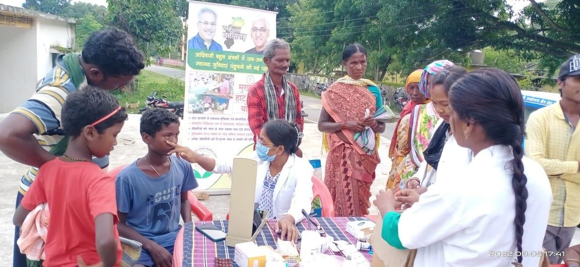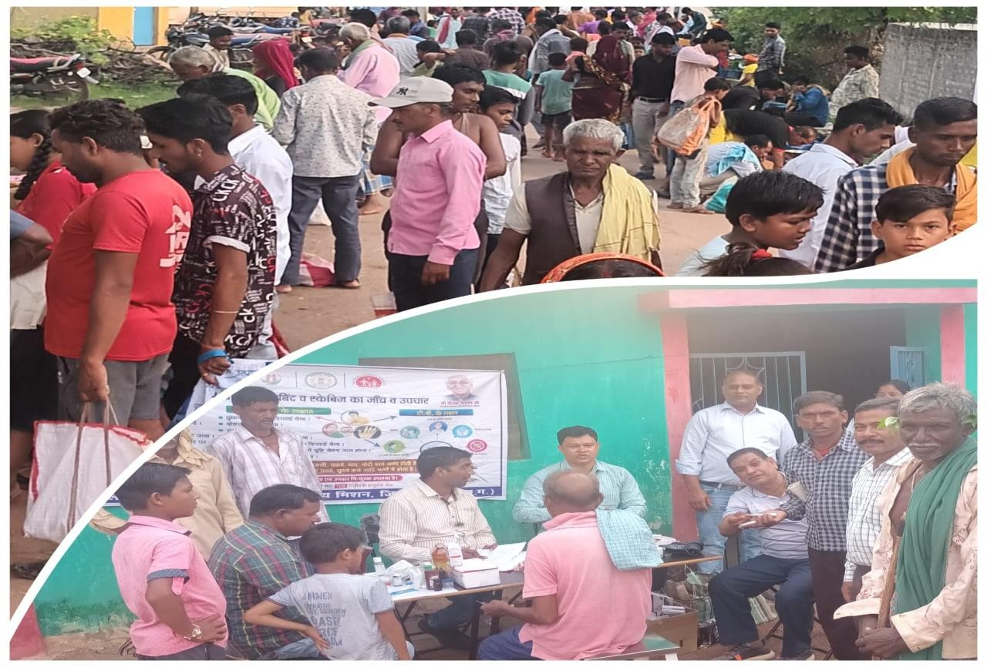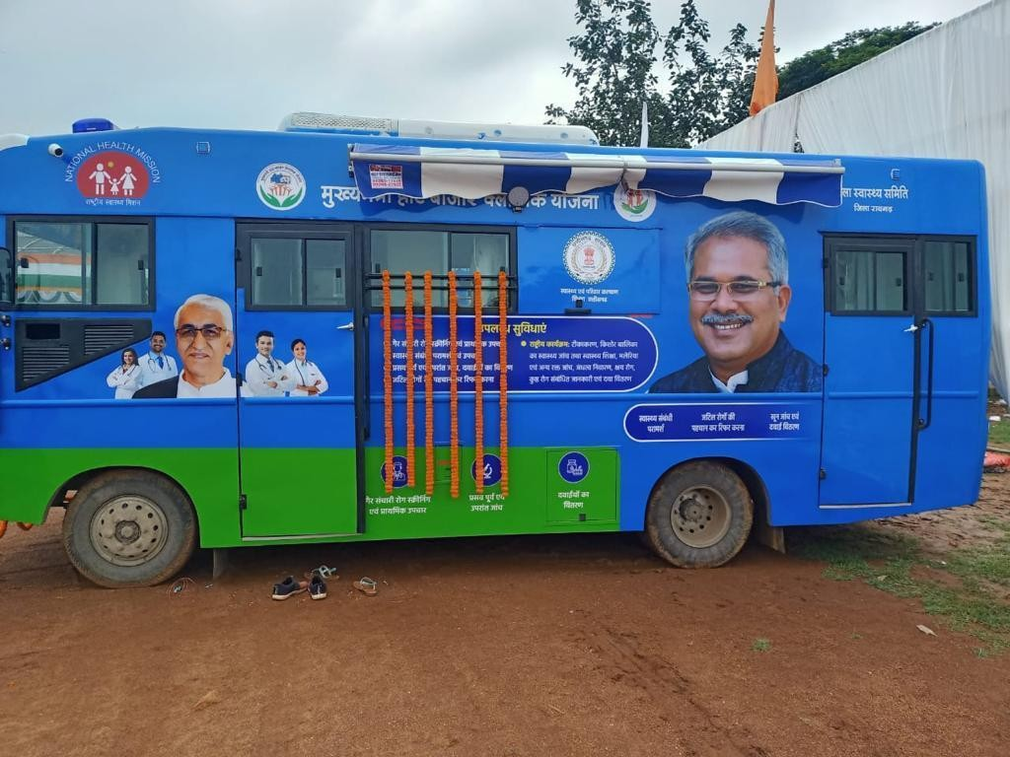

##### मुख्यमंत्री हाट बाज़ार क्लिचनि य जना

165

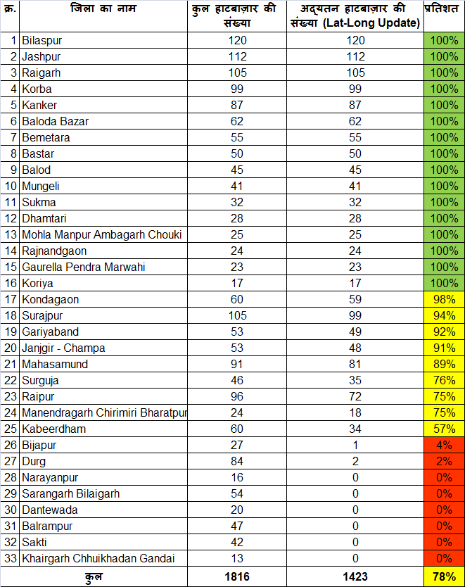 **चिक्लित हाट बाज़ार मे ं Latitude & Longitude िी क्लिचत**

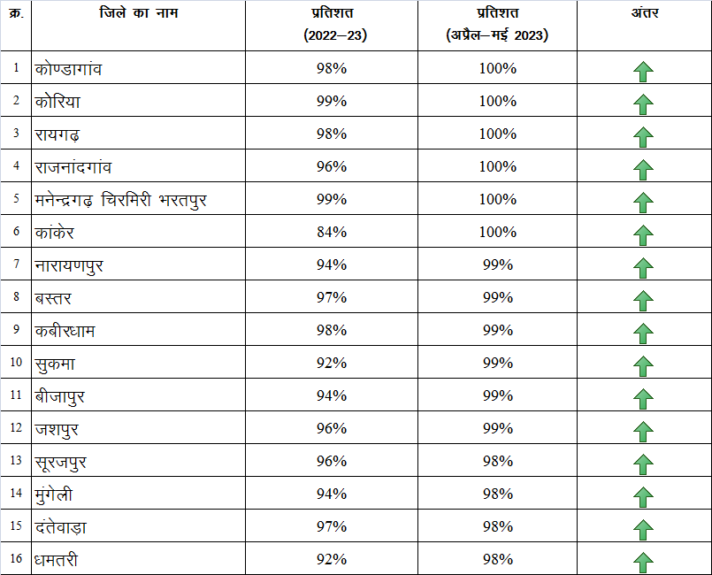 **चजलेवार वाहन पंहुिने िी क्लिचत**

167

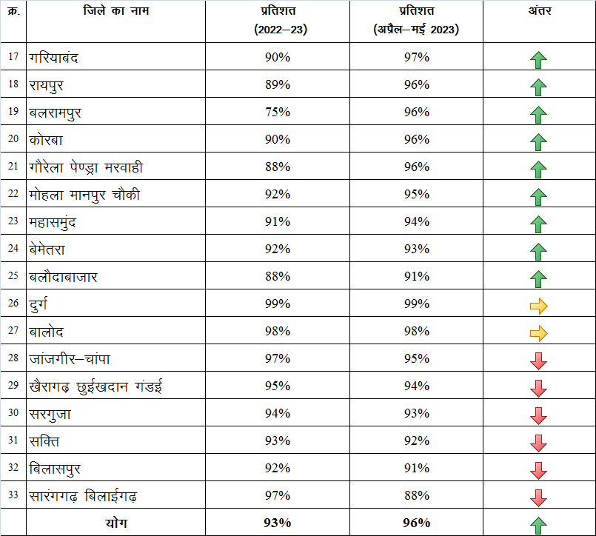 **चजलेवार वाहन पंहुिने िी क्लिचत**

168

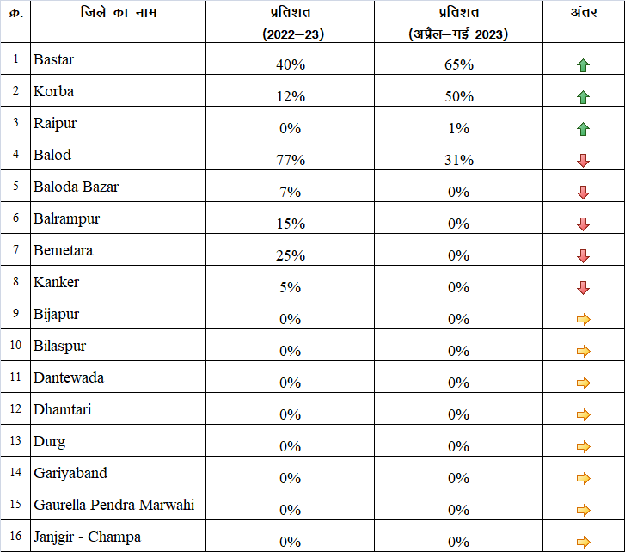 **चजलेवार मरीज ं िे रेफ़र एं टर ी िे चवरुद्ध टर ीटमेंट िी क्लिचत**

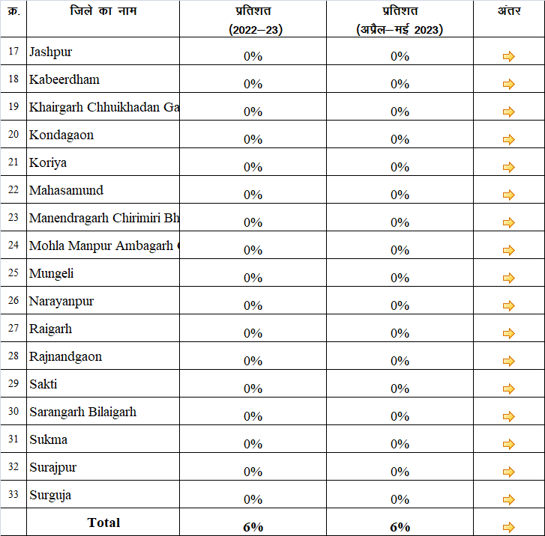 **चजलेवार मरीज ं िे रेफ़र एं टर ी िे चवरुद्ध टर ीटमेंट िी क्लिचत**

|  |  |  |  |  |
| --- | --- | --- | --- | --- |
| **Ø-** | **ftys dk uke** | **izfr'kr**  **¼2022&23½** | **izfr'kr**  **¼vizSy&ebZ 2023½** | **varj** |
| 17 | Jashpur | 0% | 0% |  |
| 18 | Kabeerdham | 0% | 0% |  |
| 19 | Khairgarh Chhuikhadan Gandai | 0% | 0% |  |
| 20 | Kondagaon | 0% | 0% |  |
| 21 | Koriya | 0% | 0% |  |
| 22 | Mahasamund | 0% | 0% |  |
| 23 | Manendragarh Chirimiri Bharatpur | 0% | 0% |  |
| 24 | Mohla Manpur Ambagarh  Chouki | 0% | 0% |  |
| 25 | Mungeli | 0% | 0% |  |
| 26 | Narayanpur | 0% | 0% |  |
| 27 | Raigarh | 0% | 0% |  |
| 28 | Rajnandgaon | 0% | 0% |  |
| 29 | Sakti | 0% | 0% |  |
| 30 | Sarangarh Bilaigarh | 0% | 0% |  |
| 31 | Sukma | 0% | 0% |  |
| 32 | Surajpur | 0% | 0% |  |
| 33 | Surguja | 0% | 0% |  |
|  | **Total** | **6%** | **6%** |  |

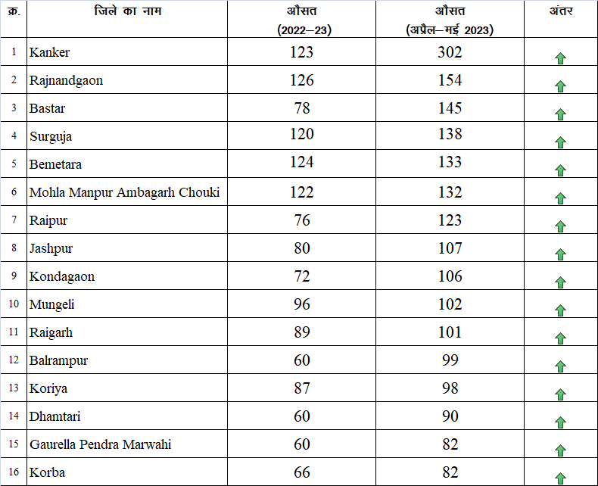 **चजलेवार प्रचत हाट बाजार उपिाररत मरीज ं िी औित िंख्या**

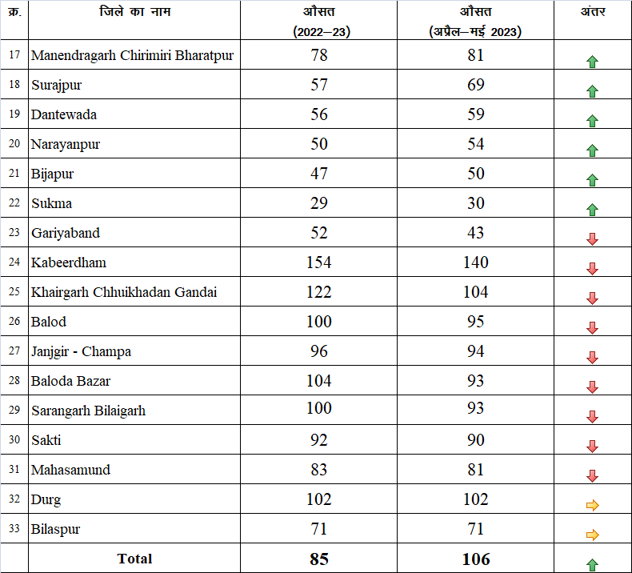 **चजलेवार प्रचत हाट बाजार उपिाररत मरीज ं िी औित िंख्या**

**NHM - Finance**

|  |  |  |  |  |
| --- | --- | --- | --- | --- |
| **jk"Vªh; LokLF; fe'ku] foRrh; izxfr fjiksVZ ekpZ 2023 rd (FY 2022-23) yk[k esas** | | | | |
| **dz-** | **dk;Zdze** | **ctV (ROP)** | **O;;** | **izfr'kr %** |
| ***1*** | ***RCH Flexi Pool*** | ***33123.92*** | ***26180.53*** | ***79.04*** |
| ***2*** | ***Mission Flexipool*** | ***143786.46*** | ***126308.73*** | ***87.84*** |
| ***3*** | ***Immunisation & Pulse Polio*** | ***4160.35*** | ***3134.39*** | ***75.34*** |
| ***4*** | ***NIDDCP*** | ***13.60*** | ***12.66*** | ***93.06*** |
| ***5*** | ***National Urban Health Mission*** | ***6571.04*** | ***5474.41*** | ***83.31*** |
| ***6*** | ***IDSP*** | ***187.87*** | ***164.78*** | ***87.71*** |
| ***7*** | ***NVBDCP*** | ***3810.77*** | ***3044.87*** | ***79.90*** |
| ***8*** | ***NLEP*** | ***1614.65*** | ***1302.85*** | ***80.69*** |
| ***9*** | ***RNTCP*** | ***6899.19*** | ***5222.57*** | ***75.70*** |
| ***10*** | ***NVHCP*** | ***610.20*** | ***455.49*** | ***74.65*** |
| ***11*** | ***NRCP*** | ***45.14*** | ***38.05*** | ***84.31*** |
| ***12*** | ***NPCB*** | ***2050.75*** | ***1761.38*** | 174 ***85.89*** |

|  |  |  |  |  |
| --- | --- | --- | --- | --- |
| **jk"Vªh; LokLF; fe'ku] foRrh; izxfr fjiksVZ ekpZ 2023 rd (FY 2022-23) yk[k esas** | | | | |
| **dz-** | **dk;Zdze** | **ctV (ROP)** | **O;;** | **izfr'kr %** |
| ***13*** | ***NMHP*** | ***1063.65*** | ***840.62*** | ***79.03*** |
| ***14*** | ***NPHCE*** | ***387.50*** | ***312.22*** | ***80.57*** |
| ***15*** | ***NTCP*** | ***386.80*** | ***328.69*** | ***84.98*** |
| ***16*** | ***NPCDCS*** | ***3506.32*** | ***2359.05*** | ***67.28*** |
| ***17*** | ***PMNDP (Dialysis)*** | ***956.60*** | ***416.21*** | ***43.51*** |
| ***18*** | ***NPCCHH*** | ***225.80*** | ***201.57*** | ***89.27*** |
| ***19*** | ***NPPCD (Deffness)*** | ***315.70*** | ***232.83*** | ***73.75*** |
| ***20*** | ***NPPCF (Flurosis)*** | ***42.00*** | ***38.97*** | ***92.78*** |
| ***21*** | ***NOHP (Oral Health)*** | ***400.00*** | ***371.82*** | ***92.95*** |
| ***22*** | ***NPPC (Pallative care)*** | ***78.60*** | ***18.98*** | ***24.14*** |
| ***23*** | ***NPPMBI (Burn & Injuri)*** | ***277.06*** | ***6.97*** | ***2.51*** |
| ***24*** | ***Infrastructure Maintenance*** | ***9713.00*** | ***9713.00*** | ***100.00*** |
|  | **GRAND TOTAL** | ***220226.98*** | ***187941.63*** | 175 ***85.34*** |

|  |  |  |  |  |
| --- | --- | --- | --- | --- |
| **leLr ftyk foRrh; fjiksVZ ekpZ 23 rd (FY 2022-23) yk[k esa** | | | | |
| **SN** | **Activity** | **ALL DISTRICTS TOT** | | **AL** |
| **ROP** | **EXPENSES** | **%** |
| **1** | **RCH Flexi Pool** | 26,615.37 | 23,484.43 | 88.24 |
| **2** | **Imm.& Pulse Polio** | 3,156.54 | 2,723.14 | 86.27 |
| **3** | **NIDDCP** | 7.00 | 6.60 | 94.26 |
| **TOTAL RCH** |  | **29,778.90** | **26,214.17** | **88.03** |
| **4** | **IDSP** | 119.15 | 102.46 | 86.00 |
| **5** | **NVBDCP** | 1,934.67 | 1,843.85 | 95.31 |
| **6** | **NLEP** | 1,573.89 | 1,284.86 | 81.64 |
| **7** | **RNTCP** | 3,294.96 | 2,668.09 | 80.98 |
| **8** | **NVHCP** | 232.11 | 170.46 | 73.44 |
| **9** | **NRCP** | 36.56 | 34.38 | 94.03 |
| **TOTAL NDCP's** |  | **7,191.33** | **6,104.10** | 176 **84.88** |

|  |  |  |  |  |
| --- | --- | --- | --- | --- |
| **leLr ftyk foRrh; fjiksVZ ekpZ 23 rd (FY 2022-23) yk[k esa** | | | | |
| **SN** | **Activity** | **ALL DISTRICTS TOTAL** | |  |
| **ROP** | **EXPENSES** | **%** |
| **10** | **NPCB** | 1,424.50 | 1,219.03 | 85.58 |
| **11** | **NMHP** | 672.54 | 611.15 | 90.87 |
| **12** | **NPHCE** | 350.50 | 303.29 | 86.53 |
| **13** | **NTCP** | 324.80 | 273.74 | 84.28 |
| **14** | **NPCDCS** | 2,129.11 | 1,897.84 | 89.14 |
| **15** | **NPCCHH** | 28.00 | 24.21 | 86.47 |
| **16** | **NOHP (Oral Health)** | 393.40 | 364.63 | 92.69 |
| **17** | **NPPC (Pallative care)** | 32.80 | 18.51 | 56.44 |
| **18** | **NPPCF (Flurosis)** | 42.00 | 38.97 | 92.78 |
| **19** | **NPPCD (Deffness)** | 297.60 | 227.26 | 76.36 |
| **20** | **NPPMBI (Burn & Injuri)** | 112.00 | 6.97 | 6.22 |
| **TOTAL NCD** |  | **5,807.25** | **4,985.60** | **85.85** |
| **21** | **NUHM** | 4,854.13 | 3,939.90 | 81.17 |
| **22** | **Mission Flexipool** | 104,377.32 | 87,105.72 | 83.45 |
|  | **GRAND TOTAL** | **152,008.93** | **128,349.49** | 177 **84.44** |

|  |  |  |  |  |
| --- | --- | --- | --- | --- |
| **National Health Mission, Chhattisgarh** | | | | |
| RANKING as per FMR Report as on March 2023 (FY 2022-23) .In Lakh | | | | |
| **SN** | **District** | **ROP (Budget)** | **EXPENSES** | **%** |
| 1 | Balarampur | 5610.41 | 5469.78 | 97.49 |
| 2 | Balod | 4930.99 | 4684.86 | 95.01 |
| 3 | Dhamtari | 4627.36 | 4342.32 | 93.84 |
| 4 | Raipur | 8331.56 | 7627.73 | 91.55 |
| 5 | Rajnandgaon | 8480.66 | 7595.27 | 89.56 |
| 6 | Korba | 6405.32 | 5657.43 | 88.32 |
| 7 | Sarguja | 6390.10 | 5635.60 | 88.19 |
| 8 | Kawardha | 4436.64 | 3906.63 | 88.05 |
| 9 | Kondagaon | 4791.78 | 4196.40 | 87.57  178 |

|  |  |  |  |  |
| --- | --- | --- | --- | --- |
| **National Health Mission, Chhattisgarh** | | | | |
| RANKING as per FMR Report as on March 2023 (FY 2022-23) . In Lakh | | | | |
| **SN** | **District** | **ROP (Budget)** | **EXPENSES** | **%** |
| 11 | Raigarh | 8140.72 | 7120.28 | 87.47 |
| 12 | Surajpur | 5810.34 | 5030.97 | 86.59 |
| 13 | Jashpur | 7152.67 | 6039.25 | 84.43 |
| 14 | Kanker | 6400.25 | 5391.28 | 84.24 |
| 15 | Sukma | 2931.56 | 2444.45 | 83.38 |
| 16 | Mahasamund | 5851.61 | 4727.39 | 80.79 |
| 17 | Gariyaband | 4832.03 | 3902.12 | 80.76 |
| 18 | Mungeli | 3752.10 | 3025.08 | 80.62 |
| 19 | Balodabazar | 6148.62 | 4932.47 | 80.22 |
| 20 | Janjgir Champa | 7390.89 | 5923.60 | 179 80.15 |

|  |  |  |  |  |
| --- | --- | --- | --- | --- |
| **National Health Mission, Chhattisgarh** | | | | |
| RANKING as per FMR Report as on March 2023 (FY 2022-23) In Lakh | | | | |
| **SN** | **District** | **ROP (Budget)** | **EXPENSES** | **%** |
| 21 | Korea | 5083.26 | 4010.09 | 78.89 |
| 22 | Bijapur | 3284.15 | 2566.49 | 78.15 |
| 23 | Bastar | 6970.66 | 5297.66 | 76.00 |
| 24 | Bemetara | 4051.10 | 3043.29 | 75.12 |
| 25 | Narayanpur | 2542.29 | 1900.49 | 74.76 |
| 26 | GPM | 2614.29 | 1954.08 | 74.75 |
| 27 | Bilaspur | 6512.29 | 4855.24 | 74.56 |
| 28 | Dantewada | 2957.46 | 2185.26 | 73.89 |
| **Grand Total (ALL)** |  | **152008.93** | **128349.49** | 180 **84.44** |

**NHM - Financial Progress Report**

**Till the Month Of MAY 2023 (F Y 2023-24)**

|  |  |  |  |  |
| --- | --- | --- | --- | --- |
| **jk"Vªh; LokLF; fe'ku] foRrh; izxfr fjiksVZ ebZ 2023 rd (FY 2023-24) yk[k esas** | | | | |
| **dz-** | **dk;Zdze** | **ctV (ROP)** | **O;;** | **izfr'kr %** |
| ***1*** | ***RCH Flexi Pool*** | ***33689.16*** | ***725.80*** | ***2.15*** |
| ***2*** | ***Mission Flexipool*** | ***136434.11*** | ***7885.28*** | ***5.78*** |
| ***3*** | ***Immunisation & Pulse Polio*** | ***4090.24*** | ***26.71*** | ***0.65*** |
| ***4*** | ***NIDDCP*** | ***13.60*** | ***0.00*** | ***0.00*** |
| ***5*** | ***National Urban Health Mission*** | ***6731.51*** | ***411.12*** | ***6.11*** |
| ***6*** | ***IDSP*** | ***123.73*** | ***1.58*** | ***1.28*** |
| ***7*** | ***NVBDCP*** | ***2979.11*** | ***9.27*** | ***0.31*** |
| ***8*** | ***NLEP*** | ***1761.57*** | ***2.47*** | ***0.14*** |
| ***9*** | ***RNTCP*** | ***5989.57*** | ***65.47*** | ***1.09*** |
| ***10*** | ***NVHCP*** | ***667.14*** | ***0.01*** | ***0.00*** |
| ***11*** | ***NRCP*** | ***45.14*** | ***0.77*** | ***1.70*** |
| ***12*** | ***NPCB*** | ***1810.75*** | ***4.06*** | 182 ***0.22*** |

|  |  |  |  |  |
| --- | --- | --- | --- | --- |
| **jk"Vªh; LokLF; fe'ku] foRrh; izxfr fjiksVZ ebZ 2023 rd (FY 2023-24) yk[k esas** | | | | |
| **dz-** | **dk;Zdze** | **ctV (ROP)** | **O;;** | **izfr'kr %** |
| ***13*** | ***NMHP*** | ***949.15*** | ***1.79*** | ***0.19*** |
| ***14*** | ***NPHCE*** | ***487.60*** | ***0.29*** | ***0.06*** |
| ***15*** | ***NTCP*** | ***386.80*** | ***0.08*** | ***0.02*** |
| ***16*** | ***NPCDCS*** | ***2974.64*** | ***11.27*** | ***0.38*** |
| ***17*** | ***PMNDP (Dialysis)*** | ***999.68*** | ***0.00*** | ***0.00*** |
| ***18*** | ***NPCCHH*** | ***225.80*** | ***1.57*** | ***0.69*** |
| ***19*** | ***NPPCD (Deffness)*** | ***331.68*** | ***0.46*** | ***0.14*** |
| ***20*** | ***NPPCF (Flurosis)*** | ***31.36*** | ***0.00*** | ***0.00*** |
| ***21*** | ***NOHP (Oral Health)*** | ***400.00*** | ***0.03*** | ***0.01*** |
| ***22*** | ***NPPC (Pallative care)*** | ***54.60*** | ***0.00*** | ***0.00*** |
| ***23*** | ***NPPMBI (Burn & Injuri)*** | ***277.06*** | ***0.00*** | ***0.00*** |
| ***24*** | ***Infrastructure Maintenance*** | ***9713.00*** | ***1618.83*** | ***16.67*** |
|  | **GRAND TOTAL** | ***211167.01*** | ***10766.85*** | 183 ***5.10*** |

|  |  |  |  |  |
| --- | --- | --- | --- | --- |
| **National Health Mission, Chhattisgarh** | | | | |
| RANKING as per FMR Report as on MAY 2023 (FY 2023-24) In Lakh | | | | |
| **SN** | **District** | **ROP (Budget)** | **EXPENSES** | **%** |
| 1 | Durg | 5524.90 | 478.84 | 8.67 |
| 2 | Bemetra | 4006.79 | 272.90 | 6.81 |
| 3 | Raipur | 8323.50 | 556.74 | 6.69 |
| 4 | Surguja | 6331.56 | 378.10 | 5.97 |
| 5 | Korba | 6440.95 | 325.98 | 5.06 |
| 6 | Gariyaband | 4651.98 | 220.72 | 4.74 |
| 7 | Balod | 4867.51 | 220.02 | 4.52 |
| 8 | Baloda Bazar | 5059.33 | 225.02 | 4.45 |
| 9 | Rajnandgaon | 4455.96 | 190.76 | 4.28 |
| 10 | Sukma | 2804.69 | 114.99 | 4.10 |

|  |  |  |  |  |
| --- | --- | --- | --- | --- |
| **National Health Mission, Chhattisgarh** | | | | |
| RANKING as per FMR Report as on MAY 2023 (FY 2023-24) In Lakh | | | | |
| **SN** | **District** | **ROP (Budget)** | **EXPENSES** | **%** |
| 11 | Kabirdham | 4471.68 | 179.30 | 4.01 |
| 12 | Mahasamund | 5705.27 | 227.97 | 4.00 |
| 13 | Bijapur | 3218.94 | 126.24 | 3.92 |
| 14 | Narayanpur | 2405.39 | 87.58 | 3.64 |
| 15 | Dhamtari | 4630.07 | 166.71 | 3.60 |
| 16 | Bilaspur | 6284.99 | 188.41 | 3.00 |
| 17 | Bastar | 6757.81 | 196.94 | 2.91 |
| 18 | Sakti | 2929.01 | 85.24 | 2.91 |
| 19 | Korea | 2314.75 | 65.44 | 2.83 |
| 20 | Khairagarh CG | 1702.49 | 47.45 | 2.79 |

|  |  |  |  |  |
| --- | --- | --- | --- | --- |
| **National Health Mission, Chhattisgarh** | | | | |
| RANKING as per FMR Report as on MAY 2023 (FY 2023-24) In Lakh | | | | |
| **SN** | **District** | **ROP (Budget)** | **EXPENSES** | **%** |
| 21 | Sarangarh Bilaigarh | 2436.14 | 65.55 | 2.69 |
| 22 | Mohala Manpur AC | 2066.46 | 55.60 | 2.69 |
| 23 | Kanker | 6336.29 | 158.96 | 2.51 |
| 24 | Surajpur | 5682.20 | 135.65 | 2.39 |
| 25 | Balrampur | 5514.94 | 127.98 | 2.32 |
| 26 | Jashpur | 6983.39 | 158.67 | 2.27 |
| 27 | Mungeli | 3747.35 | 84.62 | 2.26 |
| 28 | Manendragarh CB | 2727.27 | 55.46 | 2.03 |
| 29 | Janjgir Champa | 4354.53 | 87.32 | 2.01 |
| 30 | Dantewada | 2942.33 | 58.63 | 1.99 |
| 31 | Raigarh | 6451.36 | 116.85 | 1.81 |
| 32 | Kondagaon | 4756.34 | 82.76 | 1.74 |
| 33 | Gaurela PM | 2541.11 | 42.25 | 1.66 |
| **Total (ALL)** |  | **149427.26** | **5585.66** | **3.74** |

Chhattisgarh State AIDS Control Society

**District Wise Contractual VACANT Post under AIDS Control Programme (NACO-CGSACS)**

|  |  |  |  |  |  |  |  |  |  |  |  |  |
| --- | --- | --- | --- | --- | --- | --- | --- | --- | --- | --- | --- | --- |
| **S.No.** | **Name of Disticts** | **Counselor** | **Lab technician** | **Data Manager** | **Staff Nurse** | **Medical Officer** | **Care Coordinator** | **Technical Officer (SRL)** | **Blood Transportation Driver (outsourcing)** | **Blood Transportation Attendent (outsourcing)** | **Lab Attenden t** | **Total Vacant Post** |
| **1** | **Raipur** | 4 | 8 | 1 | 2 |  |  | 1 | 1 | 1 | 1 | 19 |
| **2** | **Baloda Bazar** | 2 | 0 |  |  |  |  |  |  |  |  | 2 |
| **3** | **Gariyaband** | 1 | 3 |  |  |  |  |  |  |  |  | 4 |
| **4** | **Durg** | 2 | 3 |  | 2 | 2 |  |  |  |  |  | 9 |
| **5** | **Balod** |  |  |  |  |  |  |  |  |  |  | 0 |
| **6** | **Bemetra** |  |  |  |  |  |  |  |  |  |  | 0 |
| **7** | **Rajnandgaon** | 1 | 2 |  |  |  |  |  |  |  |  | 3 |
| **8** | **Kabirdham** | 1 | 2 |  |  |  |  |  |  |  |  | 3 |
| **9** | **Bilaspur** | 5 | 3 | 2 | 3 | 2 |  |  |  |  |  | 15 |
| **10** | **Mungeli** | 1 | 1 |  |  |  |  |  |  |  |  | 2 |
| **11** | **Koria** |  | 2 |  |  | 1 |  |  |  |  |  | 3 |
| **12** | **Surguja** | 6 | 3 | 2 |  |  |  |  |  | 1 |  | 12 |
| **13** | **Surajpur** | 1 | 1 |  |  | 1 |  |  |  |  |  | 3 |
| **14** | **Balrampur** | 1 | 1 |  |  |  |  |  |  |  |  | 2 |
| **15** | **Jashpur** | 2 | 6 |  |  |  |  |  |  |  |  | 8 |
| **16** | **Raigarh** | 6 | 10 |  | 1 | 1 |  |  |  |  |  | 18 |
| **17** | **Janjgir-Champa** | 3 | 4 |  |  |  |  |  |  |  |  | 7 |
| **18** | **Korba** | 1 | 2 |  |  | 2 |  |  |  |  |  | 5 |
| **19** | **Dhamtari** |  | 1 |  |  |  |  |  |  |  |  | 1 |
| **20** | **Kanker** |  | 1 |  |  |  |  |  |  |  |  | 1 |
| **21** | **Bastar** | 2 | 4 | 1 |  | 1 | 1 |  |  |  |  | 9 |
| **22** | **Kondagaon** | 1 | 2 |  |  |  |  |  |  |  |  | 3 |
| **23** | **Mahasamund** |  | 1 |  |  |  |  |  |  |  |  | 1 |
| **24** | **Dantewara** | 3 | 4 |  |  |  |  |  |  |  |  | 7 |
| **25** | **Sukma** | 2 | 1 |  |  |  |  |  |  |  |  | 3 |
| **26** | **Narayanpur** |  |  |  |  |  |  |  |  |  |  | 0 |
| **27** | **Bijapur** | 2 | 2 |  |  |  |  |  |  |  |  | 4 |
| **28** | **Gpm** |  |  |  |  |  |  |  |  |  | 188 | 0 |
|  | **Total** | **47** | **67** | **6** | **8** | **10** | **1** | **1** | **1** | **2** | **1** | 144 |

|  |  |  |  |
| --- | --- | --- | --- |
|  | HIV - TB coordinati | on committee me | eting |
| **S. No** | **Regular** | **After 2-3 month** | **After more then 8-10 months** |
| 1 | Bilaspur, Balodabazar, Balrampur, Dantewada, Durg , Dhamtari, Jaspurnagar, Kondagaon, Kanker, Korea, Mahasamund, Raigarh, Raipur, Rajnandgaon, Sarguja & Surajpur | GPM, Gariyaband & Janjgir Champa, Korba,, Bijapur | Balod . Mungeli, Bemetara, Kawardha & Sukma , Narayanpur  189 |

|  |  |  |  |  |
| --- | --- | --- | --- | --- |
|  | HIV | -TB Cross referral | 2022-23 |  |
| **District**  **/Division** | **Counsaling/Tested for HIV(General Clients)** | **No. of Client referred from SAICTC to NTEP** | **No. of Client In Referred from NTEP to SA-ICTC** | **% of Referral** |
| Baloda Bazar | 7723 | 821 | 572 | 10.63 |
| Mungeli | 4831 | 500 | 423 | 10.35 |
| GPM | 2610 | 265 | 346 | 10.15 |
| Koriya | 7007 | 692 | 475 | 9.88 |
| Surajpur | 4982 | 475 | 17 | 9.53 |
| Balrampur | 4620 | 424 | 293 | 9.18 |
| Bemetara | 3133 | 249 | 258 | 7.95 |
| Kondagaon | 2920 | 231 | 104 | 7.91 |
| Rajnandgaon | 7916 | 592 | 675 | 7.48 |
| Bilaspur | 16498 | 1153 | 1072 | 6.99 |
| Kanker | 7835 | 544 | 231 | 6.94 |
| Raipur | 28478 | 1961 | 1183 | 6.89 |
| Surguja | 6611 | 431 | 165 | 6.52 |
| DHAMTARI | 4701 | 300 | 327 | 6.38 |
| Jashpur | 7846 | 465 | 503 | 5.93 |
| Sukma | 2170 | 122 | 228 | 1905.62 |

|  |  |  |  |  |
| --- | --- | --- | --- | --- |
|  |  | HIV-TB Report 20 | 22-23 |  |
| **District**  **/Division** | **Counsaling/Tested for HIV(General Clients)** | **No. of Client referred from SAICTC to NTEP** | **No. of Client In Referred from NTEP to SA-ICTC** | **% of Referral** |
| Raigarh | 17900 | 1001 | 876 | 5.59 |
| Durg | 17152 | 931 | 676 | 5.43 |
| Dantewada | 3354 | 182 | 448 | 5.43 |
| Gariyaband | 6388 | 345 | 1066 | 5.4 |
| Korba | 14996 | 775 | 626 | 5.17 |
| Janjgir Champa | 7641 | 367 | 91 | 4.8 |
| Kabirdham | 9059 | 381 | 431 | 4.21 |
| Balod | 7545 | 316 | 198 | 4.19 |
| Mahasamund | 12114 | 434 | 578 | 3.58 |
| Bijapur | 5376 | 167 | 119 | 3.11 |
| Bastar | 13862 | 330 | 212 | 2.38 |
| Narayanpur | 1414 | 9 | 139 | 0.64 |
| **G. Total** | **236682** | **14463** | **12332** | 191**6.11** |

NABL Certification of ICTC

|  |  |  |  |
| --- | --- | --- | --- |
| **NABL Certification Status of ICTCs_Chhattisgarh** | | | |
| **SN** | **District** | **Name of ICTC** | **Status from NABL** |
| 1 | Korba | ICTC DH Korba | Certificate Issued by NABL |
| 2 | Baloda Bazar | ICTC CHC Simga | Certificate Issued by NABL |
| 3 | Dhamtari | ICTC CHC Nagri | Status pending at NABL Level. |
| 4 | Manendragarh-Chirmiri- Bharatpur | ICTC CHC Chirmiri | Status pending at NABL Level. |

|  |  |  |
| --- | --- | --- |
|  | Documents Required for NABL | Certification |
| **SN** | **Document** | **Availability of Document** |
| 1 | Legal Identification of ICTC Lab | CGSACS |
| 2 | Refrigerator Calibration Certificate | CMHO/CS Office |
| 3 | Centrifuge Calibration Certificate | CMHO/CS Office |
| 4 | Micropipette Calibration Certificate | CMHO/CS Office |
| 5 | Refrigerator Temperature Chart | ICTC |
| 6 | Valid Pollution Control Certificate BMW (Bio Medical Waste) | CMHO/CS Office |
| 7 | Valid Pollution Control Board Registration Certificate | CMHO/CS Office |
| 8 | Duration of Preservation of Records | CMHO/CS Office |
| 9 | EQA (External Quality Assurance) Report | State Reference Lab, Pt. JNM Medical College, Ra1i9p4 ur. |

|  |  |  |  |
| --- | --- | --- | --- |
|  | District wise LFU & | Viral Load Penden | cy |
| **SNo.** | **District** | **LFU** | **Viral Load** |
| 1 | Raipur | 484 | -- |
| 2 | Durg | 300 | 05 |
| 3 | Bilaspur | 244 | 1228 |
| 4 | Bastar | 191 | 50 |
| 5 | Balodabazar | 169 | 117 |
| 6 | Koria | 143 | 06 |
| 7 | Ambikapur | 114 | 02 |
| 8 | Mahasamund | 106 | 01 |
| 9 | Kawardha | 86 | 91 |
| 10 | Rajnandgaon | 75 | 395 |
| 11 | Bemetara | 68 | 50 |
| 12 | Janjgeer | 67 | 477 |
| 13 | Kondagaon | 44 | 10 |
| 14 | Gariaband | 40 | 00 |
| 15 | Raigarh | 39 | 75 |
| 16 | Kanker | 38 | 07 195 |

|  |  |  |  |
| --- | --- | --- | --- |
|  | District wise LFU & | Viral Load Pende | ncy |
| **S.No.** | **District** | **LFU** | **Viral Load** |
| 17 | Balod | 35 | 26 |
| 18 | Dhamtari | 34 | 00 |
| 19 | Balrampur | 33 | 00 |
| 20 | Mungeli | 29 | 195 |
| 21 | Dantewada | 28 | 03 |
| 22 | Narayanpur | 11 | 04 |
| 23 | Bijapur | 10 | 02 |
| 24 | Sukma | 09 | 02 |
| 25 | Korba | 02 | 136 |
| 26 | Jashpur | 02 | 04 |
| 27 | Surajpur | 00 | 00 |
| 28 | Mungeli | 00 | 196 |
| 29 | Sakti | 00 | 04 |
| 30 | GPM | 00 | 38 |
| 31 | Sarangarh | 00 | 01 196 |

Thank You